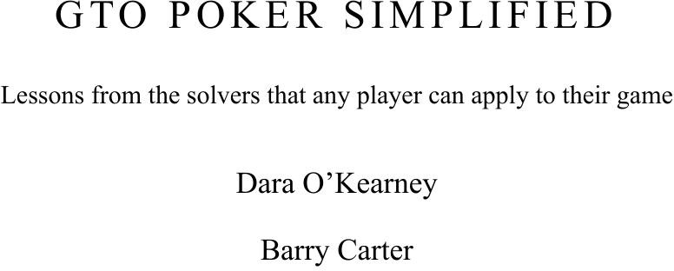

GT O P O KE R S IM P L IFIE D

Lessons from the solvers that any player can apply to their game

Dara O’Kearney Barry Carter

# CONTENTS

Title Page Assumptions

Chapter 1: What is GTO? Chapter 2: Exploitation

Chapter 3: Your value bets drive y our actions Chapter 4: Range Advantage

Chapter 5: Blockers Chapter 6: Board Coverage Chapter 7: The river Chapter 8: The flop Chapter 9: The Turn Chapter 10: Preflop

Chapter 11: Other GTO Considerations Chapter 12: Exploitation revisited Further Study

Acknowledgements

About the Authors

Other books by the authors



GTO Poker Simplified

*Lessons from the solvers that any player can apply to their game*

Dara O’Kearney

with Barry Carter

GTO Poker Simplified

Copyright © 2022 Barry Carter and Dara O’Kearney

All rights reserved. No part of this book may be reproduced or transmitted in any forms or by any means, without written permission from the authors, except for the inclusion of brief quotations in a review. To request permission to use any part of the book in any way email: [barryrichardcarter@gmail.com.](mailto:barryrichardcarter@gmail.com)

ISBN: 978-1-5136-9913-4

Cover design by Tiger-Fruit, [www.tiger-fruit.com](http://www.tiger-fruit.com/)

Dara’s headshot courtesy of Tambet Kask and Unibet Poker.



*Dedicated to Jan Suchanek (1967-2022), perpetual Czech, perpetual friend.*

# ASSUMPTIONS

Tựa đề làm việc ban đầu của cuốn sách này là **“GTO for Normies”**, đây là một trò đùa nhỏ của chúng tôi về sự “đối lập” giữa đối tượng độc giả và chủ đề của cuốn sách.  
**Game Theory Optimal (GTO)** trong poker không phải là điều mà chúng tôi mong bạn đã hiểu — toàn bộ mục tiêu của cuốn sách này là **giải thích những khái niệm nâng cao theo cách mà những người chơi nghiệp dư nhiệt huyết cũng có thể nắm bắt được**.  
Chúng tôi cũng tin rằng đây là **cuốn sách khởi đầu lý tưởng cho những người chơi chuyên nghiệp** nhưng cho đến nay vẫn chưa từng nghiên cứu về GTO.

Chúng tôi **không kỳ vọng bạn là một người chơi đẳng cấp**, cũng không yêu cầu bạn **phải hiểu về GTO hay công nghệ solver**. Tuy nhiên, chúng tôi **giả định rằng bạn đã có ít nhất một chút kinh nghiệm chơi**, có hiểu biết hợp lý về trò chơi và các thuật ngữ của nó.  
Đây **không phải là cuốn sách nhập môn** cho người mới bắt đầu. Chúng tôi mong rằng bạn **đã chơi poker ít nhất khoảng một năm**.

Chúng tôi cũng mong bạn **biết rằng hiện nay có một trào lưu học poker mới gọi là GTO**, và rằng **những người chơi hàng đầu sử dụng công cụ “solver”** như **PIOSolver**. Có lẽ bạn **đã không mua cuốn sách này nếu điều đó không đúng**.

Đây **chủ yếu là một cuốn sách về postflop**. Trong suốt cuốn sách, chúng tôi sẽ cho bạn thấy **các bảng lưới bài (hand grid)** như thế này:

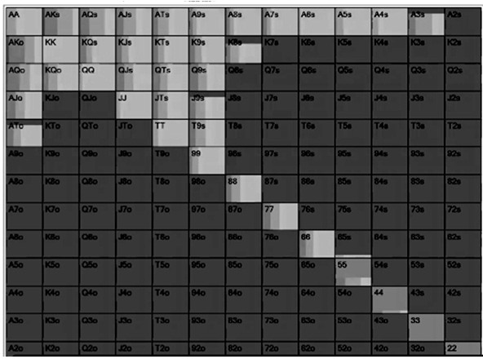

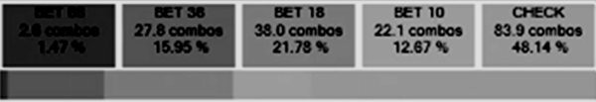

Bảng lưới này được lấy từ **PIOSolver** và cho thấy **các hành động mà chúng ta sẽ thực hiện với từng hand trong range của mình**. Các kích thước cược (bet size) được tính theo đơn vị **big blind (BB)**.  
Như bạn có thể thấy, **với JJ chúng ta check hầu hết thời gian**, còn **với AKs thì luôn luôn bet**. Khi bet với AKs, solver sẽ **trộn giữa một cú bet lớn (36BB)** và **một cú bet nhỏ (18BB)**.  
Những hand **không có ký hiệu tương ứng bên dưới**, như **74s**, là **những hand fold preflop**.

Một lưu ý nhỏ về cách đọc solver:  
Khi bạn thấy solver **chọn một line với tần suất nhỏ hơn 5%**, chẳng hạn như **bet 66 size 1.47%**, **bạn có thể bỏ qua nó**. Nếu solver được **chạy mô phỏng lâu hơn**, **kích thước cược đó sẽ bị loại bỏ**.  
Tương tự, nếu solver **chọn hai kích thước cược tương tự nhau** với tần suất gần bằng nhau (ví dụ **bet 10 hoặc 18BB**), thì bạn có thể **coi rằng bất kỳ loại cược nhỏ nào cũng đều ổn**.  
👉 **Đừng sa vào tiểu tiết**, hãy **tập trung vào những hành động có tần suất cao nhất**.

Trong tất cả các phân tích hand, chúng tôi **không xem xét từng hand riêng lẻ**, mà xem xét **cách chúng ta sẽ chơi toàn bộ range trong cùng một tình huống**. Đây là **một khía cạnh quan trọng trong tư duy poker hiện đại**, và **bạn cũng nên làm được điều đó sau khi đọc xong cuốn sách này**, nếu bạn chưa từng làm như vậy.

Chúng tôi sử dụng nhiều **công cụ solver khác nhau** trong suốt cuốn sách, bao gồm:

**PIOSolver**

**Range Trainer Pro**

**GTO Wizard**

**Poker Snowie**

Ban đầu, chúng tôi dự định **tạo ra các hand grid riêng cho cuốn sách**, nhưng cuối cùng quyết định **hiển thị trực tiếp kết quả từ các solver thực tế đã sử dụng trong từng ví dụ**.  
Mục đích là để bạn **có thể tự tái tạo các tình huống bằng cùng công nghệ**, đồng thời **làm quen dần với nhiều loại solver khác nhau**.  
Chúng tôi hy vọng nhiều bạn đọc sẽ **đăng ký sử dụng ít nhất một trong số những công cụ này**, và nhờ việc thấy chúng trong sách, **bạn sẽ không còn cảm thấy xa lạ khi thực hành**.

Một vài hình ảnh từ solver **sẽ khó nhìn rõ trong bản in đen trắng**. Nếu bạn gặp khó khăn, **tất cả hình đều có sẵn bản màu, kích thước lớn, tại địa chỉ:**  
👉 [tinyurl.com/solverpics](https://tinyurl.com/solverpics)

Phần lớn ví dụ trong cuốn sách là **các hand giải đấu (tournament hands)**, nhưng chúng tôi cũng bao gồm **một số hand cash game**.  
Bạn **không cần là người chuyên chơi MTT** để sử dụng cuốn sách này — **các bài học đều mang tính phổ quát**, áp dụng được **cho mọi thể loại postflop**.  
Lý do chúng tôi **tập trung vào MTT** là vì đó là **thể loại mà chúng tôi – các tác giả – thường chơi**, và **các cuốn trước đây của chúng tôi cũng viết về tournament**, nên **độc giả hiện tại sẽ mong đợi các ví dụ tương tự**.

Ở cuối hầu hết các chương, chúng tôi có phần gọi là **“Heuristics for Real Life” (Nguyên tắc thực hành trong đời thực)**.  
Bạn **không cần phải chơi GTO hoàn hảo**, và chắc chắn **đối thủ của bạn cũng sẽ không làm vậy**.  
Trong phần này, bạn sẽ tìm thấy **những cách ứng dụng thực tế của các bài học GTO vào các ván bài đời thực**, nơi đối thủ chơi không hoàn hảo.

Giống như trong các cuốn sách trước, chúng tôi **trình bày các bài học theo thứ tự có vẻ phi logic**, bởi vì chúng tôi muốn **ưu tiên những nội dung quan trọng nhất trước tiên**.  
Nửa đầu cuốn sách sẽ **giới thiệu những khái niệm GTO cốt lõi**, còn nửa sau sẽ **tập trung vào từng street (vòng cược) trong một hand No Limit Hold’em**.  
Tuy nhiên, phần đó **bắt đầu với river, rồi đến flop, sau đó là turn, và cuối cùng là preflop**.  
Chúng tôi hứa rằng đây là **thứ tự tối ưu nhất** để bạn **hấp thụ giá trị của cuốn sách**, và **khi đọc tiếp, bạn sẽ hiểu lý do vì sao**.

Ba chương đầu tiên **có thể khá nặng** vì chúng tôi giới thiệu các khái niệm nền tảng, **nhưng các chương sau sẽ dễ theo dõi hơn**.

Trước khi đi xa hơn, chúng tôi muốn **bày tỏ sự tri ân** đến **Andrew Brokos** và **Michael Acevedo**, tác giả của hai cuốn sách GTO bán chạy nhất:

Play Optimal Poker (Brokos)

Modern Poker Theory (Acevedo)

Chúng tôi xem hai cuốn này là **tác phẩm game theory hay nhất trên thị trường**, và **cuốn sách của chúng tôi không nhằm cạnh tranh trực tiếp**.  
Thay vào đó, chúng tôi tin rằng **cuốn sách này nằm ở giữa** — giữa **Modern Poker Theory (rất thực tiễn)** và **Play Optimal Poker (rất nặng lý thuyết)**.

Hai cuốn kia **đã quá xuất sắc**, nên ban đầu chúng tôi **không định viết sách GTO riêng**, và **Dara chỉ giới thiệu chúng cho học viên của mình**.  
Tuy nhiên, anh ấy nhận ra rằng **nhiều người chơi cảm thấy khó hiểu** nếu **không có phần giới thiệu cơ bản về GTO đi kèm ví dụ thực tế** — và **đó chính là nguồn gốc ra đời của cuốn sách này**.

👉 **Mục tiêu của chúng tôi** là **trình bày những bài học then chốt của GTO** dưới dạng **các nguyên tắc có thể áp dụng ngay**, dành cho **những người mới bắt đầu tiếp cận lý thuyết trò chơi** hoặc **từng gặp khó khăn khi hiểu nó**.

Chúng tôi tin rằng sau khi đọc xong cuốn sách này, **những độc giả muốn tìm hiểu sâu hơn về GTO** sẽ **tiếp tục đọc hoặc quay lại với hai cuốn sách nói trên**.

Và khi đã nói đủ phần mở đầu rồi —  
👉 **Giờ thì cùng bắt đầu thôi…**

**Part I: Concepts**

# CHAPTER 1: WHAT IS GTO?

Game Theory Optimal (GTO) poker means playing a strategy that cannot be exploited. It means not having a leak in your game like bluffing too much/too little or calling too much/too little that can be exploited by another player. The alternative to GTO is exploitative poker, which is when you change your strategy to extract more money from an opponent by targeting an obvious leak in their game.

A typical exploitative strategy might be when you are playing against a calling station you value bet more hands and use a bigger bet size. This is a fine strategy when you get it right but it leaves you open to counter exploitation. If you have been value betting thin in your usual games and a good regular spots it, they can start to raise you and force you to fold hands that might have otherwise been profitable if you had played them more passively.

We will cover this in more detail in the next chapter but until then we have assumed that you have a reasonable understanding that GTO exists and that the best players in the world use it. Rather than diving into the history of game theory and how it relates to poker, first we wanted to bring you up to speed with how GTO has impacted the modern game, what ‘solving’ a hand looks like and to also dismiss some myths about GTO.

## Dara’s Personal History With GTO And Solvers

For many people learning GTO and using solvers is a mind blowing experience. They have played one way for a long time then suddenly are presented with a new, counterintuitive way of playing. There can be resistance along the way, especially if the player in question has had success with an exploitative style previously, but it can also open up exciting new doors. My co-author Barry said that he has loved working on this book because, for him, it was like learning poker from scratch again, with all the wonder and enthusiasm that comes with it.

For me discovering solver technology was more a case of confirming the suspicions I had developed over a number of years as a professional poker player.

I learned poker the way everyone did back in the day, which was trial and error. I would see what worked and what didn’t, and the lessons eventually became heuristics about how to play.

The first inkling I had that game theory could be applied to poker was after I read *Harrington On Hold’em*. There was a sentence that really jumped out to me where Dan Harrington talked about shoving as a bluff. He said that if you add 33% to your stack when the shove gets through, and if you have 33% equity on average when called, you only need the shove to work 33% of the time to be profitable. I looked at that sentence and realised that it meant you can work out which hands are profitable to shove.

I worked with an equity calculator and a spreadsheet, and created push/fold ranges using trial and error. It took six months and was rendered completely useless when ICMIZER came out.

I studied this sheet when I was an SNG grinder and it worked out really well for a while, but then the regulars started to notice I was pushing wider than I used to, so they adjusted by widening their calling ranges against me. I returned to the spreadsheet, fiddled with the ranges, and created a tighter adjusted shoving range based on their new calling ranges. They adjusted again by tightening up against me, so I adjusted by widening my ranges again. A few more iterations followed and I had the eureka moment where I realised we were coming to an equilibrium, which meant that we were going to arrive at a place where neither of us would deviate from our own strategy despite knowing each other’s ranges. Soon it would be a case of if I shoved wider I would lose money, if they called wider they would lose money, and so on.

This sent me down a rabbit hole where I started to learn about game theory and how it applied to poker.

Around this time I was crushing the live poker scene in Ireland along with Dermot Blain and Jason Tompkins. For a few years there wasn’t a final table one or more of us didn’t make, in some cases a couple of us were at the same final table. The three of us had such an edge, we estimate we all had live ROIs of 300%.

It was only when I started playing abroad at EPTs that I came up against players I had no idea how to play against. They were so much better than me. I could not get any reads on them at all or work out how to exploit them. I thought I could not compete but I

remembered the basic precept of game theory was to develop an unexploitable style. It doesn’t matter what they do, if you are unexploitable they cannot beat you.

I think the most important hand I’ve ever played in terms of my career happened during this period at EPT Berlin against online legend Randy ‘Nanonoko’ Lew. It is folded around to me in the cutoff and I open with A8o. Nanonoko called in the Big Blind, he had me covered. The flop came 8-3-2 and he led really small, I thought “this is easy” and just called. The turn was a 6 and he led small again, so I called again. The river was a Q and he bet three times the pot and I was like “what the fuck?”. This wasn’t supposed to happen, he was supposed to check and then I would think about betting, or he would bet small and I would call again, where did this come from? This might have been the first time I faced an overbet in my career.

In my mind I thought he was at it, he knows I have a weak hand and he is betting to take me off it, so I have to call because he is full of shit. But then I thought he was looking at some old guy he had never seen before who can’t fold anything, he knows I have a pair and he bet big to get max value. These two conflicting thoughts were going through my mind, he knows my hand and he is trying to take me off it, or he knows my hand and he is trying to get max value. I ended up folding and I asked all the top players I knew what they would have done, half of them said “it’s Nanonoko - he is full of shit you have to call” and the other half said “you can’t even think about calling, it’s three times the pot”.

It came down to what people thought of Nano, not the hand.

That started me thinking, what do we do in this scenario? I knew we can’t always call and we can’t always fold, because we would be exploited either way. So that got me thinking about game theory and I started going back to first principles. He bet three times the pot, so if we fold four fifths of the time he is going to win one unit four times and lose three units one time if he’s bluffing. Therefore I have to call 25% of the time (otherwise he can profitably shove as a bluff always), so I had to decide what hands I call with, as well as whether blockers came into play.

From that point on I realised that elite poker was all about game theory. I continued with exploits against weak players, but for the other guys I fixated on studying how to be unexploitable. I had to learn concepts like the types of ranges, board coverage, minimum defence frequency, blockers and much more.

When the solvers arrived I was already there. I was a very early adopter of solver technology and when Holdem Resources Calculator came out I didn’t need my

spreadsheet anymore. When PIOSolver came out it just confirmed everything I had suspected from studying GTO.

This is not to say I didn’t learn from solvers. They have revolutionised my game and I continue to be amazed at some of the things I learn on a daily basis with them. They even gave me a framework for why my exploits worked, in particular when thinking about ranges and blockers.

It is no coincidence that the efforts by a lot of online poker rooms to ban Heads-Up Displays (HUDs) has coincided with the growth of solver technology. HUDs are all about exploitative poker as they show you the tendencies of your opponents. With no reads and no stats, poker is all about game theory. A good regular has to play a lot of tables to be profitable and you cannot pay attention to 12 tables at a time with no HUD, so the correct approach is to play as close to a GTO style as possible.

GTO is the starting point for all good training content these days, even if that content then goes on to be mostly about exploits. GTO should be your starting point for playing against unknown players and very good players.

There is a lot of doom mongering about GTO as the death of poker, and there are certainly a lot of exaggerations and misconceptions about GTO. There is a genuine existential threat in the form of Real Time Assistance (RTA) GTO Solvers, but for the most part you should not worry about RTA. At the time of writing a very credible source in this space estimates that the number of players who regularly use software legal solver technology like PIOSolver is under 1,000, which is a very small part of the poker world.

There are a lot of elite players who have never run a sim in their life. They do, however, have access to people who run sims and the information trickles down to them. The solver guys are like miners who refine the information into heuristics on how to play. What took them hundreds of hours can be learnt almost instantly by somebody else. That is what we will be doing for you in this book, giving you some of the most reliable heuristics from the teachings of solvers.

## Myths About GTO

One of the reasons some people struggle to pick up GTO is less about how difficult it is and more about some quite bad optics it has received in some corners of poker. There is new lingo and technology that comes with GTO, and some of its early adopters are unsurprisingly the best players in the world, so there is little wonder there seems to be a much bigger barrier to entry than there actually is. There is also a trend of some players who have chosen not to study GTO to dismiss it or denigrate it as boring, harmful or even cheating.

It is true that there are some initial teething periods when it comes to learning GTO and a lot of that is because it involves a lot of unlearning of previously unquestioned poker wisdom. We will do that in this book, but until then a good way to get up to speed on GTO is to address some of the most commonly held myths about Game Theory Optimal poker.

*Myth 1: GTO is the perfect/most profitable way to play poker*

This is one of those misconceptions that advocates of GTO fall into and that it is the only ‘correct’ way to play the game. It isn’t. GTO is simply a strategy to avoid being exploited in poker. If you can play unexploitable poker then by default you will make money whenever your opponent plays in an exploitable style, which will be often because everybody has aspects to their game that can be exploited.

GTO is never the most profitable way to play poker. If your opponent is playing an exploitable style then you will make the most money by counter-exploiting them. The problem there is that you leave yourself open to being counter exploited too.

GTO is never the ‘best’ way to play in any single hand but as an overall strategy it will prove to be profitable, whether you are playing $1 MTTs or $100,000 Super High Rollers. While some people are evangelical about GTO, all the best players diverge from it when a particularly fishy opponent sits down.

There is also a belief that solvers like PIOSolver give you the definitive ‘right’ answer for any spot. This is both peddled by GTO advocates who use solvers as a way to line check a hand and explore it no further, as well as detractors who believe that solvers are killing poker. Neither are right. A solver output is only as good as the assumptions you punch into it. When you ‘solve’ a hand you state the range you believe you and your opponent would have as well as the bet sizes you believe each of you would use in

similar spots. There is no way you can perfectly assume either of these things and if you get either wrong your solve will be flawed, get them dramatically wrong and the solve will be useless. Therefore solvers are only as good as the person who uses them.

Finally, solvers tend to mix their actions, it is rare a solver will take the same line with a hand 100% of the time. Let’s quickly remind you of that first solver image we saw in the Assumptions section:

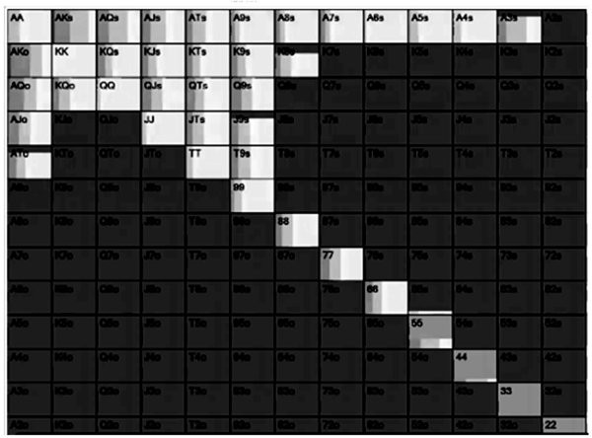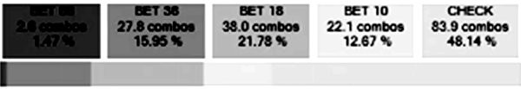

As you can see no hand takes the exact same action 100% of the time. Some hands like AKs are mostly bets, but the sizing of the bet still varies. Some hands like KK are mostly checks but it still bets a small percentage of the time.

All of this is not to say that when a solver says two or more actions are allowed (equal EV) it's ok to pick one of them all the time. For example, a solver might tell you to bet 40% of the time as a bluff and give up (check) the other 60%. Some players internalise this as "it's ok to bluff or to give up", and some will always bluff while others always check. Both of these are actually diverging from GTO. The player who always bluffs this spot ends up over bluffing, while the player who always gives up ends up under bluffing. A phrase you often hear among elite players is that "poker is a game of frequencies", and this is what they mean.

You rarely get an official ‘correct’ way to play the hand, even when you input the right assumptions into a solver, it will give you a choice of several actions and you have to decide which ones are most relevant to your game.

*Myth 2: GTO is only useful at the high stakes*

Playing purely GTO against a fish is not the best strategy. If you are up against a calling station making a small river bet with the nuts to protect your small bet range is burning money. When you know you are up against a bad player you should adjust to exploit them. When you are playing against good players or unknowns, your best strategy is to play as close to GTO as possible. You don’t make your money against good players anyway so it is best to avoid exploitation and look to make your money from the weak players. When a player is unknown, GTO is the best way to proceed with caution until you learn more about them.

Good players understand this, but this does not mean that GTO is useless against bad players. We expect the core audience of this book to be lower stakes players who don’t have to worry about facing GTO regulars. There are, however, many lessons from the world of GTO that are useful even if you are playing in soft games. The best hands to bluff with, the best hands to bluffcatch with, the right bet size for dry and wet flops, how to play against different range types, when to overbet and how to use blockers are just some of the lessons you can take to weak games as well as nosebleed tables.

*Myth 3: GTO is just breakeven poker*

Those who understand that GTO is about not being exploited sometimes mistake it therefore for playing for a stalemate. It is true that if you played perfect GTO poker against another player who is also playing perfect GTO poker, you would, over a big enough sample, breakeven.

In reality nobody is even close to playing perfect GTO poker but if you can improve your game using GTO principles your earn rate will increase, and the gains will scale up as you climb the stakes.

*Myth 4: GTO is boring*

Because there are myths that GTO is perfect/breakeven poker, an additional myth has developed that it is also boring to watch. The players are either deemed as playing very tight, usually by other players who like to gamble, or at least the players themselves are so entrenched in poker strategy that they are no fun to be with at the tables.

If we do our job right in this book you will not think GTO Is boring: not only is it fascinating to learn but many of the strategic adjustments will seem crazy at first. By the end of this book you will likely play a wider range of hands, fold to bets less often, overbet more, bluff more hands, play backdoor draws more aggressively and make more hero calls. If that sounds boring to you then maybe you should return this book right now.

*Myth 5: GTO is killing poker*

Those who think GTO is boring *or* perfect therefore also go on to believe that it is killing the game. Just in the way that people felt that HUDs were killing poker, just in the way they thought big rakeback deals were killing poker, just like prior to that online poker was killing poker and before that they felt hole card cameras were killing the game.

The people who believe GTO is killing poker are almost always the people who do not work on their own game. Either they never have or they used to win at poker but the game has passed them by. It is true that we are seeing a new wave of more studious players crushing the game just in the way that aggressive online players replaced the

‘tells based’ live players of yesteryear. The best players keep up with the trends in poker and never stop learning, the bad players look for excuses for why they are no longer winning.

*Myth 6: GTO is cheating*

A more insipid myth you see from the same detractors of GTO is that it is such an edge, it is actually a form of cheating. This is a particularly backwards way of thinking about the game, which if you take to its natural conclusion means that any form of poker study is cheating. Again, we are just dealing with the people who do not work on their games any more lashing out on those that do.

It is true that poker faces a form of cheating related to GTO in the form of RTA software. Contrary to what some may think, there isn’t a solver on the planet that can calculate how to play a hand in the time it takes to play a hand. What RTA software does is access a database of previously solved hands, if a similar one is in the database it is used for comparison. If the opponent plays differently from the assumptions an RTA has made, then that could render a real time solver useless anyway.

Do not get me wrong, the threat of RTAs is nothing to play down and all the reputable poker rooms are working hard to tackle it. But learning GTO principles and applying it to your game is not cheating and in fact something which should be applauded.

*Myth 7: You need to be a genius to do it*

The final myth is perhaps what puts off people from even starting to learn GTO and it is why its detractors deflect by suggesting it is cheating or kills the game. Because the early adopters of GTO are some of the best players in the world and invariably quite tech savvy, it can be alienating. It is also true that the early GTO software like PIOSolver comes with a bit of a learning curve. It is quite hard to understand a PIOSolver output at first, knowing what to input isn’t easy and even running it is time consuming.

We can assure you that all of this is tricky just at the beginning. Once you get used to reviewing hands the way solvers do it becomes second nature. My co-author Barry had barely ever looked at PIOSolver prior to the writing of this book but now he knows his way around it seamlessly. At the time of writing there are also lite versions of GTO solvers that do not perform all the functions of PIOSolver but introduce enough of the important outputs for people to benefit from them. DTO and RangeTrainerPro are our two favourites right now and we highly recommend them as the next step for anyone who reads this book.

The purpose of this book is to prove that the main lessons of GTO can be presented in digestible ways to flatten out the learning curve.

## What A PIOSolver Hand Review Looks Like

There are other GTO solvers out there but PIOSolver is the benchmark that other solvers are based on and it is the main technology we used for the writing of this book. Once you have solved a hand in PIOSolver, you will never talk about hands the same way again.

Let’s say you had a tricky hand from your most recent session and you wanted to review it in PIOSolver.

First of all you input the stack sizes, pot size and the flop that came down.

Then what you would do is input the ranges of both you and your opponent. You don’t just put your actual hand, you put all the hands you would play in that spot and all the hands you believe your opponent would play. It is a postflop solver so these ranges are based on the hands that get to the flop.

For example this might be your UTG opening range as you see it:

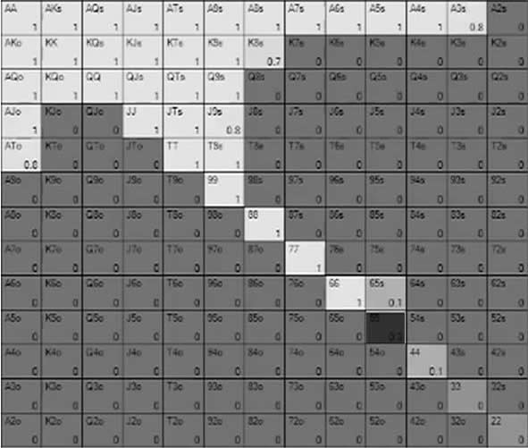

And this is how you might see your opponent’s calling range:

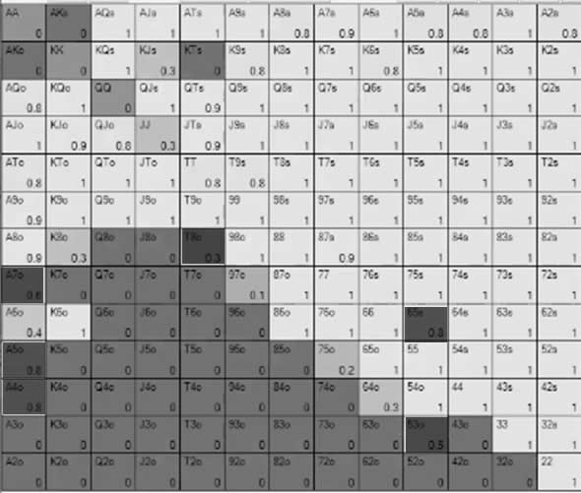

The missing hands at the top are hands you believe they would 3-bet. Hands that have a percentage in them like JJ with 0.3 are mixes, you think they would flat 30% of the time and 3-bet 70% of the time. At the bottom end of the range 53o is more likely to be a flat 50% of the time and a fold 50% of the time.

This match-up is UTG vs Big Blind but in solver world, we use In Position vs Out of Position to describe them.

After the ranges, we input the likely bet sizes each player would use on any flop, turn and river. So if we think they bet 33% of pot, 66% of pot and 120% of pot on the flop, the same on the turn, but also on the river they might bet 200% of pot we have to input all of these variables. We also input what donk leads (when the out of position player leads into the aggressor on the previous street) they may have and what size they would reraise a bet by.

This already might seem daunting, but don’t overthink it. Just think about the regular games you play and what the players tend to bet. Often in online games it tends to be whatever the predetermined bet sizes are at the online poker room. There is usually a small bet, a 2/3rds pot bet and a pot sized bet.

To people who think solver work is cheating, could you imagine a bad player using PIOSolver at this point? The ranges would be all over the place and the bet sizes would be a mess. These two factors determine the usefulness of the solve. You have to be a good player to use PIOSolver and you certainly cannot use it for a cookie cutter approach to playing. Good players will work hard to put players on ranges and to identify the bet sizes. It takes skill to interpret the data from a solver output. A bad player using a solver might come out of it a worse player than they already were.

Some players use premade GTO ranges and bet sizes when they solve a hand. This is only useful if you are actually playing against perfect players. Whenever you do a solve, you should use the actual ranges and bet sizes you believe your opponents use. Anything else is useless information because your real life opponents won’t play that way, plus it is a more holistic way to approach learning because you have to actually consider your opponents’ tendencies.

After you input this data you start the solve. This typically takes up a lot of computer resources and time, you will not get a good answer in a short space of time. The deeper the stacks, the wider the ranges and the more bet sizes you input, the more processing power and time it takes. You need a fast computer to run a solver and a Blind vs Blind 100 big blinds effective pot with wide ranges might take a day to provide something useful.

When your solve is complete it will present to you lots of information including the EV and equity of both ranges, as well as for individual hands. It will also show you things like what the best and worst turn cards are, how many combinations of hand types you have and more.

The single most important output, however, is that it shows you the actions PIOSolver takes for each hand in each range. For example, this is what the UTG range would do when the Big Blind checks on a particular flop type:

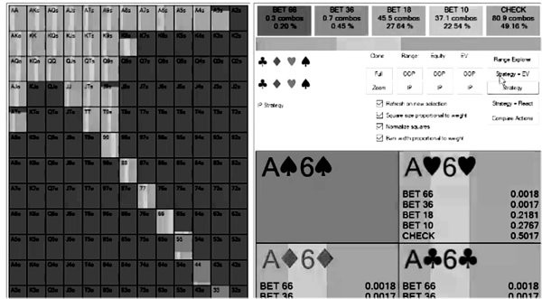

You can see that 49.16% of the time they would check back and the rest of the time they bet. 22.54% of the time that would be a small bet and 27.64% of the time that would be a slightly bigger bet and a fraction of the time it would overbet (practically speaking when the solver takes an action less than 5% of the time you can dismiss it).

You can see which hands bet and which check by looking at the colour coding on the grid. Here JJ checks most of the time and AKo bets most of the time. You can also see when the same hand takes a different course of action based on the suit. AKo might check back with a spade and bet without one, for example.

There is obviously a lot more to it but in a nutshell that is it. A solver will show you what it does for both players with all the hands in their ranges. It will take actions to avoid being exploited, so it will bet big with good hands and bluffs, it will check back with medium hands and strong hands, but it will take the course of action it deems the best if one option is clearly the most profitable. It is only when options have similar profitability that it will mix different actions a certain percentage of the time.

It is really up to the user to determine the *why* behind the solver’s actions. There is a right way and several wrong ways to use solvers.

One wrong way is to input a hand you played and look to see if you did it ‘right’, that is, did the solver take the same action as you. Good for you if it did but this is a very close-

minded way to learn and also you will discover that the solver takes lots of action *some* of the time. If the solver took your funky line 1.2% of the time, does that really mean you played it correctly?

Another wrong way to use solvers is to literally just pay attention to the actual hand you held and not your entire range or your opponents range. It’s not about how to play your hand, you should see what other hands take the same action and which ones do not. You should study how your opponent plays too, because you get to learn both In Position and Out Of Position strategies at the same time, rather than just your own unique spot.

An OK way to use solvers is to look at common spots you played and look for overall trends. You might find, for example, that JJ tends to bet big on low flops whereas AA tends to bet small. Most people learn by pattern recognition and if you do this you will probably improve your winrate, but it’s not the best way to learn from solvers.

The best way to use solvers is to look at the lines it took and ask yourself why it took them? In the last example, rather than just blindly bet big with JJ and small with AA on low flops, start exploring why it might be that it plays that way. Often when looking at solves you will discover that most groups of hands play similar to each other (small pairs might bet big, suited connectors might check/call, etc) but there will be outlier hands that diverge from those paths. First and foremost you should use solvers to plug your biggest leaks, but after that it is these outlier hands that will teach you the most. Throughout this book some of our main focus for analysis will be these strange outlier hands.

This is why we contend that GTO is not remotely boring and solvers open a new world of discovery in poker that even veterans of the game will find eye opening.

## Learning GTO Vs Exploitative Poker

The bold mission statement for this book is we want to teach players of all levels how to introduce Game Theory Optimal concepts into their poker. By no means are we suggesting by the end of the book you will be playing perfect unexploitable poker, nor would we want you to, but certainly there will be lessons from GTO that you can incorporate into your own game.

This does require us to convince you, the reader, that learning GTO is the correct approach in the first place, particularly if you are a recreational and/or small stakes player. There is an old meme in poker - "move up where they respect your raises" - the suggestion being that fundamentally sound poker strategy cannot work at the small stakes, where bluffing is much harder. In the modern era there is a similar suggestion, which is that GTO is only useful at the higher stakes. GTO shows you how to play against a perfect player, as such the smaller stakes should be played exploitatively if you want to build a bankroll.

It is true that an exploitative strategy will make the most at the small stakes. So many big mistakes will be made at, for example, a $1 MTT, that you can quickly crush those levels by pouncing on these errors. If, for example, your opponents are over folding on Ace high flops. The most profitable course of action would be to always bet Ace high flops regardless of how wide your range is, and probably betting quite small so you can get away cheaply when they have hit. A GTO approach might see you check back some of the time and would limit the number of bluffs you have if you use a small bet sizing.

The problem is that exploits at one level don't work at another. Players might overfold on Ace high flops too much in $1 MTTs but bluffcatch too much on the same flops in $5 MTTs. If you moved up to $5 MTTs with the same strategy you would end up exploiting yourself if you carried over the strategy of always c-betting in these spots.

An exploitative player has to take time to figure out the exploits when they move up. The old exploits don't work anymore, and if the player doesn't adapt they will themselves get exploited. They have to learn how to beat each level over and over again. Not to mention that different players have different leaks in the same games. The UTG player might call too much, the Cutoff might fold too much, the Button might pot control too much and the Small Blind might have inconsistent bet sizing. Not only do you have to figure out the exploits for each player pool, you have to figure them out for each player.

There is now a new school of players who refuse to diverge from GTO poker, even when they could make more money in the short term. It might take a little longer to move out of the small stakes, but the benefit is you learn a strategy that can beat any game. If you learn how to play fundamentally sound GTO in $5 MTTs you might not be winning the maximum, but you could get parachuted into a Super High Roller tournament and be a winning player. This is a bold claim that might surprise you, but it is true. There is, of course, the mental game element that might make some players crumble under the pressure in these games but if they can stick to what they have learned they will be winning players at high stakes tables.

The new roadmap for a professional poker player is to prove they are a winning player using GTO principles, even if it is at small stakes. With a big enough sample, that can get you staked to play in bigger games. A $5 MTT grinder who plays GTO can easily get staked for $100 MTTs and win. They can make much more money playing GTO in bigger games than the old method of game selecting and shot taking the larger stakes. I don’t think we are far away from players creating staking threads based on their average rating on the DTO app instead of their SharkScope or Hendon Mob ranking. It might already be happening.

Another reason to use the GTO approach to small stakes is that it is much easier mentally. If you know you made the right play by calling 40% of the time on the river you can find resolve in the fact you did the right thing. If a hand bothered you, you can study it in a solver and you will either feel better because you made the right play or at least you learned something. If, however, you had a read your opponent never bluffs, then they bluff you, it's harder to deal with, because exploits are much more instinctive.

Be warned that some players do use GTO as a crutch from a mental game perspective. There are times when it is blindingly obvious that an exploit is the way to go (let’s say the player in front of you is drunk and calling everything) but you refuse to diverge because of the uncertainty that playing an exploitative strategy brings. Also, GTO is only as good as the initial assumptions you make. You have to get the opponent’s range and betting tendencies right for the information to be useful. If you don’t revisit and question your own assumptions a few times you could be making big errors and protecting yourself from having to deal with them.

There is a bandwidth benefit to the GTO approach, you have to think about fewer things. A good exploitative player has to think about GTO, exploits, what their opponent thinks they are thinking and possibly live reads like physical tells, which is a lot of information to juggle. I once eavesdropped a conversation at breakfast between three of the top players in the world and one of them expressed the view that this is why Alex Foxen plays so slowly.

GTO, while perhaps harder to learn initially, is much easier to manage at the tables.

For the record I sit right in the middle between GTO and exploitative. If I am in a tough game I lean towards GTO, if I am in a soft game I play exploitatively. Most of the time I am somewhere in between.

But if I was learning the game from scratch today I would probably go the GTO route. It's a slower start but a faster trajectory once things start to click.

Now that we have brought you up to speed with what GTO is and is not, let’s dive right into how you can apply it to your own game…

# CHAPTER 2: EXPLOITATION

The best way to understand GTO strategy is to recognise its alternative, which is exploitative strategy. All players are essentially exploitative players because nobody can employ a perfect GTO strategy. You exploit your opponents whenever you adjust your strategy to capitalise on a weakness of theirs. You open yourself up to exploitation whenever you deviate from a perfect GTO strategy. You exploit others and open yourself up to exploitation all the time, however when you learn GTO you do so to a lesser degree.

## Rock/Paper/Scissors

Before we jump into poker it’s time to paint Mr Miyagi’s fence with an exercise that might seem pointless but ultimately will teach you the fundamental principles of GTO. You will no doubt be familiar with the schoolyard game Roshambo or Rock/Paper/Scissors. Rock blunts scissors, scissors cut paper, paper covers rock.

The Game Theory Optimal way to play Rock/Paper/Scissors is to pick each option an equal percentage of the time, but at random. If you pick Rock 1/3rd of the time, Scissors 1/3rd of the time and Paper 1/3rd of the time, while being random in their order, you cannot be exploited.

If you simulated Rock/Paper/Scissors 72 times and both players adopted this strategy, this is what the outcomes would be for Player 1:

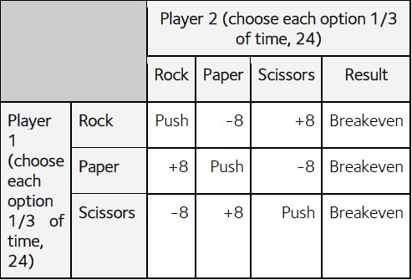

This is what we call a balanced response, in that both players have a perfect balance of Rock/Paper/Scissors. What happens, however, if Player 2 has an unbalanced response? What if they have a preference for Rock, and will play it 36 times out of 72, playing Paper 18 times and Scissors 18 times?

This is what happens:

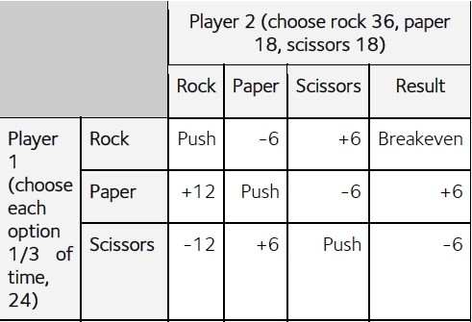

Overall Player 1 breaks even again, but one of the plays is more profitable. When Player 1 picks Paper, they are up by six games overall, but when they pick Scissors they are down six games. By playing a Game Theory Optimal strategy, Player 1 gets the same outcome regardless of the strategy of Player 2, there is just more variance involved.

We know that Player 2 having a preference for Rock is a mistake though, so what can we do to capitalise on that? Pick more Paper, obviously. This is what happens if Player 1 picks Paper every single time, knowing what they know about Player 2’s strategy:

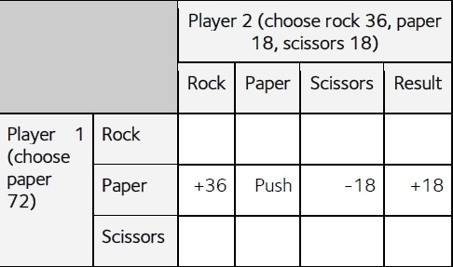

As you can see Player 1 gets crushed every time Player 2 picks Scissors, they lose 18 games. However, that is more than made up for every time Player 2 picks Rock. That leads to Player 1 winning 36 games, and being up 18 games overall.

Can you see a potential issue with Player 1 adopting this new strategy? Quite simply at some point Player 2 will realise that Player 1 is picking Paper every time, and adapt by picking Scissors more. In reality nobody would get away with this strategy for very long, so Player 1 would have to adopt a less extreme strategy. What if, for example, they chose to play Paper half the time and the other two options a quarter of the time each? That would look like this:

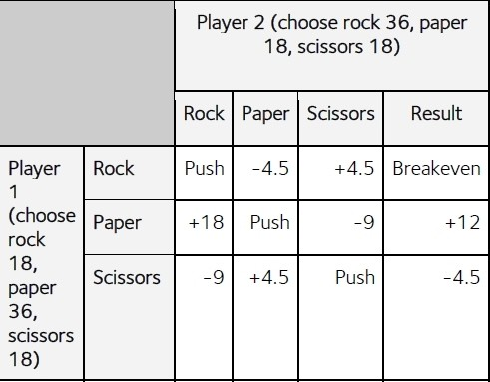

When Player 1 does this they are up 7.5 games overall, which is a long way off from the

+36 winning streak but much more sustainable. Against a weak Roshambo player this could be a long term winning strategy which goes unnoticed. It also reminds me of a joke Scottish pro Ludo Geilich told me once:

*A young boy enters a barber shop and the barber whispers to his customer: “This is the dumbest kid in the world. Watch while I prove it to you.”*

*The barber puts a dollar bill in one hand and two quarters in the other, then calls the boy over and asks, “Which do you want, son?”*

*The boy takes the quarters and leaves.*

*“What did I tell you?” said the barber. “That kid never learns!”*

*Later, when the customer leaves, he sees the same young boy coming out of the ice cream store.*

*“Hey, son! May I ask you a question? Why did you take the quarters instead of the dollar bill?”*

*The boy licked his cone and replied, “Because the day I take the dollar, the game is over!”*

What if Player 1 misjudges Player 2, who starts to counter adjust? Player 2 notices Paper is coming up more often and makes a similar counter adjustment, switching to Scissors half the time and the other two options a quarter of the time each. The new outcome looks like this:

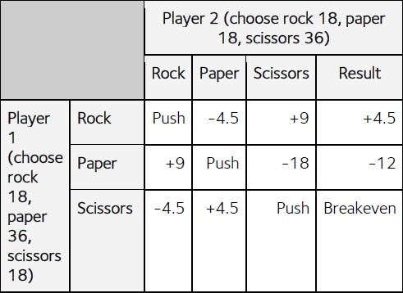

Now Player 1 has gone from winning +7.5 games to losing -7.5 games because of this counter adjustment. The exploitation strategy that saw them win +7.5 games has had the opposite effect when Player 2 noticed what was happening.

This is the core of the benefits and costs of an exploitative strategy. You stand to win much more when your assumptions are correct, but you open yourself up to exploitation. If your opponent adjusts, you lose. If your assumptions are incorrect you lose by exploiting yourself. If, however, you only play a GTO style you can only profit when

your opponent leaves themselves open to exploitation. If you both play GTO you will end up playing to a stalemate, but if either of you divert from a GTO strategy you will leave yourself open to exploitation.

## How You Get Exploited In Poker

Poker is no different to Roshambo in this sense, other than it is much more complex because of the number of card combinations, the betting structure, the stack depths, multiple players and the variance involved. The same principles apply, if you adjust to exploit your opponent you win more when your assumptions are correct but leave yourself vulnerable to counter exploitation.

Let’s look at a typical example you will be familiar with as a player, which is when you flop the nut flush draw with an Ax suited type hand. This is a classic semi bluff situation and most good players know betting here is instantly profitable. If you take down the pot with an unmade hand, great. If you hit your flush you can get a lot of value in a bigger pot. If you hit your Ace that’s a good spot too. As such, most of us will bet in this spot and it will work out well most of the time.

What happens, however, if you check back on a board with a flush draw and the third card of the same suit hits the turn? Against a bad player you still can represent the flush but a thinking player who has shared some table time with you knows you always bet when you have the big draw. As such they can exploit you by check/raising when you bet the turn and put you in a tough spot, maybe even make you fold some of your better value hands. You cannot bluff in these spots because your opponent *knows* you never have the nuts.

The adjustment, therefore, is not to always check back with the nut flush draw but to mix the two strategies. Some of the time you bet with your semi bluff, sometimes you check back with it. This is what is known in poker as protecting your range or having a balanced range. Protecting a range means having the right balance of bluffs and value in all of your actions, so that your opponent does not know where you are in the hand.

If you semi bluff the flop *some* of the time with the nut flush draw, your opponent will call you more on the flop. This means you have a protected flop bet range and as a result you can value bet your made hands and they will get called, because your opponent knows you are capable of bluffing here. If you check back with the nut flush

draw some of the time you will have a protected turn betting range. This means you can bluff more on the turn when you don’t have a hand because your opponent knows you are capable of having a flush here.

When you are capable of having bluffs and value in every spot, you become difficult to exploit. When you are only ever bluffing or only ever value betting in a spot, you become very easy to play against.

## Should You Worry About Exploitation Against Fish?

No doubt you can see the benefit of playing an unexploitable style against tough regulars in your games and when you move up stakes, but what about when you play in soft games? There are plenty of players who are not even considering your range let alone whether you are leaving your checking range open to exploitation by not including strong hands in it. When an opponent has such an obvious leak like calling too much or betting too much, surely the best approach is to counter exploit these players relentlessly? Do you really need to play a balanced style against these players?

The short answer is no, you do not need to play an unexploitable style against fish. The aim of poker is to win all the chips and you are leaving money on the table if you check back the flop with strong hands against a calling station.

The long answer is, it depends.

First of all, playing a counter exploit strategy against weak players means you have to be prepared to constantly update your assumptions. Most players adapt and get better over time, you cannot be certain that the weak player you encountered last week is making the same mistakes now. It can be quite hard to deal with when the player you marked with a fish tag is no longer falling for your exploits. You often see this if you play heads-up poker, even the very bad players can get a sense for how you are playing against them and change their style when they have played enough hands against you.

It is even harder to deal with when you are facing the prospect that your read might be wrong. In particular since the rise of GTO poker there are a lot of moves that would have once got you labeled a fish - donk leads, small bets, check/raising backdoor draws, overbetting, c-betting with underpairs - that have proven to be profitable since the solvers came out. It seems more often than ever before we find out that the player

we labeled a fish was actually a high stakes crusher (My co-author Barry joined us in Ireland for a poker tournament while we were writing this book and he made this very error. He decided somebody at his table was the value and I had to inform him he was referring to a WCOOP Main Event champion and massive online winner for over a decade. The guy thought Barry was a fish, I didn’t correct him).

With this in mind, if you are going to try an exploit strategy you have to be prepared to counter adjust or revert back to a GTO style. This requires a lot of extra mental bandwidth and many players, especially those who are playing lots of tables, prefer to just try and play as close to GTO as possible. In this respect game selection is more important than style. As long as you are in soft games you will profit from these players’ mistakes eventually.

Another big consideration is that exploiting a fish leaves you open to counter exploitation from other players at the table. If a bad player folds to 3-bets more than they should on the Button and you therefore 3-bet a very wide range against them in the Small Blind, a shrewd Big Blind will recognise this and 4-bet wide. You can value bet thin against a calling station post flop, but a tough regular also in the hand can squeeze the pair of you or bluff catch you quite wide. For exploitative strategy to work, ideally you want to ensure you get the pot heads-up against the bad player, which is hard to do with tough regulars at the table.

The best reason, however, to avoid an exploitative strategy is the same one we alluded to in the last chapter, and that it will improve your overall progress to focus on GTO. It might mean that you miss out on value at low stakes and progress slower initially, but when you develop a game that is based on GTO fundamentals and you can prove you are profitable, you can take your game to any stake and win.

Finally, if you are an online player there is a practical reason to favour a GTO style in soft games, and that is you can play more tables. In the last few years there has been a war against HUDs (Heads-up Displays) in online poker because it was deemed they gave professional players an edge. This is actually wrong in my view. If a HUD allows a pro to play 12 tables instead of six, their win rate over 12 tables is much worse per table. All a HUD does is reduce how much edge they *lose* as they add tables rather than give them an additional edge.

It is no surprise that the decline of HUDs led to the rise of GTO. A HUD allows you to play exploitative poker because it shows you player tendencies you might not have witnessed because your focus was elsewhere. With no HUDs the best option for players who want to play a lot of tables is to play GTO. When you don’t have to worry about

who you are playing against, because a GTO move is profitable against a fish and a pro, you can play more tables because you have freed up mental bandwidth. I play 12+ tables at once and 95% of the time I don’t pay attention to who I am playing against unless it is a known regular or Barry because he likes to overplay hands against me so he can tweet a screenshot to show how he thought he owned me.

If your read is strong you are burning money by not exploiting a leak in your opponent, but the more you learn about GTO the more you should try and incorporate it into your play against all players. Even if you lose a small amount of value at the time, think of it as an investment in your future game.

## Heuristics For Real Life

It is impossible for even the best players to play a perfect GTO strategy. The best you can hope for when you study GTO is to take away some broad heuristics about how you should play certain hands in certain spots. The more you study GTO, the closer you will get to it. This is why training apps like DTO are absolutely worth the price of subscription because they train GTO decisions and give instant feedback.

To help you get the most from these lessons, we are going to end every chapter with some key takeaways to help you implement these new strategies into your regular games. They are not perfect but they are the sort of adjustments that could have an immediate impact on your game.

*Am I being exploited?*

Get into the habit of asking yourself ‘am I exploitable here?’ in tricky spots. If, for example, you flop top pair and get check/raised, your instinct might be to fold. However, ask yourself if doing so with such a strong hand would make you exploitable? Likewise, if you are pondering whether to overbet top pair against a calling station, ask yourself the same question. How could you be exploited if you 2x the pot with top pair? Well, maybe a good player could slow play their big hands against you, but fold everything worse than top pair? A tough regular might check/raise in spots like this as a semi bluff as well as hands that beat top pair and put you in a terrible situation. Or

simply overbetting could allow a middling hand that would have called to fold, in that example you have exploited yourself.

Questioning regularly how you leave yourself vulnerable to exploitation is the first step to fixing some of the exploitable leaks in your own game.

*Is my opponent capable?*

An equally useful exercise to ask yourself ‘is this player capable of X?’

Let’s say you have two pair on the river and your opponent check/raises you. Ask yourself, ‘is this player capable of check/raising the river as a bluff? A good regular will have check/raise bluffs here and two pair might be a call, a fish probably never has bluffs here and mostly has a better hand than two pair, so two pair is almost certainly a fold.

Is my opponent capable of checking back the nuts? Is my opponent capable of value betting middle pair? Is my opponent capable of double barrelling a backdoor draw? These are all questions that will essentially get to the root of whether your opponent is playing a balanced style or an exploitative style, which will in turn allow you to decide whether to play GTO or counter exploit against them.

*Frequencies*

To avoid exploitation you often need to play the same hand differently at different times. Sometimes you have to bet your big hands with a big bet size, sometimes you have to use a small bet size, sometimes you have to call, sometimes you have to check. Practically speaking, how do you decide when to take option A and when to take option B?

One way to decide is by using blockers. Let’s say you have pocket Kings on a J♥9♥4♠ flop. If you have K♥K♠ you might pick the small bet size, because you have the heart blocker so you are less worried about protecting your hand against a flush draw. If however you have K♦K♠ you might bet bigger because your hand benefits more from protection. We will discuss blockers in much more detail later on in this book.

The other way to split decisions is to randomise them. Many GTO players have a system whereby they use some sort of randomiser to decide. For example I have a random number generator on my PC. If, for example, I think I should bet big with my hand 60% of the time, bet small 30% of the time and check 10% of the time, I will assign ‘bet big’ numbers 1-60, bet small numbers 61-90, and check numbers 91-100. Then the random number generator will pick a number between 1 and 100 that decides my action.

If I am playing live I will do something similar by looking at the clock on the wall. For example the seconds hand, in the example above I might say if it is pointing at 1-36 seconds I pick bet big, at seconds 37-54 I pick bet small, and at seconds 55-60 I check.

Before I go any further, I want to assure you that this is not something I do for every decision. This is for the few decisions I have in a session where I recognise that a decision needs to be split. You’ll develop a sixth sense for it as you go along, in particular the outlier type hands that require a mixed strategy. Most of your hands will have a clear strategy that is best to play straightforward.

Before I randomise there is another, more practical, way I decide when to split my action, which is when I have a read or a HUD stat on a player. If, for example, my read tells me I am up against a calling station type of player I might choose the bet big option with strong hands and the give up option with my bluffs. If the player is a nit I might choose the bet small option with big hands and bet big with bluffs.

This might seem strange, as it is essentially an exploitative strategy for playing GTO. My argument is that if you have to randomise anyway, you may as well use whatever minor help a read will give you to your advantage. I’ll even do this when I have a very small sample size of HUD stats or a read based on not much yet. I am still essentially randomising over the population of players I am facing, just not this particular player. If my read is that the player is quite bad, it will matter the least anyway because they will not be thinking about balance.

Another approach which is quite ad hoc is to recognise when you have been taking one action a lot recently so you do the opposite for a few days. If you have been betting your flush draws a lot recently, make a pledge to check with them for the next two days. This approach is likely to lean into your own biases as a player, if you are aggressive you will probably take the more aggressive option most of the time and vice versa.

Early in my career, an experienced pro advised me that “you will make the most money when you play a style completely opposite to your normal one”. By this he meant tight

aggressive players (TAGs) will profit by switching to a LAG (loose aggressive) style (at least in the short term until their opponents figure out they’ve changed their tendencies), as opponents will overfold to their new looser style. The converse is also true, when LAGs switch to TAGs they’ll find many opponents calling their value bets too often and trying to bluff them too much. As a side note, one of the advantages of playing a GTO style is you will not be one of the players who gets exploited in the short term when another player changes their tendencies. This is the basic principle of GTO: there is nothing opponents can do to exploit you.

These days the terms TAG and LAG have fallen out of favour because most players have moved closer to a standard style (close to GTO). However, it is still possible to get the same kind of gains at the margins. If you switch to 3-betting all the hands that are occasional 3-bets, you open yourself up to exploitation, but unless your opponents pick up on it, they’ll be the ones being exploited.

None of these methods are perfect, but you will never know what the right frequencies are in a particular spot when it happens at the table and it would be a waste of mental bandwidth to try. The only real mistake is to take the same action again and again in similar spots. People will notice and you will become exploitable.

# CHAPTER 3: YOUR VALUE BETS DRIVE YOUR ACTIONS

That is the most important sentence in this book and this is the most important chapter, so pay attention.

GTO is actually a lot simpler to understand once you have got your head around this idea. Your value bets are what you use to make money in poker and everything else you do should be in service of that. At every point in the hand you want to ask yourself what your strong value hands are in your range and how many of them you have? After that, what is the best strategy for your entire range that will allow your biggest hands to get paid off for the maximum in the long run?

If you have lots of strong hands, often your best strategy is to bet small with your entire range. You don’t have many bluffs and the only way to get paid is to make the bets easier to call. If you only have a few strong hands your best strategy might be to bet big and do the same thing with your best bluffs, checking the medium strength hands. When your opponent knows you are capable of bluffing, they are more likely to pay off your big bet, but they will also fold more often to your bluffs because the bet size is so large. If you don’t have many strong hands at all your best strategy might be to play passively with your value and allow your opponent to be the aggressor, they will want to capitalise on your weak range and do the betting for you.

There is a big misconception that skillful poker is all about bluffing, which we will dispel shortly in this chapter. Good poker is actually about good value betting. Winning players are primarily those who get their big hands paid off more often, and they shape their entire strategy around that goal.

## Bluff To Value Ratio

In the early days of online poker most players learnt that to be a winning player you had to continuation bet 100% of the time. In the early days of poker it was much more a case of only betting when you had a strong hand. Both approaches might work in some game types, but they are both exploitative strategies that can leave you open to exploitation.

If you only bet when you have a very strong hand, your opponent can easily adjust by getting away cheaply when you bet and pouncing on you when you don’t. If you bet 100% of the time they can exploit you by slowplaying big hands against you and check/raising more of their better bluffs against you.

You see the same thing happen when you are the player facing a bet. In the modern era most players learnt the tight aggressive strategy meaning they got used to folding a lot, because they were happy to sacrifice some EV and wait if it meant they could play against bad players when they have a big hand. Prior to this, poker was played in a much more passive ‘calling station’ style, playing hands as bluff catchers or trying to keep the pot small to get to showdown.

Again, both approaches leave you open to exploitation. Fold too often and your opponent can run you over by running multi street bluffs. Play too passively and your opponent can exploit you by value betting thin with a wider range of hands and betting bigger on each street to extract more value.

Playing aggressively, or passively, or going for maximum value, or playing nitty, are all viable winning strategies in the right games when you have solid reads that your opponents have leaks in their game. None of these strategies are useful when you are in a game of tough regulars or at a table of unknowns, not to mention they are bad strategies if your reads are wrong.

The GTO solution to betting is about balancing your bluffs with your value bets.

Bluff-to-value ratio is the number of bluff hand combinations you have in your betting range compared to the number of value bets. Your value bets and bluffs have a symbiotic relationship. If you only ever value bet your opponents will grow wise and fold to you unless they have a big hand. If you bluff too much your opponents will exploit you by slowing playing hands and bluff raising you. The GTO goal is to get the balance perfect so that your opponent is indifferent to calling with their bluffcatchers and thus your bets are unexploitable. The old wisdom in poker that ‘if you never get caught bluffing you are not bluffing enough’ has stood the test of time in this respect.

Your bet size determines the bluff-to-value ratio. The bigger your bet size, the more often you can bluff and the more value you extract with made hands. The smaller your bet size, the less often you can bluff, as you are much more likely to be called.

For example, if there is $100 in the middle of the table and you bet $100, your opponent is facing the prospect of a 2-to-1 call. They potentially risk $100 to win $200. This means for you to be perfectly balanced you need two value bets for every one bluff. If you bluff more often than that, they can call all their bluff catchers (hands that beat all your bluffs but none of your value bets) profitably. If you bluff less often than that, they can fold all their bluff catchers and your value bets won’t be getting called often enough.

If you bet smaller, let’s say you bet $25 into the $100 pot, now your opponent is facing the prospect of a 5-to-1 call. They are risking $25 to win $125. Now you need five value bets for every bluff.

A lot of players struggle with this, they think that a big pot sized bet should weight your range more towards value hands, they don’t quite understand why a big bet means you can bluff more. First think of the second example when we bet ¼ pot, our opponent is not risking much to win a lot, they are incentivised to call. They only need to be good 17% of the time when they call this bet, so they can call quite wide. When we bet pot, however, our opponent is risking much more to win relatively less. They need a stronger hand to call this bet. They need to be good 33% of the time to break even on this bet.

If you under bluff or over bluff in either of these scenarios, you become exploitable. If you bet $100 into a $100 pot, but you have three value hands for every bluff, then you are not bluffing enough. Your opponent can easily fold against you knowing you more likely have a big hand. If you make the same bet but half the time you are bluffing and half the time you are value betting, your opponent can exploit you by reraising you light or bluff catching you.

As you might have picked up on, you can flip this concept around and use it when you are the player calling the bet. If a player bets $100 into a $100 pot, they need to be bluffing 33% of the time, which is also the frequency you should be folding to them. If they bet $25 into a $100 pot they should be bluffing 17% of the time, which again is the frequency you should be folding to avoid being exploited.

If they bet $100 into a $100 pot and you call 50% of the time, you get exploited. You value town yourself and give away too much equity. If you call only 25% of the time you

are folding too much, you exploit yourself by getting run over a lot.

Whether you are calling too much or bluffing too much, your opponent doesn’t have to do anything different if they are playing GTO.

As a handy reference, here are the most common post flop bet sizes and the relevant bluff-to-value and therefore also the correct calling ratios:

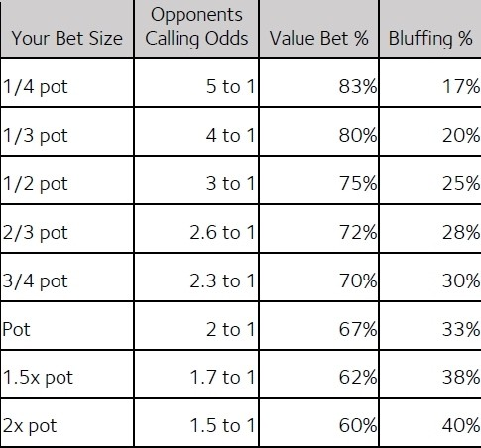

You will never get bluff-to-value perfect because it is one of those things that would require a supercomputer to do. Not only is it near impossible to keep track of all the hands in your range and do the betting maths on the fly, there are lots of other complicating factors.

Some hands on earlier streets are not strictly bluffs because they are draws, so your bet is a semi bluff that can lead to value bets on a later street. The same goes for ‘merge bets’ which are bluffs against some parts of your opponent’s range and value against the other. Then you have the complicating factor of mixed strategies and protecting your range for balance. We are going to explore the many reasons to bet in the next section and throughout the book.

Your value bets drive your action. When you decide how to play your hands post flop, first think of the value bets you have. Depending on how many of them you have and what hands in your opponent’s range you are targeting as calls, you decide what size to bet and pick the required amount of bluffs to be balanced. What remains are the hands you check back because they have showdown value or because you intend to give up with them. You do not need to balance your give-up hands.

## The Purpose Of Bets

While aggression pays in poker, amateur players often do not know *why* they are betting. They couldn’t tell you whether they were bluffing or value betting, they just bet because they didn’t know what else to do. There are lots of reasons to bet in poker and the following are the types of bets you will see referring to in strategy content. It’s important to note that often a bet is made for two or three of the following reasons simultaneously, so these classifications are not definitive.

*Value*

The most common and important type of bet is the value bet. A value bet is made when you believe you beat enough of the hands your opponent calls with to be profitable and it is the way you make money in poker. For a value bet to be profitable, it must win more than 50% of the time when called (in other words it must be ahead of over half the opponent’s calling range).

*Bluff*

A bluff is when you don’t believe your hand will win at showdown but you think you can win the current pot by forcing your opponent to fold the best hand. For a bluff to be profitable, your opponent must fold a certain percentage of the time depending on your bet size. If you bluff with a pot bet, you are risking pot to win pot so your bet needs to work more than half the time. If you use a half pot size, it only needs to work more than a third of the time. If you bluff for twice the pot, it has to work more than two thirds of the time, and so on.

*Semi Bluff*

This is when you try to make your opponent fold but you have outs to a straight and/or flush if you are called, giving you the chance to win a bigger pot as a value bet on a later street.

*Protection bet*

You believe you have the best hand right now but your hand can be easily outdrawn, so you want to get value now while it is good, but are also happy to take the pot down now. Betting a hand like 99 on a 822 flop is a good example of this. You know you are usually ahead but fear over cards on the turn and river, which may cause your opponent to pull ahead, or be less likely to pay off a bet with a worse hand.

*Equity denial*

You have a medium strength hand that can easily be outdrawn by your opponent’s checking range, so you bet to clear out the equity of the weak part of their range to take the pot down now. If you have a hand like 44 on a 22T board you might bet small here to get all the KQ/KJ/QJ and Ax hands to fold, as well as random stuff like 67 and 78. Unlike the protection bet you are not certain you are ahead here but there are enough weak hands you do not want to give free cards to justify the bet.

*Blocker bet*

A small, out of position, bet you make to prevent your opponent from either checking back or making a larger bet size you do not want to call. For example, you might bet 1/3rd pot out of position to prevent your opponent making a 2/3rd pot bet if you checked to them. You also make blocker bets with strong hands on scary boards, so for example if you have 22 on a 289TJ board, you have a strong enough hand to get value from one pair, but a hand like that would be scared of a 7 or a Q on this board and would not value bet it if checked to.

*Merge bet*

A complicated bet with a medium strength hand that will sometimes make better hands fold and simultaneously make weaker hands call. For example, if you have KK on an AJ3 board, a big bet might make A8 fold because it has kicker problems but KJ might call because it beats the bluffs and blocks AK/AJ.

*Balance*

In GTO world all hands will do this to some extent. You will sometimes make blocker bets with monster hands or bluffs to protect the blocker bet range. You will overbet with bluffs so that your overbet value bets get paid. If your bets are not balanced you become exploitable.

Note that all the above example are the way we as humans think about bets, or classify them, but when you boil it down there are only two real reasons to bet:

1. To get worse hands to call, so you win more when you win the pot
2. To get hands that have a chance to win to fold, so you win the pot more often

It’s important to realise that most bets actually benefit both of these factors, particularly on earlier streets. When you bet the nuts on the flop, you are happy to get called (because you know you have the best hand right now), but you still benefit when you fold out hands you are ahead of but had a small chance of outdrawing you. When you bet and cause a hand that had a 10% chance of outdrawing you to fold, your chances of winning the pot (your pot share) increased from 90 to 100%.

Similarly, bets that are mostly done for protection (like a low pair you bet hoping to fold out overcards) still benefit when a hand with less than 50% chance of outdrawing you calls.

## How To Pick Your Actions

One of the things a solver does perfectly that a human possibly cannot is to pick the right bet sizes for a range that factors in the opponent’s range, board coverage, balancing bluffs and value, blockers, semi bluffs and 20 other things. The best we can do is rough heuristics based on pattern recognition and a bit of creativity.

Throughout this book we will explore how the solvers pick the hands they bet with and try to extrapolate what we can take to the real life tables with that information. The following is an example of that from Range Trainer Pro.

In this example the UTG player has opened and the Big Blind has called, with 40 big blinds effective. The flop is A♠2♥3♠. This is what the Big Blind calls with:

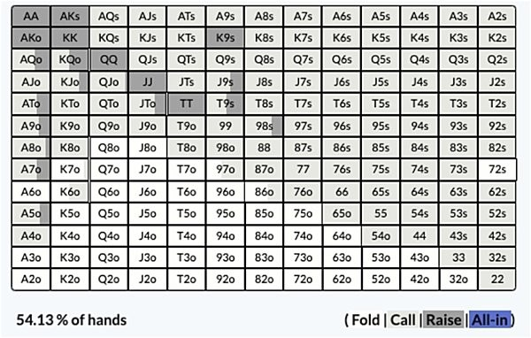

This is the UTG opening range:

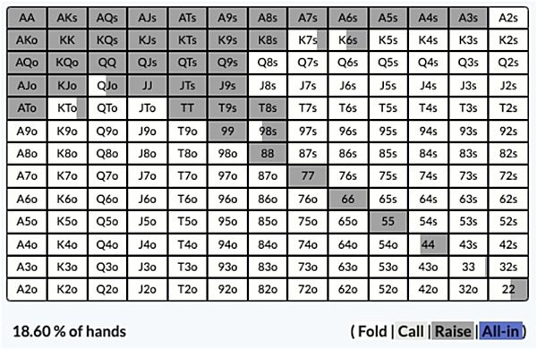

The Big Blind checks 100% of the time and this is the UTG opening range and how the solver would play all their hands:

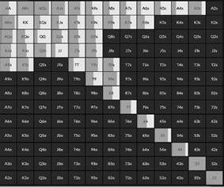



As you can see 43% of the time UTG checks back, 54% of the time they make a small bet and 3.4% of the time they go for a larger bet. One of the most useful ways to learn from solvers is to attempt to work out *why* it takes certain actions with certain hands, so let’s do that right now. This is our interpretation of why the solver tells UTG to take these actions.

The value bets here are almost exclusively the Ax hands for top pair. UTG does not have the bottom two sets or straights here and only one combination of two pair. All the Ax hands value bet to some extent but many of them check too.

AK to AT are bet most of the time and rarely checked. It’s hard to see because it is a small percentage but they are also bet big the most often, especially AK and AQ. These

are the pure value bets, with the strong kickers they can get value from lots of weaker hands including other Ax hands.

AA and A3 are the strongest Ax hands obviously, but notice they are never bet big, they favour the small size when they do bet. This is because they do not benefit from folds, they want money to go into the pot, they don’t want their opponent to fold, and they are less worried about flush and straight draws because they can redraw full houses or better. They also heavily block our opponents' strong hands that might continue to a big bet, so they are incentivised to bet smaller targeting calls from weaker hands. AK and AQ, as strong as they are, also benefit from folds. They want value but they also don’t mind if they can make a drawing hand muck, because top pair shrinks quickly if a card like 4♠ hits the turn.

When you get to the medium Ax hands like A6s-A8s we see more checking. These are the best hands to play as bluff catchers. If UTG bets these hands and gets action they are often up against a better Ax or an even stronger hand/draw. They also would get worse hands than theirs to fold most of the time. So checking to induce a bluff is the best way to get value. Also they need Ax hands in our checking range, otherwise they would be easy to bluff on the turn.

A5s can bet a little bit more than A6s, however. When we get below A9 kickers do not really matter but what this hand has going for it is it also have a gutshot straight draw. This hand works as a value bet but when it gets called by stronger hands, it can hit a very strong hand on a later street. The way the solver splits whether A5s bets or check is it will bet with A♥ 5♥, but check the other combinations. This hand is not only top pair and a gutshot, but also a backdoor flush draw which improves its EV considerably.

Notice also that AA is one of the hands that checks a lot. This is because as we have already noted it does not benefit from folds. It is also to protect the checking range. While UTG has a lot of strong hands on this flop, they don’t have many ‘nutted’ hands (two pair or better). If they only checked our weak Ax and worse, their opponent could pile pressure on them on the turn and river. By keeping top set in the check back range, their opponent has to be much more careful on later streets, which means UTG benefits by getting more hands like KK to showdown more often. AA also heavily blocks their opponent from having top pair, so UTG is happy to give them a chance to catch up with something on later streets.

Now let’s look at the pocket pairs. Notice that KK, QQ, JJ and TT hardly ever bet, but 77-44 mostly bet. They also use the big sizing some of the time. This might be a head scratcher to some of you, why is this?

KK-TT are still strong hands on this board, but betting here would allow UTG’s opponent to play perfectly against them. They could fold all of their weak hands and continue with Ax or better. The best strategy here is to turn these hands into bluff catchers by checking.

77-44 have all essentially been turned into bluffs. They bet to deny equity, it is really bad for a hand like 77 to check back, the turn comes a 9 and the opponent gets there with a J9 type hand they would have readily folded to anything on the flop. 44 and 55 bet more often and bigger because they also are a semi bluff, they can turn a straight and for that reason are happier to get more money in when called.

What is left is the bluffs and ‘give up’ hands. Hands like KQs-K9s, QJs-Q9s, JTs-J9s and T9s-T8s are all weak on this flop, but they tend to bet around half the time. This is when they are either spades for a flush draw or hearts for a backdoor flush draw. When they are clubs or diamonds they will just check to try and get to showdown, or give up. The broadway hands also have backdoor straight draws they can make in addition, QTs for example can hit a runner runner K and J for a straight. Notice that the Kx hands will bet less often than Qx and Jx hands, this is because king high has better showdown value than queen high. It will be good more often than queen high will.

UTG needs big bet bluffs and small bet bluffs to balance their value bets. Here hands like Q ♥ J ♥ are more likely to be small bet bluffs, because getting a fold with two backdoors is a great result. Q♠J♠ is more likely to be used as the big bet bluff because it has a more immediate strong draw. When you bet big, it’s much more important you get there more often because you are risking more chips.

Notice that Q9s to T9s bet as often than JTs or QTs, even though they cannot make a straight. In this instance that is because they benefit from folds much more on account of only having one draw and less showdown value. This might seem counterintuitive - why is it that QTs bets because it has two types of draw and Q9s bets because it only has one?

This is where working with solvers is always difficult for humans to understand. The answer is simply bluff to value ratio. The solver looks at the value bets we have and then it has to find the bluffs from somewhere. Sometimes there are very obvious bluff candidates and sometimes it has to be more creative. It also has to consider board coverage on future streets (more on that shortly). Don’t get bogged down on trying to understand perfectly why it picks certain hands at certain ratios, even elite players are not able to replicate a solver output like this. Instead think about what we have just discussed as part art and part science. You will never 100% be able to understand why

the solver did what it did, but you can recognise patterns and trends you can apply effectively to your own games.

Don’t worry if that analysis was hard to follow. It might be worth rereading it again but we promise this gets easier the more you do it.

## Bluffing Is Overrated

One of the great myths in poker that recreational players hold onto is that it is a game of bluffing and hero calling. Bluffs and bluff catching are sexy, they sometimes require nerves of steel and they look good on camera. Even serious players get obsessed with bluffs and bluff catching. They spend a lot of time studying what the right combos and the right blockers are, because that is one of the more difficult parts of poker study.

Bluffs by their very nature are supposed to be break even. Similarly bluff catching should only break even long term. You make money in poker from having the best hand and getting value from it.

Take this example, we are at the river on a Q♠J♦2♠4♦8♠ board with 43 big blinds in the middle and 19 big blinds behind. When checked to, this is the in position player’s range and actions:

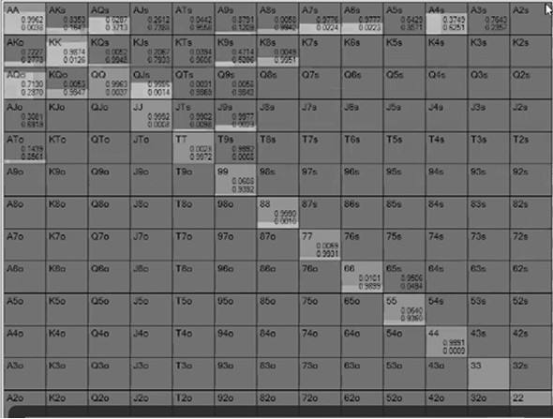

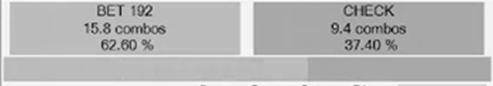

If you look at the individual hands here, A♠K♠ is the nuts and obviously bets. The expectation for A♠K♠ here is 55 big blinds.

Contrast this with A♥6♥ which bets as a bluff. It also has a positive expectation of just

0.6 big blinds.

One hand makes you 55 big blinds and the other makes 1% of that.

The same is true with bluff catching. When the in position player makes that bet, this is the defender’s range and actions:

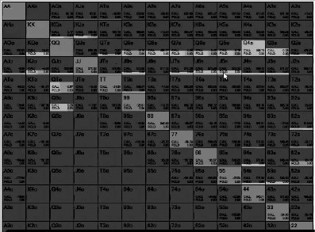

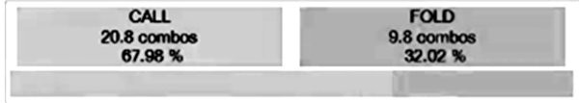

Calling with Q♥J♥ for top two pair earns you 51 big blinds on average.

The bluff catcher here is Q♥ 9♠, the spade blocker being the reason why this makes a good bluff catch. That hand earns us a mere 0.4 big blinds, less than 1% of what the call with two pair makes us.

If you think of your range as a business, your value bets are the part of the company that makes all the money and the bluffs are that department that breaks even but is in service to the successful part of the business. Think of your bluffs like the Human Resources department of your poker business, they are not supposed to turn a profit. If you never

bluff your value bets will never get called. If you never bluff catch your opponents will bluff you into oblivion.

This advice is only when you are facing balanced players. Bluffing against nits who overfold is very profitable and bluff catching against maniacs who overbluff is also a big earner.

When a bluff or bluff-catching spot is close to breakeven the tendencies of the player should be the deciding factor. If you move the dial in either direction from perfect equilibrium it suddenly makes lots of money. If somebody is supposed to bluff 33% of the time you can turn it into slightly more than break even by folding when you block bluffs and calling when you block value. If a player over bluffs you should always call with your bluff catcher and if they under bluff you should always fold.

Value betting the nuts is not exactly sexy, anyone can do it, but there are still plenty of players who own themselves by playing trappy with the nuts. The skill is not in betting the nuts but on constructing a range and playing it in such a way that your nut bets get called. That means, among other things, bluffing at the right ratio so that your value bets get paid off. GTO is the opposite of fancy play syndrome in this respect, your value hands drive how you should play and the rest of your range should be trying to disguise and support your value.

## Natural Bluff Candidates

Now that we have completely shit on the idea of bluffing, let’s discuss how to do it well.

As discussed, bluffs should be breakeven if you are balanced but in practice you can make them slightly profitable if they are natural bluffing candidates. This means, rather than a ‘stone cold bluff’ with nothing except balls of steel, there is actually something about your cards that makes a bluff more likely to work.

*Semi bluffs*

The first type of natural bluff is the ‘semi bluff’ which is when you bet with an unmade hand on the flop or turn with the intention of taking the pot down, but if you are called you have outs to make a stronger hand you can turn into a value bet.

The classic example is when you have a hand like Q♥J♥ and the flop is T♥8♥2♠ - you are probably not ahead in a raised pot here and taking this pot down uncontested is a good result. However, if you are called you can hit a heart for a flush, a 9 for a straight, you can pick up a double gutshot straight draw with a King or an Ace, and you will usually be happy if you hit a Jack or Queen to give you top pair.

In theory betting with pocket threes on this flop would be a semi bluff, in the respect that you could turn a set of threes. In reality that isn’t a desirable semi bluff, but you might be surprised what hands solvers do pick for semi bluffs. You will find throughout these pages that ‘double backdoor’ hands (hands that can hit runner runner to make a straight and runner runner to make a flush) are great bluffs as are gutshots, because they can give you strong value bets by the river. Even bottom pair weak kicker is sometimes used as a semi bluff compared to small pocket pairs, a hand like 23 on the flop above makes a better bluff than 33, because 23 has two 2s and three 3s it can hit to overtake better one pair hands, whereas 33 only has two 3s it can hit.

Overvaluing tenuous semi bluffs is a likely leak that can creep in when you start to study GTO so use them sparingly. Most of the hands we will cover in future chapters will detail the good semi bluffs and the bad ones in each spot.

*Blocker bluffs*

The other type of natural bluff is when you have a blocker to a strong hand that makes it less likely your opponent has a hand they can call with. These bluffs tend to be most effective on the river when there are no more cards to come, leaving your opponent with made hands and give ups.

A classic GTO example is when the board reads something like K♥7♥2♠Q♦8♥ and you have A♥T♦. You have completely missed this board but there is a possible flush out there and you hold the A♥, meaning nobody else can have the nuts here. You block the nuts. This is an excellent spot to bluff, in fact it is a good spot to do something more creative like bluff raising a river bet or check/raising the river. The more aggressive you go the stronger a hand is needed for your opponent to call, in the right spot they might even throw away sets or low flushes.

Probably the best way to explain the power of blockers is using a preflop example. In our book *Poker Satellite Strategy* we also pointed to a preflop example of when

blockers help you take down pots uncontested. We showed that in the late stages of tournaments when ICM pressure is huge, it is more profitable to open shove or 3-bet shove with A5s than Pocket Jacks. This is because when ICM pressure is significant, the range of hands a player can profitably call shrinks and is weighted towards Ax hands and big pairs. If we think they will only call with AK and QQ+ on the bubble, when we have JJ there are 34 combinations of hands that call us, but when we have A5s there are only 27, because we block AK and AA. So bluffing with a rag Ace reduces the number of hands that could call us by about 20% (we pick suited A5s hands because if they do get called they have flush and wheel outs against any hand).

Like semi bluffs we are going to discuss blockers in much more detail throughout this book.

## Bad Bluff Candidates

Solvers will often pick your worst hands to bluff - hands with no showdown value, no blockers and no outs to make a strong hand on later streets. This is for the obvious reason that they will not make money any other way, so taking down a pot is a good result for them. Whether a solver picks these hands to bluff with depends on what other bluffs are available in your range. If you have lots of backdoor draws, gutshots and blockers in your range, it will probably use those primarily to bluff. If it doesn’t it has to find the bluffs from somewhere.

Bluffing with unnatural bluff candidates is by no means an error in GTO, but certainly something you should do sparingly while you are learning GTO. You will simply make more if you stick to natural bluff candidates for the time being while you discover the nuances of GTO. Making ‘stone cold bluffs’ often is going to be a long term mistake in most cases.

The worst bluff candidates, however, are hands that have reasonable (but not great) showdown value. Hands like king high or third pair on a dry board, for example. Bluffing with these hands, as you will see in future chapters, allows your opponent to play perfectly against you. They fold the hands you beat and continue with hands you are dominated by.

These hands are much better played by just trying to get them to showdown as bluff catchers. By definition a bluff catcher is a hand that can’t beat any of your opponent’s value range but will beat everything else.

## What Does My Value Want To Do?

To reiterate the goal of this chapter, here are three simple GTO examples that highlight how your value bets drive your betting strategy.

This is a 100 big blind cash game example and UTG opens with this range, which is from GTO Wizard:

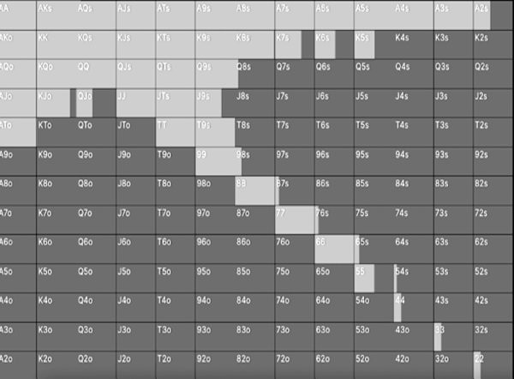

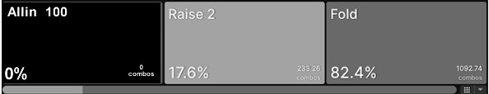

And the Big Blind responds with this range:

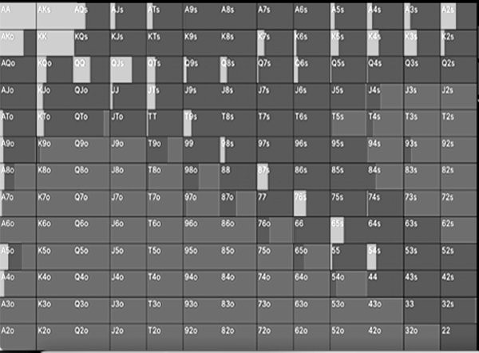

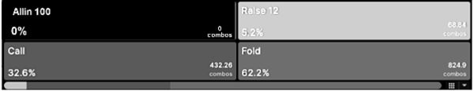

When the Big Blind calls, UTG has a much stronger, tighter, range. The Big Blind has a lot of middling to weak hands, so we will expect UTG to be betting more in this situation on the flop. We won’t delve into the whole game tree, but the betting differs greatly depending on the board.

For example on a K♣ J♦T♣ flop, the Big Blind checks 100% of the time and UTG bets 100% of the time, mostly with a small 33% pot sized bet. This is what most players would call an ‘action flop’ and in real life games you would see big bets here, but in this spot solvers bet small because UTG has so much value and the Big Blind not much at all. UTG has both straights, all three sets, every combo of two pair, an overpair, the stronger one pair hands and the strongest combo draw hands like A♣J♣ and A♦K♦. The

Big Blind doesn’t have Aces, has fewer sets, fewer combinations of straights and weaker top pair type hands. More importantly, the Big Blind misses this flop most of the time with hands like 87o and 52s.

While you will see UTG bet for a big sizing in a live poker room in this spot, it will usually fold out most of the Big Blind’s range. The value bets in this scenario want to bet small because that is the best way for the Big Blind to continue with worse.

What about if we make the flop T♦8♠4♠, all other details the same? The Big Blind still checks 100% of the time, but this time UTG will check back 43% of the time and the rest of the time will bet large, 76% of pot. Why is this?

UTG still has the stronger range overall, but the Big Blind is in a much better position. UTG has all the overpairs, but the Big Blind hits this board strongly much more often. The Big Blind has more combinations of top pair, 2nd pair and two pair, and much more straight and flush draws. They both have the same amount of sets.

As such UTG can’t bet small 100% of the time into that range because there are too many hands that could check/raise them. Instead the broad strategy is to check back most of the medium strength hands like 66 or Q8, but bet with the really strong hands like sets, overpairs and bluff strong combo draws like J♠9♠.

Because there are fewer hands in the value betting range and more bluffs, UTG gets to bet larger. This is what is called a polarised betting strategy, instead of having a wide range all of which hits the flop and a weak opponent’s range, here we have very strong hands and very weak hands, with an opponent who has enough strong hands to call a big bet. In this example our value bets want to bet big, the way that they are able to do this is by checking back all the medium strength hands but keeping in more bluffs to make it more likely our opponent will bluff catch with their own strong hands.

One last example, same spot but this time the flop is 6♠5♦4♣.

This time we do not see the Big Blind check, what actually happens is that they lead out for a small bet 81% of the time, which UTG always just calls. In the rare instance the Big Blind checks, UTG checks back 60% of the time, even with very strong hands like overpairs. What is happening?

In this example the flop heavily favours the Big Blind. UTG never flops a straight or two pair here, but the Big Blind can. The Big Blind also flops a lot of high equity combo draw hands like 7♣ 5♣ which can hit a 3,5,7,8 to give it a very strong hand, or

runner runner clubs to make a flush. UTG hardly has any of these hands and will often be in big trouble if they bet out.

As such the best way for UTG to get value with hands like AA or a set of sixes is to play passively. The Big Blind knows they should bet here and by playing a bluff catching style UTG extracts the most value from the bluffs without getting into trouble when they raise.

Two identical ranges but three very different betting strategies based on the flop. In each case the primary strategy is built around how to get the maximum value for the strongest hands. When the entire range is strong the best way to get value is to bet small, otherwise you’ll get no action at all. When part of the range is strong but a middle part is not, the best strategy is to only bet the strongest portion of the range for a big bet size with enough bluffs to make bluff catching worth your opponent’s time. When your opponent has the stronger range, the best way to get value for your biggest hands is to let them take the betting lead and get value from more bluffs.

## Heuristics For Real Life

*Big bet or small bet?*

You will never get bluff-to-value perfect at the tables but you can still use it to great effect. An immediate takeaway is to think about what big and small bets mean. When you bet small, most of the time you should be betting for value, because bluffs are not going to get through as often.

When you bet big, this is the size you should use for your biggest value hands and most of your bluffs, because the bluffs will work more often but when value bets get called you want the best hand.

A useful heuristic to use when value betting is to have a “value target”. This is a term coined by Andrew Brokos and it refers to the weakest hand you are hoping to get called by. For example, if you have top pair OK kicker like AT on an Ace high board, you might decide to target all the weaker Ax your opponent can have. Your value target is then A2, and you should bet the biggest amount you think your opponent would call with that hand. Conversely, when you are bluffing, you should think about what the strongest hand your opponent might fold is (a “bluff target”), and bet the smallest amount you think they would cause them to fold that hand.

You may have different value and bluff targets for different sizings. For example, let’s say you want to value bet, and you think your opponent will call with worse 50% of the time to a half pot bet, but only 30% of the time to a full pot bet. Which size should you use? The answer may be slightly surprising to you but it’s actually better to bet full pot and win an additional full pot bet 30% of the time (which means the bet nets 30% of pot in the long run), whereas a half pot bet wins an additional 50% half the time (which means the bet nets only 25% of pot in the long run).

Similarly, if you’re bluffing you’re also better off betting full pot. Your bluff will work 70% of the time, and remember it only needs to work half the time to break even, so it wins you 40% of the pot in the long run. For example, if you bet 100 into a pot of 100 as a bluff ten times and it works seven of those times (70%), you will win seven pots of 200 for a total of 1400 on an investment of 1000.

If you bet half pot it only needs to work 33.3% of the time to break even. If it actually works half the time, then it’s clearly profitable, but how profitable? Using the same example, we are now betting 50 (half pot) into a pot of 100, and it’ll win 150 half the time (five times, for a total of 750). In this case you are investing 500, and you win 750,

so the bluff is profitable for 250 in total, or 25 on average (25% of pot), which is less profitable than the full pot size.

More broadly just think about what your own range looks like to your opponent before you decide your bet sizing. Think about how many strong hands you tend to have on a particular flop, if the answer is a lot - let’s say you 3-bet preflop and the board comes KQJ rainbow - you should probably bet small because you don’t have many bluffs. If the flop comes 923 rainbow, this might be a spot to bet big because you have some very strong overpair type hands that want value but lots of misses too that like folds.

We will highlight bluff-to-value ratio throughout this book so don’t get too bogged down into trying to get this right yet. For now, small bets are when you have lots of value and not many bluffs, big bets are for when you have some very strong hands and lots of misses.

*Why are you betting?*

Start to think more about the *why* behind your bets. Acknowledging there are myriad reasons to bet beyond just bluff and value is the first step to becoming a thinking player where betting is concerned.

Does your hand benefit from protection? Is there an obvious draw out there or can your top pair easily get outdrawn by over cards? That would lean you towards betting big with it.

Does your hand not benefit from protection? Do you have a big overpair or strong top pair, or better? A small bet is more likely to get action and it protects the rest of your small bet range.

Do you have a modest hand that benefits from equity denial? A small bet with third pair might seem like a wasted bet, but if it can clear out all the junk overcards that is of great benefit to your hand.

Do you have a strong hand but your opponents are only likely to call with a better hand, like KK on an AJJ flop? This is usually a time not to bet, but to bluff catch instead.

Don’t worry too much about protecting your range just yet, that will come with time and throughout this book. For now just remember your bets have a purpose and try your best to figure out the best action for each hand.

*Start with natural bluffs only*

For now, restrict your bluffs to natural bluffs. Bluffs that can make big hands by the river or bluffs that block the calling range are just going to work more often than ‘stone cold bluffs’. You need a good reason to make an unnatural bluff. It is not true that all bluffs are the same because they all require your opponent to fold, some bluffs truly are better than others. Simply put, a bluff containing cards that make it less likely your opponent has a hand that will call (blockers to value hands) will work more often than a bluff containing cards that make it more likely they will call (blocking give ups). For example, on a Q♥9♥6♦ flop with a board that runs out 2♦2♣ (so the flush draw misses), a missed flush draw like 5 ♥ 4 ♥ is a much worse bluff than J ♣ T♣ (missed straight draw). When you bluff on this board, a lot of your opponents' give ups will be missed flush draws, so you would rather not have a heart in your hand (and two is even worse!), and furthermore the 5 and the 4 don’t block any value hand your opponent might call with. On the other hand, J♣ T♣ doesn’t block missed flush draws, and does block some hands that might call, such as QJ, QT, JJ, TT, J9 and T9.

Another reason to adopt a natural bluffing strategy is it will get you out of the mindset that bluffs are the most important thing to study. Just go back to the example in this chapter where our bluffs made us just 10% of our value bets.

If you take nothing else away from this chapter or book, it is to prioritise your value bets in your poker study. Bluffs might be sexy but your value bets pay the bills in poker.

# CHAPTER 4: RANGE ADVANTAGE

Most poker players talk about strategy in terms of ranges rather than specific hands. This makes perfect sense when discussing our opponent’s holding because despite the movie tropes of a poker professional being able to look at the way somebody blinks to determine they have Aces, most players realise they cannot put somebody on an exact hand. In a game of incomplete information the next best thing we can do is ascribe particular *types* of hands they might be playing and then develop an aggregate strategy that works well against those types of hands.

It’s a little harder to think of strategy in terms of our own range, rather than our specific hand, because we know what our specific hand is. We have the curse of knowledge working against us when we open under the gun with JJ and the board comes AK2 rainbow. That’s a terrible flop for our hand but a very good flop for our range. The right strategy here might be to continuation bet even though our gut tells us to check back.

How you play one hand in your range impacts how you play all of them. How you play your value bets is determined by how you play your bluffs, as well as how many of each you have. If you want your Aces to get paid, you need to have enough thin value bets and bluffs in your range that your opponent will call you. A GTO approach is a holistic approach to poker that takes into account how *all* your hands play before deciding what to do with the two cards you are looking at right now.

It’s hard enough to juggle in your head all the possible hands your opponent could have while making a decision, let alone all the potential holdings your opponent might think you have. This is a skill that can be developed with practice and is much easier when you think of ranges as having a particular shape, rather than memorizing every hand in them.

## Range Types

There are essentially four types of range in poker - Linear, Polarised, Capped and Condensed. You will get some random ranges at times on later streets and multiway pots that don’t fit into any of these categories, but most of the time they will be identifiable as one of these four types.

We will briefly look at each in the context of preflop, before exploring them all post flop later.

## Linear Range

A linear range is one which contains the strongest hands. Typically linear ranges start at Aces and get weaker in a sequential order, hence the name linear.

For example, if your opponent opened with the top 20% of hands from middle position, this is a linear range:

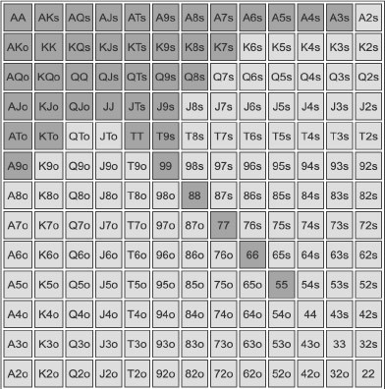

It is literally just going from AA downwards in terms of hand strength until 20% has been reached. Some linear ranges might have more pocket pairs and less suited broadway hands, but it is essentially a range based purely on hand strength.

The player who is first to raise preflop should have a linear range: there is no reason to open some hands that are weaker than other hands we fold. Similarly cold 4 bet ranges (when you decide to 4 bet after one player opens and another 3 bets) should be linear, you simply choose the strongest hands in this spot. A final example, when calling an all in, it only makes sense to call with the weakest hand that has the correct equity, and all stronger hands than that. It doesn’t make sense to fold any stronger hand in this case, or call a weaker one.

The typical post flop strategy with a linear range is to either play the whole range the same way with small bet sizings, or to split up the range into a big bet range (biggest hands and good bluffs) and a small bet/check range for the rest of the range.

## Polarised Ranges

A polar range is one which contains very strong hands and weak hands, with nothing in the middle. Value bets and bluffs only:

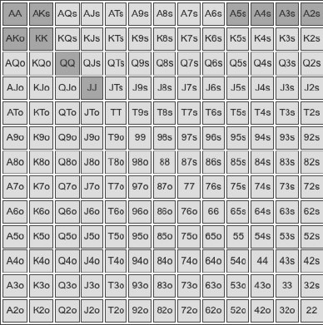

This is a good example of a tight polarised range. It includes some very strong pairs and AK for value, while also betting the suited wheel Aces as bluffs (because they block the likely calling range and can hit the flop hard if called). In spots where we can profitably

call a lot of hands, we polarise our 3-betting range preflop (or our betting or raising range postflop) between hands we are happy to continue with if we face further aggression, and hands we are happy to fold to further aggression. Hands that fall into neither category (like AJs and TT which we aren’t thrilled about calling a raise with or folding to a raise) we simply flat.

Ranges tend to get more polarised on later streets as bet sizings get bigger and as such most middle strength hands should fold. However, some ranges start polarised, usually when a player 3-bets preflop.

The typical strategy with a polarised range postflop is to bet big, in some cases even overbet. You get the maximum value from your big hands when called and you get more folds with your bluffs.

## Condensed Ranges

A condensed range is one that mostly contains middle strength hands and excludes very strong or very weak hands.

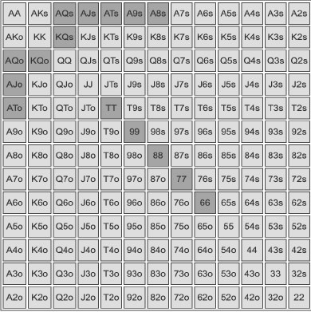

This is a good example of a condensed range. All the hands in the range have decent showdown value and there isn’t any garbage in it. However, there are no really strong hands or obvious bluffs in it. Preflop, when we call in position after someone opens, we

typically do so with condensed ranges, as our strongest hands would 3-bet, and our weakest hands just fold, so we are left with the middle. Similarly, if we open and get 3- bet, our flatting range will tend to be condensed, as we would 4-bet our strongest hands (with some weak ones we choose as 4-bet bluffs), and fold our weakest hands. As an aside, playing with a condensed range is both difficult and less profitable than playing with a polar or linear range, so it should be avoided as much as possible. Good players will flat very strong hands sometimes for this very reason, to ensure their flatting range isn’t completely condensed.

The typical strategy with a condensed range is to play a passive bluff catch style, rather than bet out with it. If you bet with a condensed range you will fold out the hands you beat and leave in the ones that beat you. However, a condensed range will beat all the bluffs so it is better to play a check/call strategy with it.

## Capped Ranges

Capped ranges have medium and weak hands in it, but miss the really strong hands. They often get confused with condensed ranges because both miss the top of the range, but condensed ranges don’t have weak hands that can be used as bluffs in them.

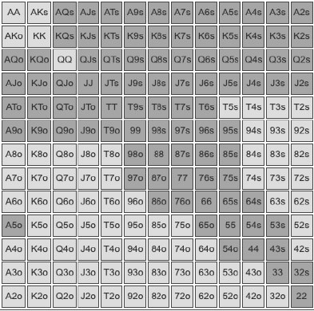

This is a good example of a capped range and is a typical Big Blind defending range. It is missing the QQ+ AK powerhouse hands, but has the medium strength hands like TT-

66 and A2s-AQs etc. It also has the weak stuff like J4s and 87o.

A capped range misses most flops and as such is typically played quite passively. However, it can have very strong hands on certain board textures, so a capped range will sometimes have some bluffs and value bets in it. Generally, though, the bet sizings will remain quite small because of the capped nature limiting how much value it can get before it runs into a much stronger hand.

Post flop a range can be capped in a different way. Going back to our polar range:

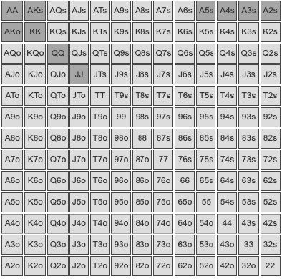

On a 9 ♦ 7 ♦ 8 ♥ flop, while the overpairs are still strong, this range is now capped. It cannot have two pair, a set or a straight here. By contrast, our example preflop capped range has all the straights, sets and two pairs as well as lots of draws and total trash (hands like 43s that have missed completely) so it has now become more polar.

Preflop capped ranges can’t be avoided when defending the Big Blind, and aren’t that big a deal anyway as they can turn into uncapped ranges on the flop as we have just seen. But capping your range on the flop or turn should be avoided at all costs because a capped range can be attacked on later streets by overbets.

Weak live players often unknowingly cap their checking and calling ranges on the flop by betting and raising all their strongest hands. If you do this, that only leaves medium and weak hands in the checking and calling ranges, capping the range as you head to the turn. Players who do this are very easy to exploit. For example if we are playing someone who will raise all their top pair hands or better on a 9♦7♦8♥ flop, then when they decline to raise and when the turn is a brick like a 2 that improves none of their draws, this is a great spot to overbet putting their entire capped range under pressure. If they fold it all, your bluffs will print, while if they call with too much, your value bets will.

## Range Advantage

We don’t just think in terms of ranges but also range advantage, which is a very important GTO concept that will help you shift away from thinking about specific hands and instead your whole range. Range advantage refers to which of the two players has the stronger raw equity on a particular flop. It doesn’t need to be a major advantage, having 51% equity against a range is an example of range advantage. Whom has range advantage determines the betting strategy of both players. The bigger the advantage, the more profound the strategic shift.

UTG opens with this range in a 40BB effective MTT pot. We are using Range Trainer Pro.

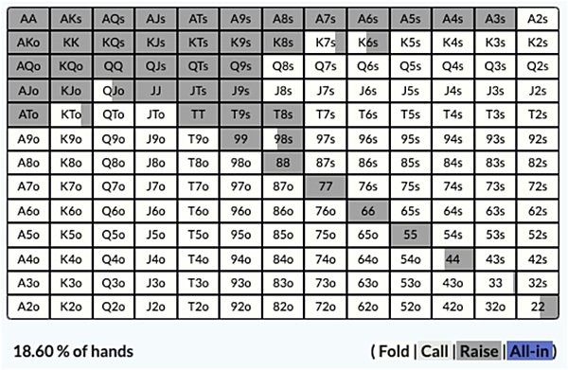

And the Big Blind defends with this range:

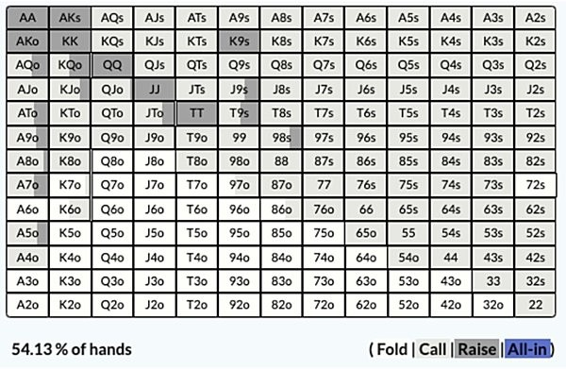

The flop is Q♦6♥2♥

Who has the range advantage here?

UTG does. Both players have Qx, but it makes up a bigger overall proportion of UTG’s range and the Big Blind has kicker problems with theirs. UTG also has overpairs plus top and middle set. The Big Blind has middle and bottom set, more draws, but for the most part they wildly miss this flop. Overall UTG has a 63%/37% range advantage, meaning their overall range has 63% equity and the Big Blind has just 37% equity (this means that if both players always get to show down with their entire range on every runout, as they would if it was checked down or one of the players was already all-in, UTG would win 63% of the time). The Big Blind, of course, has individual hands which crush here, 66 for example has 91% equity, but they have so much junk that has very little equity that the overall equity comes down.

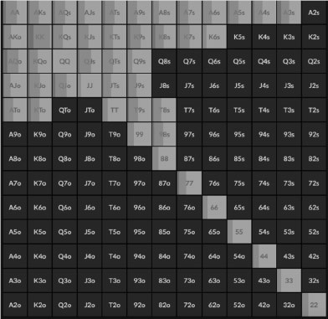



UTG has such a significant range advantage here the correct strategy is to bet all the time mostly for a 25% pot size, even with weak hands like T8s regardless of the suit. The range is so strong, the most profitable thing they can do is capitalise on that by betting all their hands.

In response to the bet, this is what the Big Blind does:

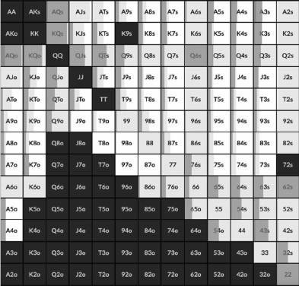



They fold 42% of their range, no surprise there, they get rid of all their low equity junk. They do check/raise with their strongest hands like AQ/KQ/Q6/62/, the sets sometimes and they use their better draws as bluff raises. The rest of the time they have to fold or play passively with 81% of their range, because UTG has such an equity advantage. Raising with anything other than a strong hand/draw is a recipe for disaster, as would be leading out with them, as that will fold out the hands they beat and keep in all the monster hands.

In this example, UTG has a strong linear uncapped range so they can profitably bet all of their hands. The Big Blind has a capped range so the only way they can extract value is by playing passively with their value hands or constructing a very narrow check/raise range.

## Nutted Advantage

You have range advantage when your overall range is stronger than your opponents, but there is another major strategic consideration where range is concerned - nutted advantage. Nutted advantage refers to who has the higher proportion of very strong ‘nutted’ hands.

Going back to our ranges in the last example, let’s imagine all criteria are the same but this time the flop is A♦3♥2♥

UTG opens with this range in a 40BB effective MTT pot.



And the Big Blind defends with this range:



UTG still has range advantage here as strong Ax makes up a big percentage of their range. The Big Blind has plenty of Ax, but for the most part misses this board completely. As such UTG has a 66% to 34% range advantage, which is actually a bigger advantage than the previous example.

The Big Blind checks 100% of the time like in the previous example, so what does UTG do?

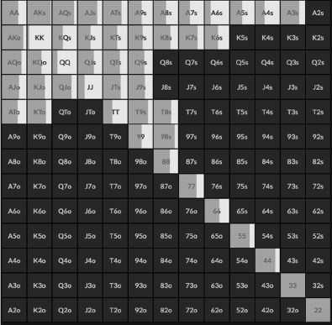



They actually bet much less. They bet 100% of the time in the first example, they bet 63% of the time here. They also favour a smaller size much more, there was some large bets in the last example but it is all 25% of pot this time.

What has happened here to force UTG to play a more cautious style?

It is because while UTG has the significant range advantage, they have far fewer ‘nutted’ hands, ie. two pair or better. The only very strong hand UTG has is top set and top two pair. The Big Blind, however, has middle and bottom set, A3, A2s and 32s for all the possible two pairs, and 45 for a flopped wheel straight. The Big Blind also has the high equity combo draws like 5♥6♥ and A♥4♥.

As such UTG has to play more cautiously and mix their strategy. They still have an overall range advantage so they still bet most of their hands at some frequency. The bigger Ax will bet here for value and the medium Ax will check more to play as bluff catchers. AA will mix it up because it doesn’t benefit from protection, A3s will bet more because it doesn’t block as much of the calling range. 44 and 55 will bet mostly to deny equity but also because they have gutshots. Hands like KK-99 mostly check because they will only be called by Ax or better, but are very strong bluff catchers.

If UTG bet 100% of the time here, they would run into big hands and check/raise bluffs more often than they would like. In the previous example we had range advantage and nutted advantage, so we could run over our opponent and all they could do was bluff catch us. We would not be put into too many scenarios we really don’t like.

This is also why UTG bets smaller more often. If they bet big, they would hate it a lot of the time if they got check/raised. They also would not be put in a great spot if their opponent called because most of the hands that call would be very strong, giving them a tough decision on the turn. Betting smaller gives them leeway to fold if they get reraised and also keeps in more hands that they beat.

Let’s go with another example, this time a 100 big blind cash game, using GTO Wizard. UTG opens with this range:





This is the Big Blind response:



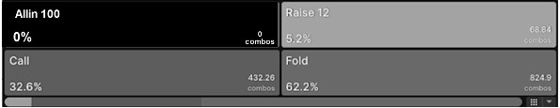

The Big Blind calls. The flop is 6♣ 5♦4♥.

In terms of range advantage this is a straight 50/50 split in terms of equity. UTG has more strong hands in general including all the overpairs, but they have no nutted hands and miss this flop a lot with broadway high cards. The Big Blind, however, has lots of misses but crucially all the super strong hands.

The Big Blind has 87 (UTG has this too but at a low frequency) and 32 for a flopped straight as well as all the combinations of sets, two pair and all the combinations of one

pair. They also have every type of draw and combo draw. For example, a hand like 7♦4♦ and 6♦3♦ both have over 69% equity against UTG's range with one pair, an open ended straight draw and a backdoor flush draw.

There is such a gulf in the number of nutted hands each player has that the correct strategy here is for the Big Blind to actually lead out 81.1% of the time. The bet size is always small, because they have a significant advantage.

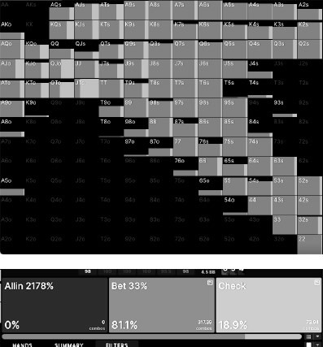

They lead out with all their hands and just have a small check range. For practical purposes they can probably lead out small 100% of the time here.

When they do lead out, this is how UTG responds:

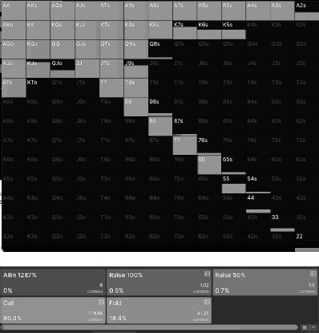

They have to call 80% of the time and fold the rest, there is no raising. They cannot even raise with their best hands like a set of sixes, because they could still run into a better hand or a combo draw that is flipping. The lack of nutted hands in UTG’s range has forced them to play passively.

This is a great example of the power of nutted advantage. For all practical purposes UTG usually has the best hand here and the Big Blind usually misses, but the fact that the Big Blind could have a very strong hand and we know UTG never does is a very significant driver of the action. Against a weak calling station player UTG could still raise here but against a thinking player it would be a huge mistake.

You have nutted advantage when you have a higher proportion of very strong hands than your opponent. By very strong hands we mean hands you would be happy to stack off with. This is determined by stack-to-pot ratio. When the stacks are shallow, two pair would be considered a nutted hand you always stack off with, but in a 200 big blind pot you might only have nutted advantage with a straight or better.

Knowing who has nutted advantage in the hand is just as important as who has range advantage. Having range advantage does not correlate with nutted advantage at all, the player with range disadvantage is just as likely to have nutted advantage.

## How Range Advantage Switches

Most people can assign a range to a player and visualise it to some degree, the skill part that requires more work is keeping track of it over several streets. Ranges change over the course of a hand, as does the shape of a range and who has range/nutted advantage. When a player bets, unless they are betting their entire range, their range has transformed into a betting range, meaning all the hands that would have likely checked have been eliminated from it. When a player calls a bet, their range has transformed into a calling range meaning all their ‘give up’ hands are removed. Even when hands go check/check the ranges change, because the hands that should have bet can be eliminated from the range.

Ranges become more polarised as the streets develop because invariably they are made up of just the hands that can continue in the face of action. It is common for range advantage to swap around on the turn/river for this reason.

Let’s take another hand example, the same ranges as our first 40BB UTG vs Big Blind MTT example, but the flop is 5♠7♦9♦.

UTG still has a range advantage here, but it is closer than before, 53% to 47%.



This time UTG has range advantage mostly due to their overpairs and strong 9x. They also have all the sets and their Ax has reasonable equity too.



As usual the Big Blind’s wide range includes a lot of misses, but they have a lot of strong hands and the nutted advantage. They have lots of 9x for top pair but not much in the way of overpairs. They have all the sets, but crucially they have all the combinations of two pair, lots of combo draw hands like 78 and 56 and they also flop the straight with 86o and 86s.

The Big Blind checks 100% of the time and this is how UTG responds:

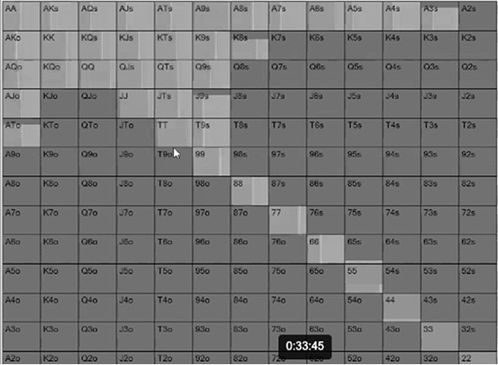

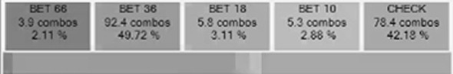

It’s a similar strategy to the earlier example, UTG cannot bet their entire range so they mix betting and checking. This time they bet most of the time with all their overpairs and 9x as well as their sets. Their bluffs come from broadway hands like QJs and KTs when they also have a backdoor flush draw, as these hands can also hit runner runner straights/flushes and top pair. A bigger bet sizing is favored here than in the earlier example because it is a low dynamic flop, so value hands want to extract more value while they are ahead as well as to deny equity to drawing hands (more on this sort of flop betting strategy later).

When UTG does bet big, this is the Big Blind response:

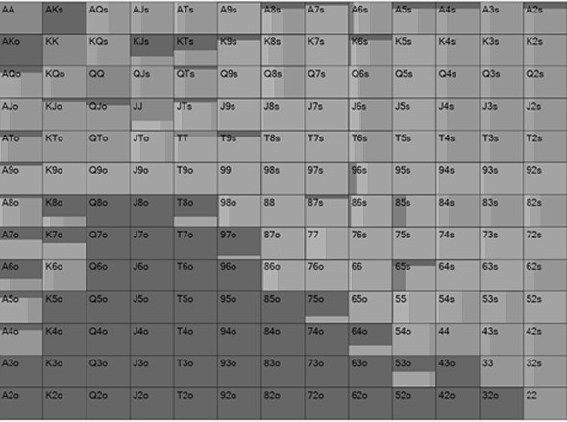

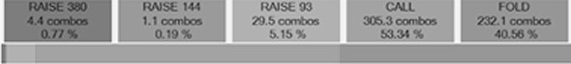

All the nutted hands call, as does all the 9x, 7x, 5x and draws. The weakest hands that call are hands like JT which can hit runner runner to make a straight and often will be ahead when it makes a pair. Most of the Ax/Kx/Jx folds.

Despite having all the nutted hands, the Big Blind’s range was so wide and had so many misses that UTG still had range advantage at the start of the hand. However, the big bet from UTG has cleared out all of the junk from the Big Blind’s range and essentially made it much stronger. Range advantage has now shifted before we head to the turn, it is now 52% for the Big Blind and 48% for UTG.

Naturally things change depending on the next card. Below is a breakdown of what the Big Blind’s equity would be for every single potential turn card:

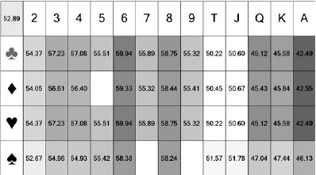

Remember they had a 52% range advantage when they called the flop bet and as you can see, most turn cards increase their advantage. The bad cards are the broadway cards. You will recall they mucked most of their broadway cards and UTG bet lots of overpairs for value and KQ type hands as bluffs. All of the broadway cards put range advantage in favour of UTG again or at least reduces it for the Big Blind.

The low cards are good for Big Blind, mostly because we know that UTG does not have much in that department and the Big Blind had lots of 52s and 64s type hands they defended with.

The good cards for the Big Blind are the middle hands 6-7-8. These are the cards that already gave them nutted advantage and were bad for UTG. These are the cards that will complete straight draws as well as turn two pairs/sets into boats and quads. The best card of all is a 6 because it completes straight draws that the UTG does not have but Big Blind does with 34, 48 and 8T.

This is the primary strategy the Big Blind takes when they are first to act based on these turn cards:

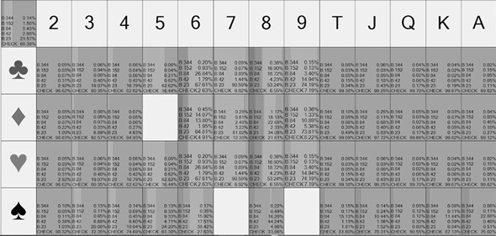

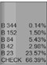

The middle portion of the grid (5-9) are mostly bets, everything else is mostly checks.

They understandably check when the broadway cards come in, they also tend to check when the lower cards hit - these cards are good for them but not so good that they bet into the flop aggressor. When the card is between 5 and 9, the Big Blind will take the initiative and lead out (what used to be uncharitably referred to as a donk bet). This is both with their value hands and their bluffs. There is some mixing but it is still quite clear cut, the middling cards are so good for the Big Blind and range advantage has shifted so considerably that the UTG player now has the ‘capped’ range and their strategies should switch.

They understandably check when the broadway cards come in, they also tend to check when the lower cards hit - these cards are good for them but not so good that they still do not check to the flop aggressor. When the card is between 5 and 9, the Big Blind will take the initiative and lead out (what used to be uncharitably referred to as a donk bet). This is both with their value hands and their bluffs. There is some mixing but it is still quite clear cut, the middling cards are so good for the Big Blind and range advantage has shifted so considerably that the UTG player now has the ‘capped’ range and their strategies should switch.

This is a very important lesson and one which a lot of modern players do not appreciate. A lot of online players learnt that the game was about aggression, aggression, aggression and would ‘barrel’ most turns to avoid ‘looking weak’. Even more would continue with their overpairs at least thinking they could get value on such a wet flop. If UTG reraised a lead from the Big Blind on a 6 turn then they would fold out most of the hands they beat and keep in all the very strong hands. If, however, they flat called the lead bet with their good hands they will at least get value from all the bluffs.

The reality is that range advantage is a dynamic concept and it shifts on every street, especially when money has gone in on the previous street. There are good cards for your range which are bad for your opponent’s range, and vice versa. Recognising this and how to adjust is the hallmark of a balanced player. Continuing to be aggressive because you saw Phil Ivey do it and you didn’t want to appear weak leaves you open to exploitation.

## Heuristics For Real Life

*Is this my board?*

As with all new concepts that you learn the first thing to do is to just get into the habit of asking yourself who has range advantage on every board. Ask yourself ‘is this my board or their board?’ and likewise ‘is that card good for my range or their range?’ In addition, ask yourself what the ‘nutted’ hands are on each board.

If a board is really good for you, consider betting your entire range. You may miss value with the best of your range but it will be made up for when you can get folds from the weak part of your range.

If the board is good for you, but your opponent has more nutted type hands, proceed with caution. Mix checking and betting, as well as favouring a smaller bet sizing. It is a mistake to miss out on bluffs and value just because your opponent *could* have 75s for a flopped straight, but it is equally a mistake to pile on so much pressure that only the big hands will ever call you and the big bluffs will put you in a horrible spot.

When a board is clearly much better for your opponent, take the passive line, even with your strong hands. Allow your opponent to bluff with range advantage so you can bluff catch profitably. You can always check/raise your opponent later.

One huge takeaway is to recognise that when your opponent calls your bet, their range has got stronger (While stronger, sometimes, however, you can cap their range if they do not reraise you), because all the junk hands will have given up. Do not continue aggression just because it would ‘look weak’ to slow down on a bad turn card.

*How ranges change on the turn*

Instead of just putting people on a range of hands like a list, think of the shape of their range, it will make things much easier with a bit of practice.

This is by no means a 100% accurate list, but this is a usual rough idea of how a range can change on the turn based on the flop actions. We will be looking at hand examples of the type below in future chapters, until then these are reasonable imperfect heuristics to follow in single raised pots that are not Blind vs Blind:

***When the flop goes check/check -*** the out of position range tends to stay the same (because most of the time they check 100%) but the in position range becomes more condensed (because they would usually bet their strong hands balanced by some weak hands bet as bluffs).

***When the flop goes check-bet-call*** - the out of position range becomes more linear or condensed (they fold all their junk), the in position range stays roughly the same (they will usually bet their range).

***When the flop goes check-bet-raise-call*** - out of position becomes more polarised (they will only raise big hands and good bluffs, no middle hands), in position gets stronger but also more condensed (they fold all their bluffs but would often 4-bet really strong hands).

***When the flop goes lead-call*** - out of position becomes polarised (they would not bet middle strength hands out of position), in position becomes condensed (they fold junk hands but may have raised nutted hands).

***When the flop goes lead-raise-call*** - out of position becomes stronger but condensed, in position becomes polarised.

# CHAPTER 5: BLOCKERS

Now we’ll get onto perhaps the most misused aspect of modern GTO poker - blockers.

No matter what your level of GTO understanding is, if you have been around poker for a while you will have heard about blockers when hand histories are being discussed. Blockers are perhaps the gateway concept that introduces GTO to the masses, often because they tend to be the deciding factor in a particularly ballsy bluff or hero call that goes viral on YouTube. Poker players tend to be curious about blockers and when they first learn about them they greatly overestimate their value.

Blockers are by no means the most important concept in poker strategy but the way in which we use them has shifted dramatically since solvers were invented.

You have a blocker when one or both of your cards make it less likely your opponent has hit a strong hand.

Poker is a game of incomplete information but one thing we know for certain is the two cards we have been dealt. Of the 52 cards in poker we know we have the two cards we have been dealt and we also, therefore, know two cards our opponents cannot have. The two cards we are dealt reduces the probability that they will have certain classes of hand. Our cards ‘block’ our opponents from having particular hands; this is also known as card removal in poker.

The classic example is let’s say we have A♣ 9♦ and the board reads T♣ 2♣ 9♥7♣ 3♥. We hold a middling hand at best, but we know for a fact that our opponent cannot have the nuts because that requires our A♣ . If instead we had Q♣ 9♦ we still have a good flush blocker. Let’s say this is our opponent’s range on the river.





Their suited hands are AK-AJs, A8s, A6s-A3s, KQs-K8s, QJs-Q9s, JTs-J9s, T9s and 65s. There are 21 suited club hands in that range, but when we have Q♣ 9♦ that number goes down to 18 potential flush hands. It’s a very small part of the overall range, however, we have only taken five of the 116 combinations of hands out of this range.

The fact that we have our cards and that means our opponents cannot have them might seem obvious and much of the time it only changes the probability of them having a particular hand slightly. Blockers become very powerful, however, when our opponent has a very narrow range or when we are at a point of indifference.

## Narrow Ranges

Looking at a narrow range first, on a ‘wet’ board and against wide ranges a blocker effect is very marginal. However, against tight ranges and on ‘dry’ boards they can be profound. Let’s say you are against a very tight opponent and their UTG range is as follows:

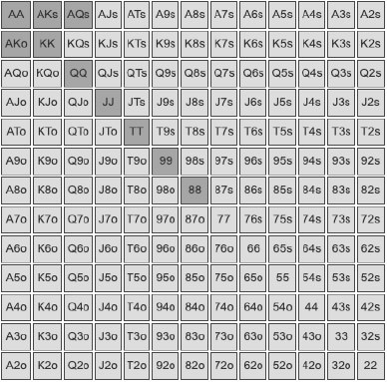

The flop comes K♣ 7 ♠ 3 ♥ and you think he will bet his entire range, except A♦Q♦ because it doesn’t contain a backdoor flush draw.

The turn comes 6♣ and he bets again. Now we narrow his range to A♣Q♣, AK, AA & KK.

The river is 7♦. Now we think he checks AA & AK, bets KK for value and bluffs with A♣Q♣.

If we have a bluff catching hand like JJ we have 25% equity (we beat his one combination of a missed flush draw but lose to three combinations of KK). If we have a hand like K2o we have 50% equity, because now he can only have one set of KK. Our King blocker is worth 25% equity.

If we have either A♣ or Q♣ in our hand that means he cannot be bluffing, he must have KK, so our equity drops to 0%.

So in this example if we have AA or AK with an A♣ , we should fold, but K2o is a break even call.

This is a slightly exaggerated example for effect, but it is not a far cry from some spots you find yourself in against tight players and/or narrow ranges on dry boards. You will often find yourself with similar decisions in 3-bet pots and by the river, for example, where ranges have gotten very narrow.

## Point Of Indifference

A point of indifference in poker is when the expected value of two particular decisions is the same or very close. A point of indifference might be, for example, when a weak hand is close to being either a bluff or a fold, when a medium strength hand is on the cusp of being a bluff catcher or a thin value bet, or when a very strong hand is a close decision between a value bet or a slow play. We have already discussed why we need to mix our strategies for balance purposes. When the decisions are close, blockers have the final say.

A very simple way to see this in action is a toy game I developed based on a dice game many of the High Rollers use to explain game theory concepts. Imagine if Player A always randomly gets AA, 33 or 22 and Player B always randomly gets KK, QQ or JJ. This is a betting game, a single pot sized bet each time, and you can either bet or check, or fold or call like in a regular poker game. I replicated this betting game in PIOSolver

by putting in a board of 8♠ 9♥ 4♠ 8♥ 8♦ (essentially a meaningless board where the preflop hand strengths were identical to the river hand strengths).

In the dice version the options were Player A got numbers 6, 2 or 1 and Player B got 3, 4 or 5, with 6 being the highest value number.

What the solver found was what the High Rollers suspected. When Player A is first to act, they go all-in 50% of the time. They do this 100% of the time with AA, ¼ of the time with 33 and ¼ of the time with 22. AA is a value shove and the other times Player A bets are bluffs, made at the right bluff to value ratio of two value combinations for every bluff.

The pot is laying Player B odds of 2-1, meaning that they can call 50% of the time profitably, folding the other 50% of the time. Which of the three hands does Player B call with? KK, QQ or JJ?

The answer is all three of them, 50% of the time. 50% of the time with KK, 50% of the time with QQ and 50% of the time with JJ. The hand strength does not matter, KK is just as behind to AA as JJ is, and just as ahead against 22 and 33.

This is a point of indifference. There is literally no difference in the expected value of KK as there is JJ.

Something very interesting happens when you change the ranges slightly for Player B. If you replace the three combinations of KK with A9o played ½ of the time, the range has the same overall combination of hands in it. They now will randomly be dealt the 12 combinations of A9o half the time (so six combinations), six combinations of QQ or six combinations of JJ. A9o gives us top pair on this board, which is still only beating the 33 or 22, and losing to AA, just like KK was.

Rerun the experiment and Player A plays the exact same way. They value bet AA 100% of the time and bluff with 33/22 ¼ of the time each, always for a pot sized bet.

The difference this time is that Player B will *always* call when they have A9o and only

¼ of the time with QQ or JJ. Overall this still means that Player B calls just 50% of the time, but their range is weighted towards calling with A9o and calling with the two other, technically stronger, hands less to achieve balance.

The reason Player B does this is because A9o contains a blocker. They are worried about Player A having AA, so by holding one of the Aces themselves, the chances of running into AA goes down considerably. Against QQ and JJ Player A has six

combinations of AA, but against A9o Player A only has three combinations of AA. The chances of them having Pocket Aces has halved because Player B is holding one of the four Aces in the deck.

In the first example Player B was at a point of indifference, KK was the same as QQ or JJ, so all three hands played the same. In the second example having the blocker broke such a deadlock. When the decision between options is very close then let the blocker be the decider.

Let’s look at a real poker hand example to see this in action.

In this example an UTG raiser with 40BBs effective has opened and the Big Blind has called. They bet small on the flop, got called, bet bigger on the turn, got called and now we are at the river. The board is Q♠9♥6♦2♦T♣.

The Big Blind checks and this is UTG’s range on the river, and their actions. We are using Range Trainer Pro:

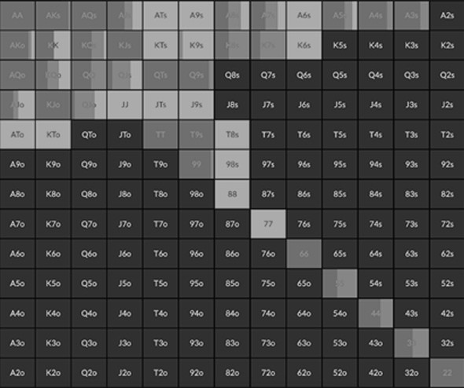



The highest frequency bluff at the smallest bet size is K7s, why? Because it blocks the most hands. It blocks good one pair hands like KQ/K9/KT but more importantly it blocks two different straights. It blocks 78 for a 6789T straight and it also blocks KJ for the 9TJQK straight. What all bluffs have in common is they cannot beat any of the value hands, but K7s blocks the most and strongest value hands, so it is the most natural bluff candidate.

Assume that UTG bets and now the Big Blind is pondering a call, this is what their GTO calling range is:

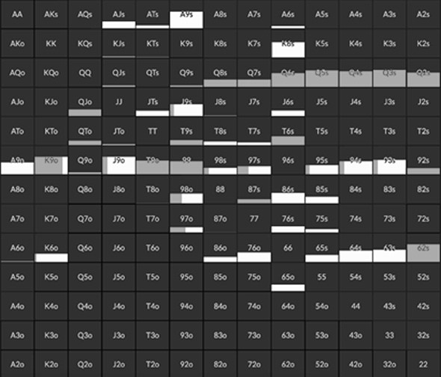



No surprises on the big hands that call but what about the hands on the margins? In this example notice that A9 and ATs both fold, but K9o calls. In terms of pure hand value, K9o is weaker than A9 and ATs, so why is this a call? Again it is because of that straight blocker. A9, AT and K9 are all essentially the same hand in that they beat most 9x and lose to any Qx, so the only thing that separates them is the kicker. In this case the K kicker is much more useful than the A kicker because it blocks bluffs), and you do not have to worry about running K9 into A9 or AT because those hands did not bet.

The blockers only factored in around the 9x hands because that is the point of indifference, the place where the decision is already close between a call and a fold.

All of the Qx calls because top pair is very strong on this board, so blockers don’t play a role in the decision.

This brings us to a subtle mindset shift where blockers are concerned. Poker players who learn about blockers can sometimes misuse them as excuses to do wild bluffs and bluff catches that get the adrenaline pumping. This can be a counterintuitive and stressful way to think about them. The better way to think about blockers is that, in order to be balanced, you have to find your bluffs and bluff catchers from *somewhere* in the range. When the decision between two is close, you may as well pick the hand with the blocker.

## Unblockers

As you may have immediately guessed, an ‘unblocker’ is the opposite of a blocker. You have an unblocker when you do not make it less likely your opponent has a potential hand. When you have a strong hand, you want to ‘unblock’ their worse value hands, when you have a bluff you want to ‘block’ their calls, when you have a bluff catcher you want to ‘unblock’ their bluffs.

Here is a common example of how unblockers play a regular part in your decisions. This a Button betting range on a J♠ 7♦ 5♦ flop. We are using Range Trainer Pro.

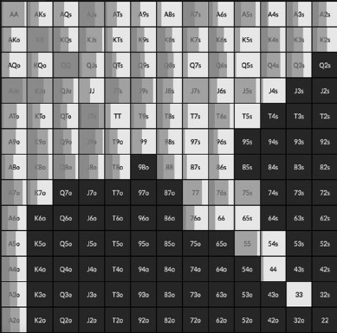



You can ignore most of the details here but look at how the sets play. JJ checks most of the time but 77 and 55 bet most of the time. The reason being is that when you value bet on this flop, you are targeting Jx hands for the calls and having JJ for top set greatly reduces the hands that call, given there is only one possible Jack left in the deck. With a set of Jacks the best strategy usually is to bluff catch to protect that range and let your opponent catch-up and hit something they can call with. It is vital to have some very

strong hands in your bluff catching range, hands that can withstand and indeed welcome overbets from your opponent. If you only ever bluff catch with weak hands that “only” beat a bluff, your opponents can make life miserable for you with overbets. Top set is generally the best candidate.

A set of sevens or a set of fives, however, ‘unblocks’ that Jx calling range. You can bet out with these hands and if you get action there is a good chance it’s a top pair type hand you can get several streets of value from. Notice also that AA-QQ favour betting for the same reason, they are targeting Jx for value and they (mostly) unblock Jx hands. Strong top pair hands KJ and QJ check back some of the time because they block Jx hands.

Perhaps the most common decision of all where unblockers play a role is deciding whether to bluff with a missed draw. If this has been a practice of guesswork for you until this point, worry no more, blockers and unblockers have shown us the best times to bluff your missed draws and when to give up.

Let’s jump into another example, this time UTG has opened and the Cutoff has called. It has gone small bet flop, small bet turn and we have made the river and the board is Q♠J♥2♦3♦2♥.

This is UTG’s range and options. We are using Range Trainer Pro

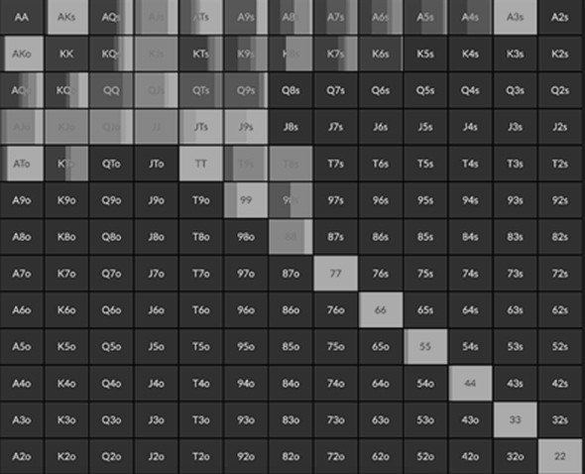



The straight draws on this flop were 98/T9/K9/KT and AT. Wouldn't you know it, they all bluff this river, almost all the time. Given we need some give ups and these hands have a small amount of showdown value, why do they bluff so often?

The answer to this is they block the calling range. There are no straights or flushes possible here. This is a board where big one pair hands are going to call a river bet, so as such our missed straight draws bluff because they all block hands like AJ/KJ/AQ/KQ/QT/Q9/JT/J9.

KT bets big because it blocks the most hands (KQ/KJ/QT/JT) and ideally you want your best blockers for the bigger bluffs. The rest are mixes. AT is the only bluff that

sometimes checks because it has the most showdown value. Likewise 44-77 check instead of bluffing for the same reason.

Practically speaking 44-88, 98/T9/K9/KT and AT are all equally as strong, in that they cannot beat any of the likely hands that call them, which will be Jx or better. 88/98/T9/K9 and KT, however, block the calling range. Despite missing their straight, the silver lining is they make a better than average bluff.

Let’s look at the same situation but when we miss a flush draw. In this example it is Button against Big Blind. The flop has gone check, small bet, call. The turn has gone check, big bet, call. The Big Blind checks the river and the Button is now pondering a bet. The board this time reads K♠8♥5♠J♣ 2♣ so this time the predominant draw on the flop was a spade draw, the only possible open ended straight draw was with 67. When checked to, this is the Button’s betting range:

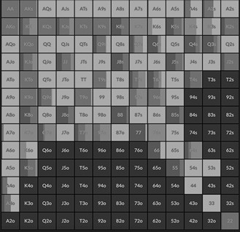



There is no possible straight or flush on this flop, so the value is mostly top pair to a set, so let’s look at our bluffs.

Qx is our most common bluff, which makes sense because it blocks KQ and QJ. However, Q9s, Q7s and Q6s do not bluff if they are spades. Q4s and Q3s bluff always regardless of suit, but that is because they block 45 and 32 which sometimes call, in addition to blocking KQ and QJ.

T9s, T7s and T6s all bluff because they block QT, JT and T8, however once again these hands do not bluff when they are Tx of spades.

97s and 96s always bluff regardless of suit, because they block 98, 87 and 65, which call sometimes. 76s also always bluffs because it blocks 87 and 65.

Most of the Axs hands check behind. In any given range, Axs is always going to be your most likely flush draw hand. Yet even though a hand like A♠7♠ blocks AQ and AJ, it does not bluff. It is true that Axs will have more showdown value than other missed bluffs, but it still is a hand that cannot beat bottom pair in a pot that has seen money go in on the flop and turn.

So why is it that missed straight draws make good bluffs and missed flush draws do not? When you have a missed flush draw and you want your opponent to give up their hand, the most likely hand that gives up on the river is….a missed flush draw. You block their give ups and unblock their value hands. Blockers help us in close decisions because we know our opponent cannot have every possible combination of certain hands, but that is not the case with a missed flush draw, we learn nothing extra about their hand other than they probably are more likely to have a showdown hand.

Missed straight draws, however, are different because they have a more immediate relationship with the sort of hands that call. The hands in a range tend to be two cards very close to each other in sequential value (AK, KQ, TT etc) rather than random wide gapped hands like Q4. It is only high suited cards that sometimes have big gaps in them. This means that your straight draw hands have more blocker value, because a card near in value to the ones on the board is also a likely kicker card for top pair type hands.

Unless your opponent has a very wide range, your missed straight draw will usually decrease the number of top pair good kicker hands they can call with significantly.

## Heuristics For Real Life

*The narrower the range, the later the street, the more blockers matter*

You may have noticed most of the examples in this chapter have been river decisions. This is partly because they are easier to present but also because that is when blockers play the biggest role. This is because the ranges are narrower by the river and thus a

blocker has more value. It is also because with no more cards to come and hands usefulness comes down to its showdown strength or whether it is more likely to make an opponent fold.

*Nut blockers matter*

Nut blockers always make good bluffs and bluff catchers when they also have some showdown value. You cannot be sure of much in poker, you have no idea how your opponent will play two pair, for example, but you know they will be looking to shovel money into the pot when they have the nuts. Knowing they can’t have, or are unlikely to have, the nuts is a very powerful tool at your disposal.

*Bluff missed straight draws, not missed flush draws*

Missed flush draws make bad bluffs because they block other missed flush draws, which are the most likely hands that are going to give up on most boards. Missed straight draws make good bluffs because they tend to block top pair type hands. If you simply get into the habit of not bluffing missed flush draws but bluffing missed straight draws, you should see an increase in your non-showdown winnings.

*Blockers are for close decisions*

Perhaps the most important advice for real life is to not overvalue the importance of blockers. They come into their own when you have a close decision. When it is two wide ranges against each other then you will only block a very small part of your opponent’s range, it is probably more useful to pick your bluff catchers based on pure hand strength. Make sure you also block nutted hands, blocking second pair is hardly a reason to punt off your stack. Most players greatly overestimate the value of blockers when they first learn about them and it can be an expensive learning curve. Try to remember they are for the points of indifference where the EV of two decisions is close. Usually it is obvious what most hands should do at any given time.

Finally, a reminder of the mindset around blockers. Don’t think of them as the vehicle for heart racing hero calls and viral made-for-TV bluffs. Remind yourself that you need bluffs in your range and you need bluff catchers, so you may as well shrug your shoulders and use the blocker hands for those if you have them in your range.

# CHAPTER 6: BOARD COVERAGE

Unexploitable poker is not just about being capable of having bluffs and value in every spot, you also need to be capable of having all kinds of hands on every street. One of the easiest ways to exploit yourself in poker is not covering the board with your range. That means not having every possible board being one you *could* have hit.

Let’s use a simple example. You are Under-the-Gun at a full table and this is your opening range, with 100 big blinds effective:

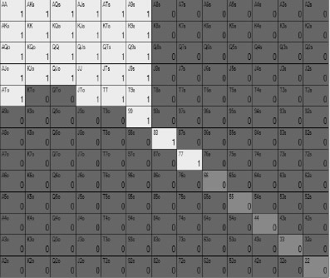

This looks like a really good solid range consisting of only strong hands and for the most part it will perform quite well.

This is what the Big Blind might defend with:



Imagine if the flop comes… 4♥4♠2♠

On this flop, you have a much stronger range than your opponent, in fact you have 59.7% equity against their range, which is about as big an advantage as you will see in a post flop spot in this book. Run this scenario through a solver and the Big Blind checks 100% of the time, but UTG in response checks back almost 100% of the time too. As you have seen in the previous chapters, it is common when somebody has a massive range advantage to bet almost all their range for a small bet sizing, but here the solver will check back all the time. Why?

Because while it is likely UTG is ahead, not only with their overpairs but also just their high cards, against this very wide range, they never have any strong ‘nutted’ hands on

this board. They never have trip fours or quads, they never have a full house and they never have a straight draw. The Big Blind, however, has all those hands as well as a lot of overpairs.

UTG does not have the nutted hands to support the betting range, so they check back. If they bet, they could get reraised and be in a world of hurt. The only way they can extract value is to encourage the Big Blind to bluff them. Even though they have almost 60% equity, all they can do is bluff catch because they have a capped range. They have put themself in the position of the player with the 3/4/5 dice in the previous chapter - most of the time they are ahead but betting will only get them in trouble.

What if, instead, our UTG opener had this range…



In terms of number of hands, this is almost identical, it is around 15.8% of hands. This range now has board coverage, meaning that it is possible to hit a strong hand on every possible flop.

All we have done is remove some of the broadway hands and replaced them with small pairs, suited Aces and a couple of low suited connectors some of the time. There are 12 combinations of offsuit hands, four combinations of suited hands and six combinations of pocket pairs. Therefore, when we remove a hand like KJo from the range we can replace it with two pocket pairs or three suited hands.

When we run this hand through a solver on the same flop, the Big Blind checks 100% of the time and now UTG bets 32.65% of the time with this range, for a small bet sizing:

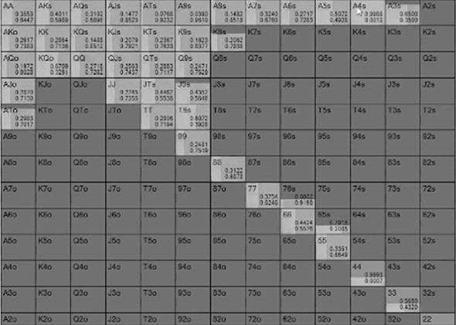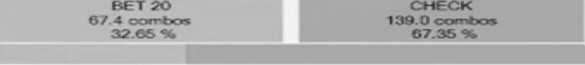

UTG has 63.14% equity in this spot, which is a little more than in the previous example, but now they get to bet a decent amount of the time because their betting range includes A4s and 44. Just by adding these two hands to the range means that UTG is able to bet hands like AA-77 confidently and get value from them, because the Big Blind will not widely reraise them.

In this example, on average UTG will make 3.9 big blinds in expected value (EV) in this pot, in the previous example they only made 3.4 big blinds EV on average. That might not sound much, but over a big sample of hands it is enormous. It translates to 50 bbs/100 hands which is an astronomical win rate few cash players ever achieve. They make more on average not just because they have a few super strong hands that get paid off, but because the whole range can play more profitably. Take a hand like K9s, which is in both ranges and the bottom of the range in both spots. K9s makes 2.71 big blinds EV in the second example and 2.5 big blinds EV in the first one. This is because K9s will work more often as a bluff because of the potential for us to have a nutted hand, it will also get to showdown and realise equity more often because the Big Blind can bluff us less.

You might not have read up on board coverage before but you have certainly used it to your advantage, just think about how easy it is to play against very tight players and how hard it can sometimes be to play against loose players. When nits bet on AAK flops you know you can muck your hand most of the time, when they check on 456 flops you know they have missed with their overcards and you can bluff them. When LAGs reraise on those 456 boards you often have to consider throwing away an overpair.

Board coverage allows us to not be exploited on any type of flop, turn or river.

## GTO ranges have board coverage

The range below is a GTO approved range for an UTG open in a tournament, with 60 big blinds effective. This is from Range Trainer Pro.

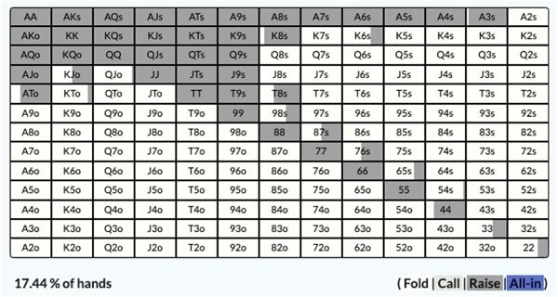

As you can see, almost every runout is covered here, we can hit most boards hard. We have the low suited Ax hands for low flops, we have all the pocket pairs and we even have a reasonable amount of suited connectors like 87s and 65s, so we can make lots of straights or better. These middle connecting cards in particular are useful because they can make the most straights, 65s for example can make 23456 straights and 6789T straights, so 4 high boards and T high boards are all covered, with everything in between.

Against this range, the Small Blind responds like this:

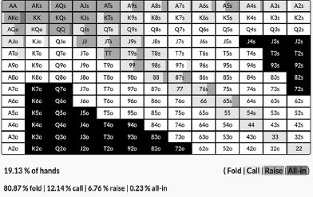

*A quick note, we wanted to show the exact solvers we use and for some reason a few of the ranges in Range Trainer Pro use both black and white to highlight folds. This is a minor bug that should not distract from the more important detail of the calls and raises.*

They have both a flatting range and a 3-betting range. The 3-betting range is stronger for obvious reasons, but both ranges cover most of the board. The only thing the 3-betting range doesn’t cover is 3s and 2s, but it does still have Ax hands that can make wheels and 65s type hands that can make a lot of straights. A lot of players would be surprised to see hands like 65s in a medium stack 3-betting range.

Not having the 3s and 2s in the range does put the Small Blind at a board coverage disadvantage, but the Small Blind is going to play aggressively on the flop and the stack-to-pot ratio is going to be small, so in the event that the board comes 223 or 332 they will probably be stacking off with overpairs anyway.

There is also a very small shove range of AKo and QQ (it’s so small you may as well always play these hands as a standard 3-bet). Notice that it does not cover the board, it doesn’t need to because it would be all-in preflop anyway.

Against the 3-bet, this is what UTG does:

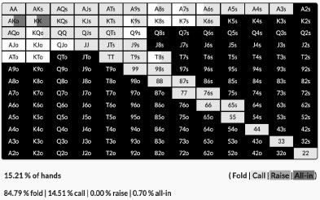

This is almost exclusively a flatting range, meaning it has to play post flop, and as such it covers the board really well. UTG also has position which makes hands like 22 and 76s easier to play against a 3-bet.

## The value of suited hands

Suited hands are your friends where board coverage is concerned, in particular suited Aces which allow you to still play a tight range while covering the whole board. Suited Aces make great hands because they block a good part of the opponent’s calling range, so as bluffs they will take the pot down preflop more often. Making top pair with an Ace is obviously a good thing most of the time, though how you play it post flop will depend on your kicker. Suited Aces make great post flop bluffing hands when you flop a flush draw and/or wheel draw. A semi bluff is always a good bluffing candidate, and not only can you make flushes/straights with these hands, often hitting the Ace is good.

Maybe the best part of suited Aces and suited hands in general is that they are very economical when it comes to range construction. There are 12 combinations of offsuit hands and four combinations of a suited hand. That means for every offsuit hand you

remove from your range, you can replace it with three suited hands without changing the percentage of hands you play.

For example in the 3-bet defending range above, we don’t really like defending with ATo because we are usually dominated against a 3-betting range. However, to avoid being exploitable we do have to call 15.21% of the time. By folding the 12 combinations of ATo we can instead play the four combinations of A5s, four combinations of A4s and four combinations of A3s.

That means we are covered on wheel flops and flushy flops. We can have trips on a 33J flop and we can have lots of profitable bluffs on a 3♦2♣Q♣ flop. With a hand like ATo we are really just hoping to make two pair if we are to win a big pot, but we have lots more ways to win with the suited wheel Aces in our range.

**Runout coverage**

Board coverage is not just a consideration with our range preflop, we also need to consider it on the flop and turn. You have to be prepared for every potential runout of turn and river cards, which means you have to have play your range in such a way that you always potentially have every type of card in every type of situation.

For example, below is what the Button does when checked to by the Big Blind on a 7♥4♠4♣ flop with 40 big blinds effective:

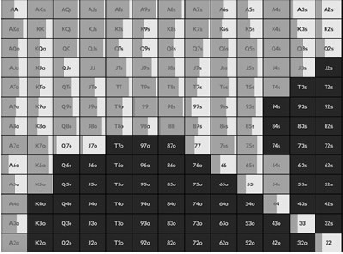



It is pretty much a 50/50 split between check and bet here. The Button has such a wide range they cannot bet all their hands, so they need to mix their strategy.

The obvious hands that want to bet in a situation like this are 7x, 4x and overpairs, all for value/protection. As you can see, they all mix it up a little. QQ-88 all bet 100% of the time because they benefit most from protection. AA and KK, however, are the overpairs that choose to check back because they benefit less from protection.

Of the 7x, A7/K7 bet the most and from Q7s downwards you see more checking. This is because A7/K7 are the hands that will win more often if they specifically get called by another 7x, because of their kicker. The Q7s hands and below work better as bluff catchers. All the 7x hands benefit from folds, because so many high cards can come on the turn and river that render them very weak. They do not all bet, however, because of

runout coverage. If you always bet 7x here, then if you checked and the turn is a 7, your opponent would know that you can never have a full house.

The only immediate draws on this board are 65s/86s/85s which can all make straights. Notice that all three of them are played half the time as a bet and half the time as a check. With so few draws out there, it is very important to potentially be able to have a straight in either scenario when a connecting turn card comes.

Even our Ax and Kx hands, which are just high cards now, adopt a mix of actions to ensure they have runout coverage. AKs-A8s all bet because they are the stronger hands but A6s/A5s/A3s/A2s all check back, so if an Ace hits the turn, you potentially have it in your range.

## Double backdoor hands

When you learn about GTO you start to think more about what the good turns and rivers are for your range, and you play your range in such a way that you have good outcomes on any runout. One of the big things the solvers have taught us is how valuable some otherwise quite weak hands are, when you consider the potential turns and rivers that could come.

We are talking about ‘double backdoor’ hands. These are hands that do not have much equity right now, but the right turn cards could give them two types of draw. This makes the turn a very profitable bluffing spot and, if you get there, the river a very profitable value betting spot.

Let’s go back to the last example, when the Button does bet, this is how the Big Blind responds:

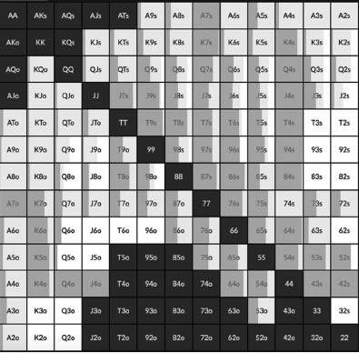



Let’s zone in on the raises here, and there are a lot of them. 65s raises here because it is an open ender, but instead look at some of the more curious bluffs - JTs, J9s, T9s, T8s, T6s, 97s, 98s and 95s.

None of these hands look very enticing, but they make great bluffs. First of all, they are all very weak hands right now, so you would be very happy to take down the pot with a

hand like T♥ 6♥ in this spot. If you get 3-bet you don’t mind folding because you had low equity to begin with.

There are also a lot of really good turn cards for these hands. If you get called when you bluff with T♥6♥ then any heart is a good card because you pick up a flush draw. A 5/8/9 is also good because you pick up a gutshot. The best card would be something like a 5♥ because you turn a flush draw and a straight draw, making this a great opportunity to fire a second bluff with a lot of equity.

If the turn brings a blank, you can just give up your hand.

Then if you make your flush or straight on the river, you obviously have a very strong value bet, with the added benefit that it is really well disguised. In most real life games nobody would ever put you on a hand that runner runner their way to a flush or straight, making it more likely you would get paid off.

One of the big shifts in strategy GTO has shown us is that double backdoor hands are great bluffing candidates, and while seemingly very weak, they are very easy to play. They are a class of bluff that requires you to understand runout coverage. You want very strong hands by the river but you also need to be able to find bluffs on every runout. Double backdoor hands are a brilliant secret weapon in the modern player’s arsenal that covers you on every board for bluffs and value.

## Heuristics For Real Life

*Do you need board coverage against fish?*

The big question is does board coverage matter if you are playing against unsophisticated opponents? If you are playing against the drunks in your local casino, they are probably not thinking about how robust your range is and how unlikely it is you have trip 2s, so shouldn’t you weight your range more towards premium hands?

This is a fair point, against weak players you can probably get away with capping your range in spots like this. However, I would go back to my previous argument that it is better to practice GTO at all levels, even if you sacrifice some immediate EV.

Perhaps a better exploitative reason to adopt the principles of board and runout coverage is that weak players tend to remember the hands where you appeared to have sucked out on them. In the example above, in a vacuum check/raising T♥6♥ on a seven high board, double barrelling on a 5 ♥ turn then getting there on the river looks like a wild maniac play. Bad players will remember spots like this and rather than think you are a ‘balanced’ player they will wrongly give you too much credit on medium connected wet boards in the future. What I call the ‘he could have anything’ fallacy.

*Protect your checking range for every runout*

One habit to certainly get into the habit of is checking back strong hands some of the time to protect your range on some runouts. The classic example is the nut flush draw, some players always bet these 100% of the time, meaning that when they check back and the flush comes in on the turn, they can never have it. It is important to sometimes check back your draws, your Ace highs, your overpairs and sets, just to keep your opponent guessing on every possible runout.

*Double backdoor hands*

Finally, do not go nuts and overplay your double backdoor hands but know they make great bluffs and in particular ones that are easy to play. If you bet a double backdoor hand and get reraised on the flop, it’s an easy fold. If you turn a big draw, it’s a really easy bluff. If you hit your hand on the river it is more likely to get paid off because it is well disguised.

**Part II: Streets**

# CHAPTER 7: THE RIVER

We now move on to the street by street analysis portion of the book. If you have read our previous books you will know we like to structure them in counterintuitive orders, favouring the most valuable lessons first rather than tackling them in a linear order. In this book we have decided to look at the river first, then the flop, then the turn and finally preflop. We promise we are not being hipsters, there is a logic to this order.

We begin with the river because it is, for the most part, the simplest street because there are no streets after it. There are no future equity considerations, you no longer have draws, you simply have a hand that is a strong hand or you don’t. Ranges are also narrower and more polarised by the river, because certain holdings can be dismissed by prior actions. The stack-to-pot ratio can only get smaller by the river which also makes your decisions easier.

Also, as you will see later on in this book, a big aspect of GTO is setting up profitable situations on the river. There are particular types of hands you want to have by the river, ie. very strong hands and bluffs that block very strong hands. You do not particularly want to get to the river of big pots with medium strength hands. Once you understand the types of situations you want to be in by the river, it informs how you play the previous streets. There are some actions you will take on the flop and turn that are made so that you find yourself in profitable river spots. You first need to understand the river to understand your strategy on earlier streets.

## River Strategy

Broadly speaking, river strategy is quite simple depending on whether you are in or out of position.

*The river in position*

As with every street, it is much easier to play the river when you are last to act. At this stage it is particularly simple because you get to end the action by checking back or calling, so no more decisions are left after that.

If you are checked to your river decision really boils down to:

* Do I have a hand strong enough that worse hands will call? (If so, you value bet)
* If not, do I have good showdown value? (If so, check back)
* If I don’t have good showdown value, how many bluffs do I have? (Pick your best bluffs and give up with the rest)

There is more to it than that of course, you have to determine your opponent’s range, decide what the right bet size or mix of bet sizes are, pick the right number of hands based on bluff-to-value ratio, and more. But ultimately the question is whether you want to bet or check back.

If your opponent bets and you are last to act, the process is very similar, it is:

* Do I have a strong enough hand that a reraise will get called by worse? (If so, reraise)
* If not, do I have good showdown value meaning I will win enough to the time for a call to be profitable long term? (If so, call)
* If I don’t have good showdown value, do I have any bluffs (the answer is yes if you have any hands that would raise for value)? (Pick your best bluffs based on blockers and fold the rest of your hands)

If you are facing an all-in on the river you don’t even have to consider the first or third point. Once again you have to factor in bluff-to-value ratio based on your opponent’s bet size but this time to determine how often you can call profitably.

Once we look at some hands we will go into more detail on your river betting strategy, but a quick summary first. Your value bets drive your river betting strategy. You will have a certain number of value bets in your range which, along with the strength of your

range and your opponent’s range, determine your bet sizing. Once you have decided on the bet size, that determines how many bluffs you have. Once you have picked your bluffs, everything else is a check back or fold.

*The river out of position*

Out of position is more complicated because the hand does not end with our action. If we have a hand we would like to get to showdown we have to be concerned our opponent will bet big and put us in a tough spot. When we have a hand that is good enough to value bet but it is the bottom of the value range, we have to worry about being bluff raised. Our bluffs need more thought because we have less information than had we been in position. If our opponent has a weak range we might want to trap our opponent by checking to induce a bluff, but if we do that too often we will let them check back and we miss a bet.

For this reason you have to factor in range protection, which you don’t have to when you are in position. In position you get to end the hand with your check backs, but out of position you have to protect your checking range. If we only check our modest showdown hands on the river then our opponent can bet big and blast us off the pot more often, so we need to put some strong hands in that range to prevent that from happening. The same is true with our small bet range, we need some strong hands in there to avoid being bluff raised too often.

When you are out of position you first must work backwards and decide how often your opponent is going to bluff and value bet. If a draw misses and you have a strong hand, you can check more to give an aggressive player a chance to bluff a missed draw. When the board is dry then you will want to lead more often to get value from weak made hands that would like to check back. If you have the stronger range you will have to bet more because your opponent will recognise this and check back more often when you don’t. If you have the weaker range you have to check more to protect the weaker hands in the range.

You will also have to make blocker bets out of position. This is when you bet smaller into a player who you believe would have made a bigger bet or checked behind. It achieves several things. When you have a strong hand that may have been outdrawn you get to pay less when your opponent calls with a better hand, or you can fold easily when they reraise. If your opponent has a weaker made hand they will call when they would

have checked back, getting you an extra bet. If you have a very strong hand it might induce a bluff reraise for more than if you had just checked.

*Polarised hands on the river*

Ranges are often more polarised by the river regardless of the action because you can always discount certain hands from the starting range by virtue of the fact that some would have bet/called and others check/folded, and so on. When significant betting action has taken place on the flop and turn, usually the ranges are very polarised by the river. Both players are usually left with strong hands and bluffs, with less medium strength hands.

In this MTT example UTG opens, it is folded around to the Big Blind who calls, the effective stacks are 40 big blinds.

This is what the Big Blind calls with:



This is the UTG opening range:



The flop is A♣J♥6♦, the Big Blind checks 100% of the time and UTG bets 100% of the time.

The turn is Q♥, the Big Blind checks most of the time and UTG bets again, the Big Blind calls.

The river is 3♠.

Apologies for skipping ahead so quickly but this is what the Big Blind gets to the river with:

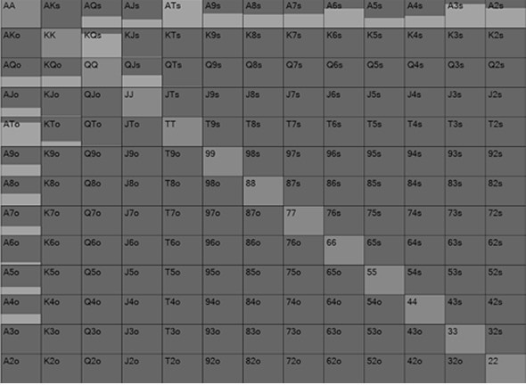

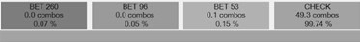

Essentially the Big Blind has continued with most two pair or better hands, but there are no really huge hands, they are mostly middling hands. There are no sets for example, we know this because AA/QQ/JJ were never in the range, 66 would have check raised on one of the earlier streets and 33 would never have called two streets. KTs for the nut straight was also not in the range because it was a preflop bluff 3-bet and KTo would have folded or check/raised the flop. The Big Blind essentially is left with bluff catcher hands. This is why they have played their big two pair hands passively, to protect the rest of the bluff catching range. The Big Blind has a condensed range.

UTG has a much more polarised range. This is what they do when the Big Blind checks, which they do 100% of the time.

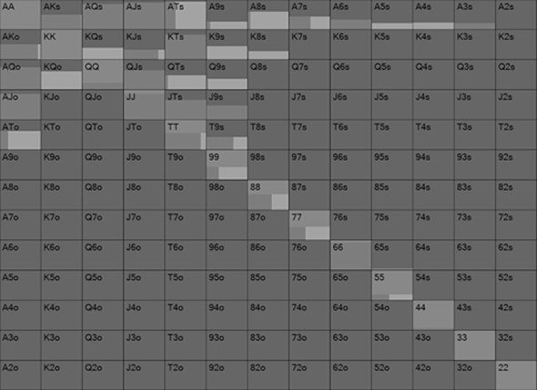

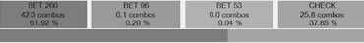

UTG gets to the river with some really strong hands - 66, JJ, QQ, AA, AJ, AQ, AK, KT. They also get to the river with weaker hands they have turned into bluffs - 55-TT, JTs, J9s, T9s etc.

Because the Big Blind has such a capped range, they check 100% of the time. They cannot bet because they do not have enough strong hands in their range. Betting would fold out all the bluffs and UTG would mostly call/raise with better. By keeping the two pair hands in the checking range, UTG cannot bet 100% of the time on this river, they check back 38% of the time.

When UTG does bet, however, they go all-in.

UTG uses that big sizing with all of the hands they bet. They use it with the nutted hands like JJ for value. It uses it with the bluffs like 99. It also, curiously, uses the same sizing with middling hands like ATs, which goes against conventional wisdom. Most educated players would argue that ATs is a terrible hand to bet big because it folds out the hands it beats (lower Ax and cry calls with other pairs) and only gets called by AJ+ or two pair and better.

However, UTG has a polarised range so as such the correct strategy is to use the largest size possible with their entire range. This means that they can get the maximum value when they get called by worse and it also allows them to have the most bluffs.

When they do that, the Big Blind has to call with worse Ax hands to avoid being exploited. This is their calling range:

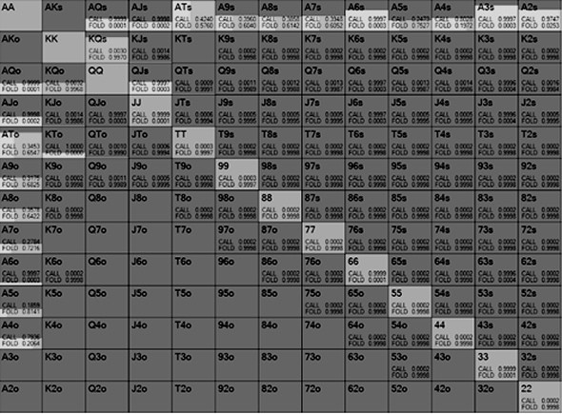

They are getting 2-1 on the call so they call with exactly 50% of their range to be unexploitable. They do indeed call with A4, A5, A7, A8 and A9 enough of the time to give value to UTG. Curiously they also fold AT some of the time to make this a ‘merge bet’ - ie. one which the bettor can make better hands fold and worse hands call at the same time.

Digging deeper, look at how often AT and A9 call UTG, compared to A2 and A3. Despite being much stronger hands in a vacuum, AT and A9 call much less often, in fact they fold more than they call. A2 and A3, however, call 100% of the time. Why is that?

To figure out why, let’s go back to the range that UTG bets:

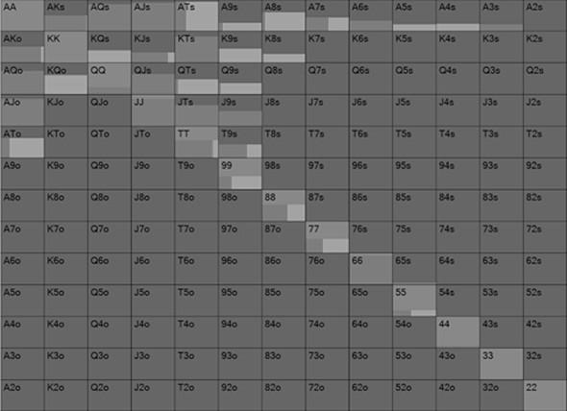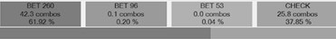

UTG’s bluffs are mostly coming from the pocket pairs that missed (55-99) as well as J9s and T9s. UTG does not bluff with 22 or 33.

A2s and A3s are 100% calls here because they ‘unblock’ UTGs bluffing range. A2s- A5s and A7s-ATs are all bluff catchers for the Big Blind, but when they have A2s and A3s they are not blocking UTG from having bluffs. When the Big Blind holds A9s or ATs it is much less likely that UTG is bluffing with 99/T9s/J9s making it a much tougher call. When they hold A2s their relative hand strength is the same as ATs in that it beats all the bluffs and nothing else, but there are more potential bluffs out there. Just as A2s and A3s unblock UTG’s bluffs, A9s and ATs block UTG’s bluffs. This is an important thing to bear in mind when bluffcatching: the relative strength of your different bluff catchers doesn’t matter (by definition they all beat bluffs and lose to value). What does matter is blockers (whether we block value or bluffs).

So why is it that we still call some of the time with A9s and ATs? It is because if we didn’t we could be exploited. UTG could stop bluffing with A9s or ATs because they know the Big Blind is less likely to have a 9, more likely to have a hand like A2s, so they are less likely to fold.

## Bluff To Value Ratio

As mentioned earlier UTG bets the maximum because it means they can have more bluffs. They are laying 2-1 with the pot sized bet, meaning for every two value hands they have one bluff. This is a breakdown of all the hands that bet:

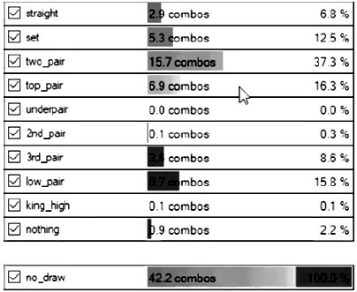

We can reasonably assume that anything top pair or above is a value hand, which is 6.9 combinations of top pair, 15.7 combinations of two pair, 5.3 combinations of sets and

2.9 combinations of straights (these are not whole numbers because sometimes the specific hands are splits that don’t play this way 100% of the time). So that is 30.8 combinations of value hands.

The bluffs are made up of 0.9 combinations lower than king high, 6.7 combinations of under pairs and 3.6 combinations of 3rd pair. That is 11.2 combinations of bluffs.

30.8 to 11.2 is far from a 2 to 1 ratio, so what is happening here?

The answer is that tricky position occupied by the top pair hands. Not all of them are value bets, some of them are actually bluffs and many of them are both. UTG can bet with A7s and as we have seen, some of the time ATs will fold but A2s will call. So this is what is known as a ‘merge bet’, a bet that can plausibly make a better hand fold and a

worse hand hero call, especially when blockers/unblockers are involved. The equity of a hand like A7s in these spots come from value and fold equity.

PIOSolver has correctly made a betting range that is two bluffs for every one value hand, but it has done so with middling strength hands that are sometimes bluff and sometimes value, rather than simply partitioning out the bluffs and the value. Don’t worry if this is starting to look daunting, this is way too complex for any human to understand or be able to do in game. Most humans, even the Super High Rollers, would never bet A7s in this spot knowing they were doing so 1/4 as a bluff and 3/4s as value. Humans don’t tend to think of top pair weak kicker as a bluff candidate, but since it blocks our opponent’s top pair plus, it often is.

The takeaway here is that if you do not bluff sometimes with made hands you do not have enough bluffs. If we never bluff with A7s or A9s in this spot then the Big Blind can fold 100% of the time with their bluffcatchers. If UTG was playing perfectly then they would be bluffing 1/3rd of the time when they bet pot meaning when the Big Blind has a bluff catcher they should call 1/3rd of the time. If they bluffed less often than that the Big Blind can fold 100% of their bluff catchers, even if they still bluffed 32% of the time. Likewise if they bluffed 34% of the time, it would mean the Big Blind should call 100% of the time with bluff catchers. Any slight deviation from GTO makes the counter adjustment instantly profitable.

## Non Polar Hand On The River

Not all hands on the river are polarised, however. Pots where less money has gone in the middle and ones that began with wide ranges often contain a lot of medium strength hands by the river.

This hand starts just as the previous one did. UTG opens, it is folded around to the Big Blind who calls, there are 40 big blinds effective.

This is what the Big Blind calls with:



This is the UTG opening range:



The flop is A♥K♥A♦, Big Blind checks, UTG bets small, Big Blind calls. The turn is 2♣, Big Blind checks, UTG checks back.

The river is Q♠.

The hand started with huge range advantage for UTG but when the Big Blind called, their range became stronger, so as such UTG played more cautiously on the turn. This is the range Big Blind gets to the river with:

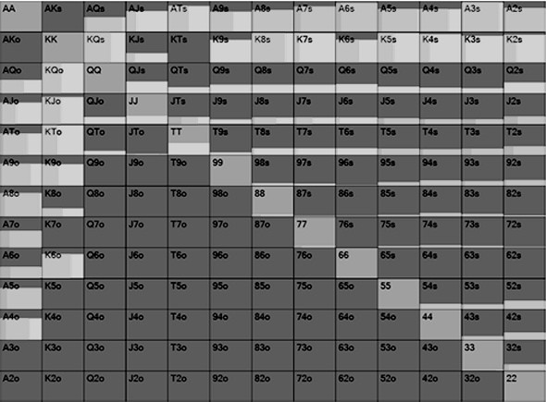

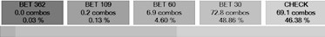

UTG no longer has range advantage on this board because the Big Blind has a lot of Ax, Kx and JTs. UTG does have the powerhouse hands like AK/AA/KK/QQ but would have bet earlier with AQ and JT, so they are not in the range. They also have a lot of misses, mostly the small pairs. Both players have similar ranges in that they both have very strong hands, medium strength hands and misses.

Unlike in the last example, the Big Blind now can lead almost half the time, because UTG no longer has range advantage. When they do lead, they lead small, 30% of pot. They need four value hands for every bluff.

Some strong Ax and JT hands get checked to protect the checking range, but most of the Ax gets bet. The bluffs are the T6/J5s type hands that missed, have no showdown, but

block hands like JT/AT/AJ. The Kx/Qx/JJ/TT hands get checked because they beat bluffs but don’t get called by worse.

In response, this is what UTG does:

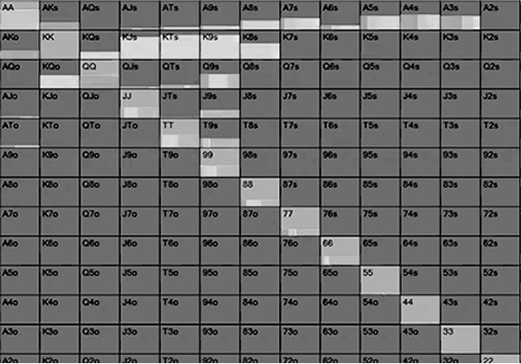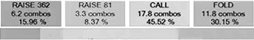

All the Kx hands just call, as they won’t get called by worse if they raise. The better Ax hands all shove for value and for the most part the bluffs are coming from small pocket pairs that have no chance of winning at showdown. UTG does not have a polarised range overall, but their shoving range is polarised which is why they can use the bigger size.

When UTG shoves, this is the response from the Big Blind:

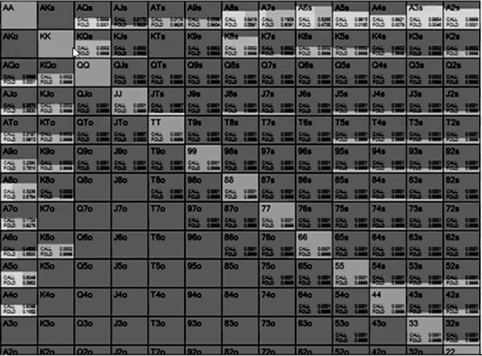

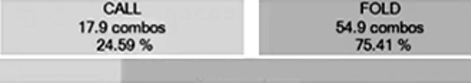

There are some folds with Ax, mostly hands like ATs-A6s. If you look back at UTG’s bluffs, they are mostly Tx or medium pairs. So in this example A3s is a better call than ATs because it is more likely UTG is bluffing. A3s unblocks the bluffs.

Rewind the hand, when the Big Blind checks the river, which they do half the time, this is the response from UTG:

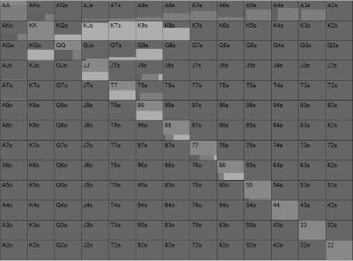

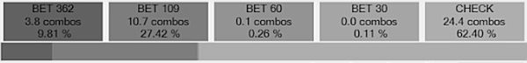

UTG bets all their Ax for value but checks all their Kx and Qx (other than QQ). The reason they do not bet with these hands is because we know the Big Blind has checked some of their Ax. This is a good example of protecting your range, when it is possible you have some strong hands in your checking range, your opponent has to respond by playing more cautiously.

They do bluff with some hands like 77 and 88, however, because the Big Blind will occasionally fold Kx.

When they do bet they bet big. This is how the Big Blind responds:

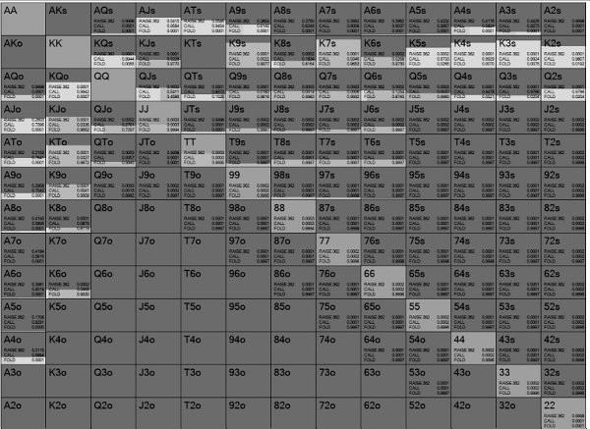

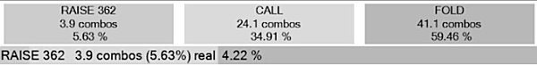

The check/raises are the Ax hands and JT obviously. The check/raise bluffs make up a very small portion of the range, 0.36%.

QJs/Q8s and TT are bluffs, they block AQ and JT. Crucially they also likely win if the opponent does not bet. It’s hard to pick check/raise bluffs but they are best made up of hands that have OK showdown value until your opponent bets, but have a blocker to a big hand. So TT will sometimes be ahead when you check and your opponent checks here, but when they bet you no longer like the hand. TT, however, blocks AT and JT making it a much better bluff than 99 which doesn’t block anything.

Deciding the value to keep back for a check/raise is also tricky. JT is held back here because it unblocks Ax hands, so there is more chance they will bet for value when checked to. Ax hands are held back less because they block other Ax hands, so it is

better to lead out to stop your opponent checking back a hand they would have called. Value check/raises should unblock opponent value bets.

## Same Hand, Different Rivers

This time we are going to look at a 3-bet pot and explore what different rivers can do to our strategy. This is a 40BB effective hand where UTG has raised, the Hijack has 3-bet and UTG has called.

This is the range the HiJack 3-bets with:

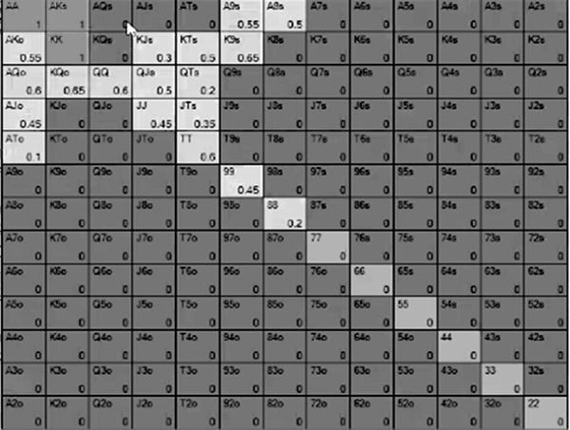

This is UTG defending range:

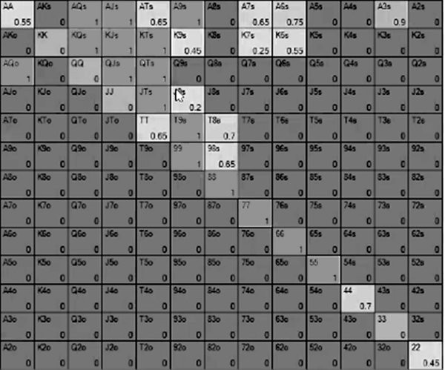

The flop comes A♠ K♦ 9♠, UTG checks, the Hijack bets small, UTG calls. The turn is 2♥, UTG checks, the Hijack bets big, UTG calls.

Before the river, this is UTG’s range, they called with almost 50% of their hands:

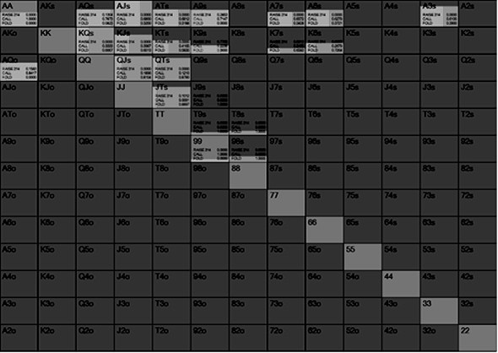

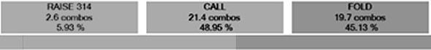

And this is the Hijack’s range before the river, we are looking at their big (130) bet range:

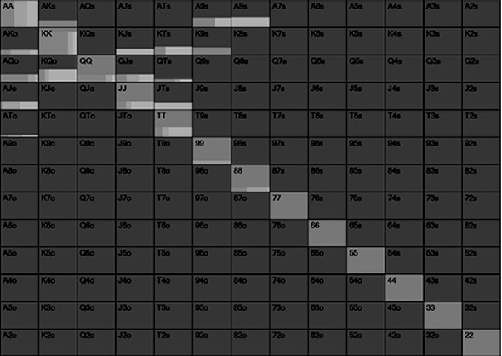

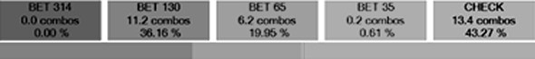

Heading to the river the Hijack has the range advantage because while UTG has lots of Ax, the Hijack has the better Ax and it is a bigger proportion of their overall range. UTG has more suited broadway type hands and Kx.

## The Worst River Card For Hijack

Let’s first take a look at what happens when the river is 8♠. So the board is A♠ K♦ 9♠ 2♥ 8♠.

This flips range advantage around. Now UTG has the range advantage because spade draws made up a bigger portion of their range.

This range is no longer condensed. It has some very strong hands (AA/99 and the flushes), some medium strength hands (Ax and Kx) and some weak hands (Non spade QJ and QT that missed the straights).

This is also a case where the Hijack has gone from a polar range to a linear range too.

The Hijack also has a few flushes that got there and AA/KK. Their AQ/A9/K9 hands have shrunk in value quite a bit. Their KQ/QQ/JJ/TT and the non spade QJ/KT/QJ hands now essentially have no equity.

Both ranges are uncapped, but UTG has the stronger overall range. Despite this UTG bets rarely and still checks and the Hijack bets big 65% of the time when checked to.

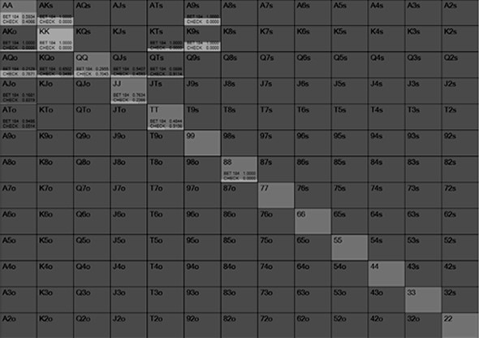

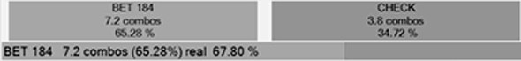

They bet the AA/KK/AK/A9/K9/88 for value as well as the flushes. They turn the QQ- TT hands into bluffs for the most part. Amazingly AA checks back half the time, the reason being that AA blocks top pair and that is the only likely hand that will call we beat. KK bets all the time, however, because it unblocks top pair.

Finally, UTG calls the bet at the correct frequency of 71% of the time with their strongest hands:

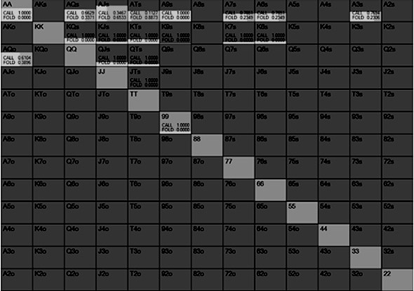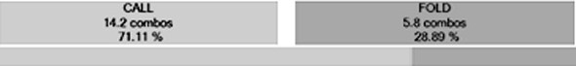

## The Best River Card

Now let’s replay the river but instead of 8♠ we make it Q♠. The board reads A♠ K♦ 9♠ 2♥ Q♠.

At first glance that doesn’t change much, but it actually does. This is actually a terrible card for UTG because it blocks all of their Qx flush draws. They still have Kx flush draws, but the Hijack blocks a lot of those

UTG still has an uncapped range, but the Hijack now has a more polar range. They have AA/KK/QQ/99 for the big sets, KTs for the flush. AQ/A9/K9 have been devalued a little by the river so are checks. Everything else has been so devalued they only work as give ups or bluffs.

As such, they bet much bigger on this river when they do bet after being checked to, with the monster hands, using 88/QQ/QT/QJ as the main bluffs, occasionally also with TT/JJ.

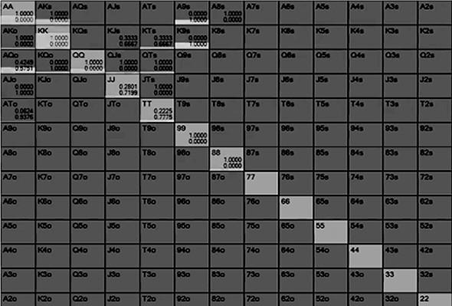

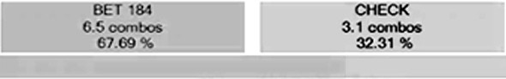

## The Blocker Bet

The blocker bet, not to be confused with a bet with blocker cards, is a useful tool to get value on scary boards with marginal hands and to also escape cheaply when you are beaten.

This is a 100 big blind cash game example and UTG opens with this range, which is from GTO Wizard:

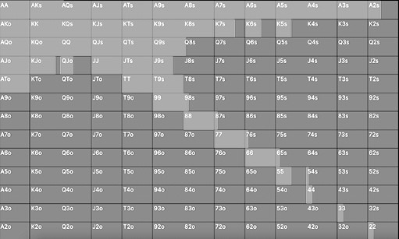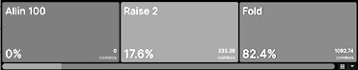

And the Big Blind responds like this:

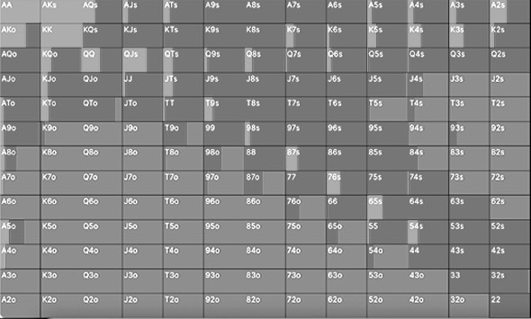

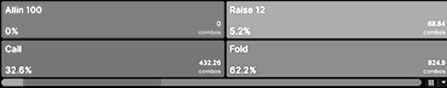

The flop is T♠8♦2♥. The Big Blind checks 100% and UTG bets 50% pot. The turn is a Q♠ and it goes check/check. The river is a 9♥.

This is the UTG range before the river:

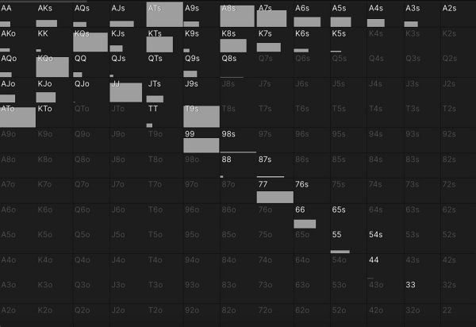

And this is the range the Big Blind got to the river with:

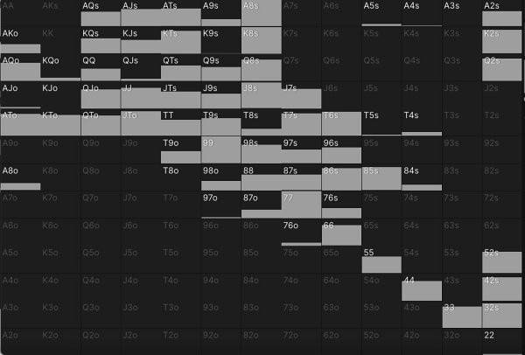

There is plenty of value for both players on a board like this but that 9 on a river has given either player with a Jack in their hand a straight, which typically would lead a player who has a strong hand like top pair or an overpair to try and check it down. If you were the Big Blind you get to this river all the sets some of the time and often UTG has a strong one pair hand here. In particular, what would you do with 88 or 99 here, which are our two most common sets?

This is what the Big Blind does on this river:

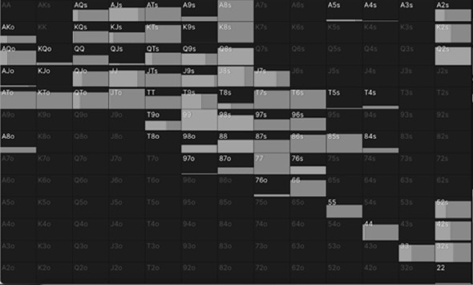

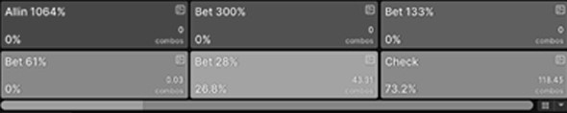

They lead out 27% of the time and always for a 28% pot bet, which is a very small sizing for a river bet, especially when there are some very strong hands here.

This is a blocker bet. We want to get value from a set, but we are aware of the probable straights out there. If we bet big, we likely fold out all the hands we beat and get action only from a Jack.

If we check, this is what UTG does:

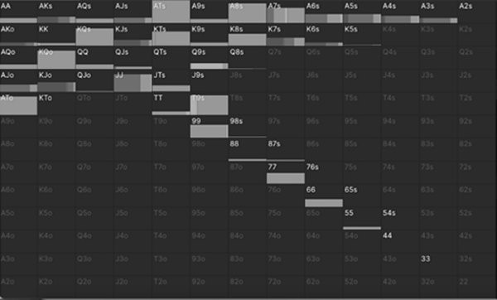

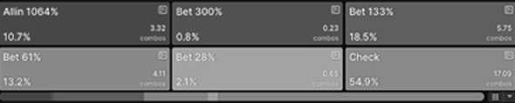

They check back a lot of hands we beat like AA/KQ/AT that might have called us, they bet big with all their Jacks and have a lot of bluffs with Ax and Kx.

If, however, we make that small blocker bet:

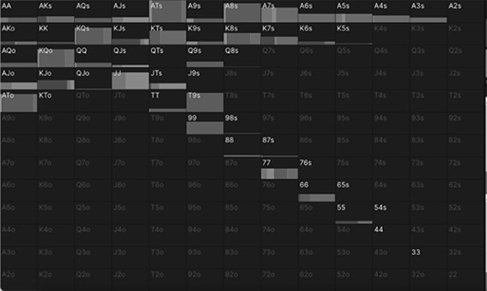

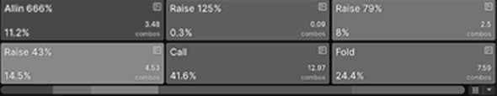

We now get more calls with KQ/AT type hands, AA even reraises sometimes as a bluff. Against the most common reraise size of 43%, this is what we do:

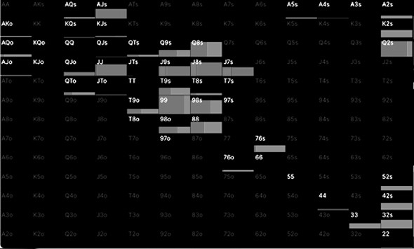

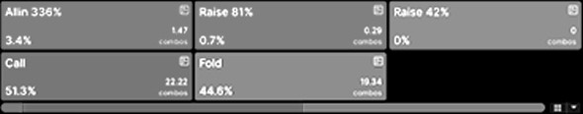

We can call more often with 99 and 88 because our smaller bet has induced some weak hands to bluff. Note that we do sometimes still fold these hands, because we are only beating a bluff. When we do fold we get away more cheaply than if we had bet, say, two thirds of pot.

The blocker bet is a good way to get value out of position on ‘scary’ boards that would lead most players to check back their value. It is also a useful way to get away cheaply or lose the minimum when you are beaten. Practically speaking in real life games, when you lead out for a small size on a coordinated board you will rarely induce your opponent to bluff, the board looks too wet for them. You can take a reraise at face value a lot of the time.

## Heuristics For Real Life

*In position*

The river is the simplest street, especially if you are in position. If you are last to act and it has been checked to you, ask yourself if there are worse hands that call your value hands or better hands that fold your misses: if the answer is yes it may be worth betting. If the answer is no then you should check back with showdown value or just give up.

*Out of position*

Out of position is trickier and here you need to think about range protection. You are going to have to sometimes bluff so you can get value in the future for your value hands and sometimes will have to check your big hands to protect your checking range. If you are at a significant range disadvantage you should check 100% of the time, even with your big hands. Unless, of course, you are playing against an unbalanced calling station type player.

Out of position the ‘blocker bet’ is very useful. This is where you lead out for a small amount when your opponent would check back the hands you beat or bet bigger with the hands that beat you. It allows you to get an extra bet when you are good, lose less when you are behind, get away cheaply when your opponent reraises and it leaves you less vulnerable to being bluffed. The blocker bet is best employed when you have a strong hand that beats a lot but the board has run out some potentially stronger hands.

*Check/raise strategy*

The best river check/raises for value are hands that unblock hands that would bet for value. If the board includes an Ace and you have a straight without an Ace, this is a good spot for a check/raise because there are more combinations of Ax out there that will bet. If you have AA in this spot, you block top pair and make it more likely that your opponent will check back, so value bet.

The best river check/raises as a bluff are hands that have good showdown value but block a very strong hand. If you have A♥T♣ on a T♥3♥2♦6♠Q♥ board, this is a good spot to check/raise bluff. If your opponent checks behind they usually won’t have Qx or better, so you will win a lot. However, if they bet your hand is no longer good (unless they are bluffing) but you can bluff because you block the nut flush (and top two pair, second set).

*Blockers matter most on the river*

Having blockers make better bluff catchers and bluffs in general on the river. In the example above if you have the A♥T♣ in position your hand will make a better bluff catcher than J♦J♣ which is essentially the same hand in that it beats all the over Tx but none of the Qx, but A♥T♣ also blocks AA, AQ, TT and the nut flush. Remember that blockers are best employed at points of indifference where a decision is close, bluffing or bluff catching with any blocker means you are playing way too loose.

*Against the recreationals on the river*

Away from GTO we have a useful piece of exploitative advice. Most recreational players give up too much out of position and check hands they should make thin value bets with. It is usually correct in softer games to bet out of position more than the solvers would advocate, because opponents will call with middle pair type hands they never would have bet with. This is why some people think bluffing is hard on the river in small stakes games, because recreational players have stronger out of position checking ranges. They should be betting more with their range but instead they check, so when you try to bluff them they are much stronger than a GTO range might suggest.

Finally, and this is just something to keep in mind for now as we will explore it in more detail, pay attention to the kinds of hands you want to have on the river. You want to get to rivers with very strong hands or hands that make for profitable bluffs because they block very strong hands. This impacts how we should play on earlier streets all the way back to preflop.

# CHAPTER 8: THE FLOP

If we learned the river first then the next logical step is the turn, right? Actually no, we are now heading to the flop. We are doing this in order of importance. We can learn a lot in a short amount of time on the river so we started there. The flop is the next most important section because we have the most things to consider.

## Dynamic Vs Static Flops

We have already discussed how your value bets drive your action in poker. When it comes to the flop, the thing that determines the number and types of value bets you have is the texture of the board. You will already no doubt be well versed in ‘wet boards’ vs ‘dry boards’ in conventional poker wisdom.

A wet board is also known as an ‘action board’ and is one that hits a lot of likely hands. K♣ Q♥ J♥ is a good example of a wet board. A lot of likely broadway hands hit this flop hard, as will heart draws. The conventional wisdom is you bet big on these boards for value as lots of hands will call.

A dry board is one which is hard to hit. 2♥2♣ 7♦ is a good example, there are no draws possible and most ranges are made up of high cards that do not improve here. The old school wisdom here is that you can bluff, and do so with a small bet sizing, because nobody is likely to have a hand they can continue with.

GTO has a different way of categorising boards, one which looks the same at first but is different. The modern way of thinking is that a board is usually static or dynamic.

A static board is one where most turn and river cards do not change the relative strength and equity distributions of each player’s range. A dynamic board is one where many cards can completely change who has range advantage.

Compare the flop A♠9♠6♠ to the flop 9♣ 6♦4♠, which would you say was dynamic and which would you say was static?

Most players would think back to the old school ‘wet vs dry’ flops and decide that A♠9♠6♠ was a dynamic flop and 9♣ 6♦4♠ was dry. It is quite hard to have a hand on the nine high flop, after all, whereas on A♠ 9 ♠ 6 ♠ you can have top pair, two pair, sets, flushes, flush draws and straight draws.

However, this is the wrong way of thinking about it. 9♣ 6♦4♠ is actually the dynamic flop in this example and A♠9♠6♠ is the more static one. Fortunes can change quickly on the nine high flop whereas the holding that is ahead on the A♠9♠6♠ flop is more likely to remain ahead by the end of the hand.

Before we explore this in more detail, just think about it for a moment. The A♠9♠6♠ flop looks scary because we all have a deeply ingrained awareness of the obvious scare cards. We see the Ace which often gives us a very strong pair and fear that any lone spade will give a random hand a flush. The reality is that flushes and flush draws make up a small part of any range and most of the time the best Ax is still winning by the river. The correct strategy here with range advantage is to bet small. Your flushes don’t need protection, the only way to get value for top pair hands is to bet small and if you get reraised you can get away from marginal hands cheaply.

Contrast that with 9♣ 6♦4♠, which looks very hard to hit. There are some straight draws here - 87/T7/75/53 - which won’t make up much of any range. A more crucial consideration, however, is the highest card, which is just a 9. How dynamic a board is depends on how many draws there are but perhaps even more it depends on how high the highest card is. If you have top pair in the A♠9♠6♠ example you are mostly worried about spades, but if you have top pair on the 9♣ 6♦4♠ flop you are worried about any T/J/Q/K/A coming on the turn that could devalue your hand. Given that you will often be up against broadway hands and big Aces, the prudent strategy on a board like this is to bet big. You want to clear out equity as well as get value while you know your hand is probably ahead.

If a lot of cards can flip range advantage then you should bet bigger, both as a bluff and as value. If the best hand right now is usually the best hand by the river then you will make more money overall betting smaller and guaranteeing more bets across more streets. Back in the day we used to call this betting for ‘protection’ and for a while it fell out of fashion. GTO has shown that it is actually an important strategy, today it is referred to as equity denial (we don’t allow our opponents to easily realise their equity). The only difference between GTO protection betting and old school protection

betting is that back in the day the protection bets would be on ‘wet’ boards that likely have hit a lot of hands, whereas today they are on ‘dynamic’ boards where a lot of high cards could change who has range advantage.

Going back to first principles, the small bet sizing on static boards and large bet sizing on dynamic boards does correlate with bluff to value ratio. We bet small when we have lots of value and not many bluffs, which is exactly what happens on static boards. On the A♠9♠6♠ board our bluffs are mostly going to be made up of offsuit cards with one spade in it, which as we are about to see is not as big a part of the range as most people think. Most of our bets are one pair, sets and flushes, so we have lots of value and not many bluffs, therefore we bet small. On the 9♣ 6♦4♠ flop, however, we have some very strong hands and bluffs. We have top pair, overpairs and sets for value bets and 87/T7/75/53 for obvious bluffs, but also our overcards like JT/JQ/KQ make great bluffs because they can hit good top pairs or runner runner draws. We have some very strong hands and plenty of good bluffs, so we bet big with them. We also have a lot of complete misses and mediocre hands, so we check with those.

## Static Board Example

Let’s play a real hand on these two flops to show you what a solver does in each scenario. First, the A♠9♠6♠ board we claim is more static than dynamic. In this example UTG has min raised and the Big Blind has defended, they have 40 big blinds effective.

This is what the Big Blind calls with:



This is the UTG opening range:



The Big Blind checks 100% of the time, because UTG has a significant range advantage mostly because of the strong Ax hands making up a big portion of their range. The monotone flop looks scary, but in this example UTG only flops a flush 4.1% of the time (with K♠Q♠/K♠J♠/K♠8♠/Q♠J♠/Q♠T♠/J♠T♠) and has a flush draw 22% of the time, with their pocket pairs and ATo-AKo and KQo). The Big Blind flops a flush 7% of the time because they call with all their suited cards and has a flush draw 19.6% of the time.

Crucially with these particular ranges, each individual player doesn’t have a spade 75% of the time, which hopefully will demonstrate that most of the time on a monotone board you both miss completely.

As such when we gave PIOSolver a range of big and small bet sizes, UTG always favours the two smallest sizes of 33% pot and 25% pot. These are the hands that bet:

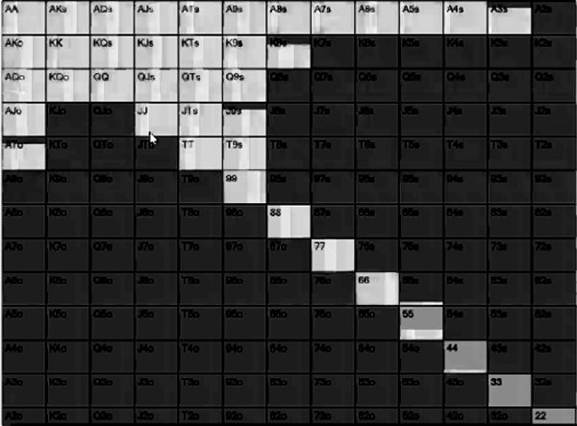

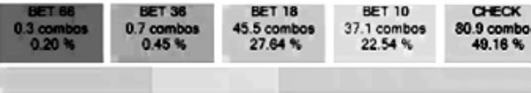

There is no reason to bet big here. Flushes don’t need protection and we want the Big Blind to call with hands our top pair type hands beat. We have a lot of strong hands here, but few absolute monsters, so betting big just puts us in a world of hurt when we get resistance. We bet small with Ax hands for value, we bet small with 9x hands to clear out equity and take the pot down right now, we bet small with our flushes to protect our range. Our bluffs are mostly made with our offsuit hands with a spade in them, which are a small part of our range. This is why we bet small, we have lots of value and few bluffs.

This is the response to our most common bet of 25% pot:

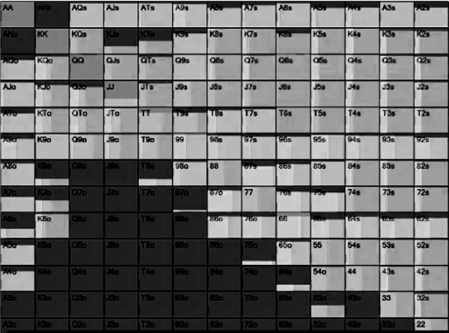

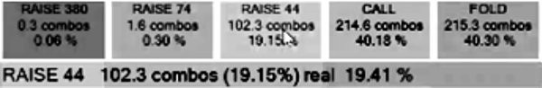

There is a decent amount of raising here, almost 20% of the time with flushes, sets and big draws mostly. UTG can easily get away from the 9x and bluffs cheaply now. The Big Blind calls 40% of the time with most Ax, 9x and a few worst pairs, as well as draws. Had UTG bet bigger they would not have been able to get value from this many hands.

When UTG bets small and is called by the Big Blind, this table shows what each potential turn card does for the Big Blind’s equity (the inverse of each number will be the equity for UTG):

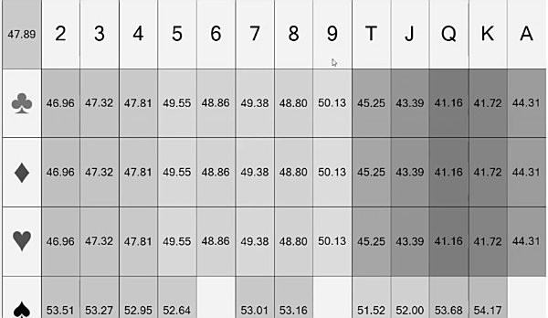

The best cards are all spades because the Big Blind has a lot offsuit spade hands. Most cards do not give the Big Blind a range advantage (ie. above 50% equity) and thus most cards are actually good for UTG, therefore there is no need to bet big here. Spades are bad for UTG but almost every other card is good for them.

## Dynamic Boards

Now let’s play that board we claimed is the dynamic one. All the other details are the same as the last hand, only this time the flop has come 9♣ 6♦4♠.

This is what the Big Blind calls with:



This is the UTG opening range:



On this flop UTG has a significant range advantage mostly because they have all the overpairs as well as strong 9x. The Big Blind has plenty of 9x and all the straight draws, but most of the time they completely miss this board.

As a result, the solver bets a lot here, 66% of the time, and massively favours the biggest bet sizing of 120% pot.

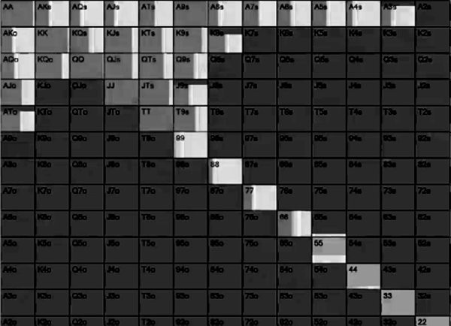

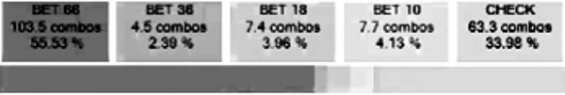

They bet big with all their overpairs for value, 9x bets big for protection and the broadway hands like KQs bet big as semi bluffs. 99 never bets big because it is a monster and it blocks the top pairs that continue. Ax mixes big bets and checks, on this board Ax has good equity so it goes into the check range because it has showdown value and also for board coverage when the turn comes an Ace.

Going back to bluff-to-value ratio, this shows that a dynamic board is also a polarised board. Overpairs and 9x are value, the rest is a miss, so the correct strategy is to bet big. When UTG does bet big, this is the response:

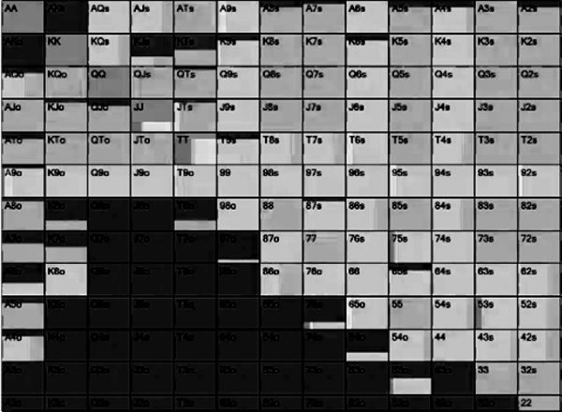

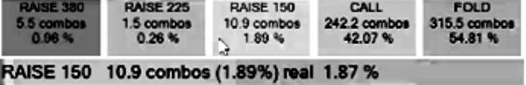

There is no raising here because UTG has a polarised range. There is no point raising because UTG will only fold all their bluffs and keep in their monsters. The calls are mostly the 9x/6x/4x type hands. For example, T4s is a call but 77 is a fold, which is interesting. This is because we are up against big hands or bluffs, and as such T4s or 77 both only beat bluffs, but T4s can hit more cards on the turn and river to outdraw some value bets.

When UTG bets big and the Big Blind calls, this is the equity the Big Blind has for every possible turn card:

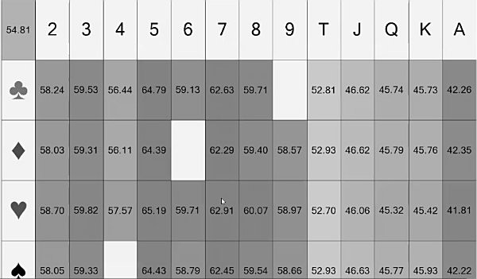

UTG has range advantage on the flop but every single card that is ten or below massively shifts the advantage in favour of the Big Blind. That is because the Big Blind has all the low cards, all the two pairs and all the straight draws. The Big Blind folds most of their broadway hands so the high cards do not favour them, plus they make up a bigger part of UTG’s betting range.

In the first example most of the turn cards did not dramatically change who has range advantage, in this example most of the turn cards do shift it in favour of the Big Blind. A ‘dry’ nine high flop is much more dynamic than a ‘wet’ monotone board. The lower the potential the top pair, the more dynamic a board is, so we bet bigger to force more folds and get more value when we are ahead. The higher the top pair, the more likely it is for the best hand right now to still be ahead by the river, so we make more money by betting small.

## Shallow Vs Deep Flop Play

Your strategy changes considerably on the flop depending on how deep the stacks are, because of a concept called stack-to-pot ratio (SPR). SPR describes the relationship between what is in the current pot to what is in the remaining effective stacks. If there

was $100 in the middle of the pot and both players had $300 behind, the SPR would be

3. The lower the SPR, the wider we are happy to commit our chips. SPR is usually considered deep when it is 10 or higher - we are not happy to stack off light here. SPR is medium when it is between 5-10. Under 5 is considered to be a low SPR, you are not going to be folding top pair much in this scenario.

SPR also determines how ‘fancy’ you can get across the streets. If the SPR is 1, you are probably going to get it in on the flop, when it is 10 you are going to have floats, check/raises, triple barrels and so on in your arsenal.

Let’s start with a simple example to demonstrate how different the strategies can be in the same spot, based on stack depths. In both examples this is a single raised pot where UTG has opened and the Big Blind has defended, however the first example is with 40 big blinds effective and the second one has 100 big blinds effective. For now we will skip past a detailed explanation of the opening ranges because that will get covered later. These are the ranges:

***40 BB UTG***



***40BB BB***



***100 BB UTG***

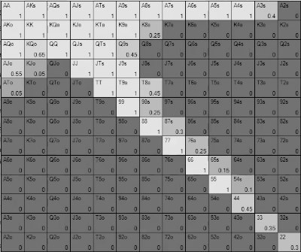

***100 BB BB***

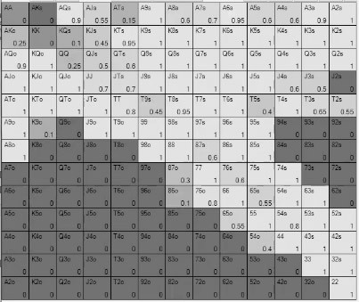

On the face of it these ranges look about the same. UTG is almost identical in each cases, and the Big Blind defending range is just a little bit wider at 40 big blinds. They are similar enough, for now, that we can do a like for like comparison of the flop strategies. This is a linear opening range against a capped defending range.

Let’s revisit that 9♣ 6♦4♠ flop from the previous examples.

In both cases, the Big Blind checks 100% of the time, because they are at range disadvantage. When checked to, this is what UTG does at 40 big blinds:

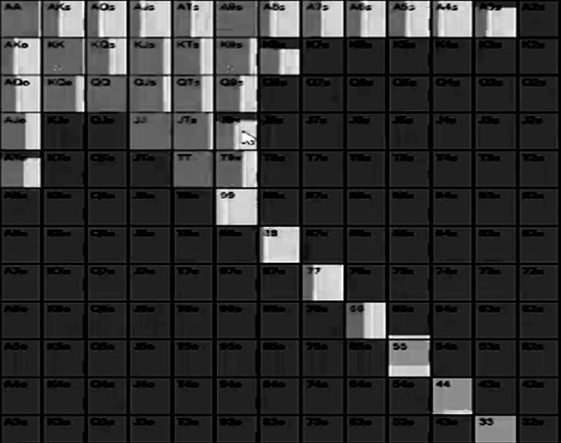

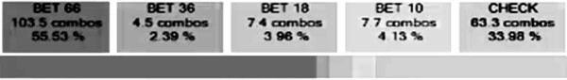

At 40 big blinds the SPR is roughly 7. UTG has a lot of hands they are happy to stack off with here - all their overpairs, all their 9x and overcards that have double backdoor draws like J♣ T♣ which can make runner runner straight, runner runner flush and a top pair that is often good. The strategy here is therefore to bet big and get the money in while we are ahead with hands like overpairs/9x and as bluffs with high equity draws. The strategy is much more polarised. This means there is also a checking range with the medium strength hands like Ax no backdoors and middle pair hands like 88 or A4s.

At 100 big blinds, this is what UTG does when checked to:

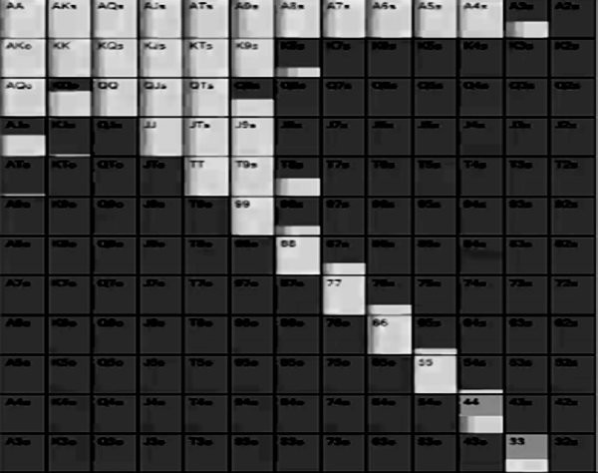

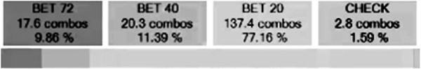

At 100 bigs the 9x hands and overpairs are nowhere near as happy to stack off. Get your money in with JJ or A9s in these spots and you are only going to get called by better. The adjustment here, therefore, is to bet much smaller. The difference, however, is that this time we get to bet much more. Because we are betting more hands we can bet more for thin value with those middling hands like 88 and A4s, because we will get called by more hands. So while we are no longer betting big and looking to stack off, we get to bet 100% of the time because of our range advantage whereas in the first example we only bet 64% with a polarised range.

Let’s jump into another example. The ranges and stacks are the same as before, but this time the flop is the A♠9♠6♠ flop from our first examples.

Once again, UTG has range advantage so the Big Blind checks 100% of the time. This is how UTG responds when checked to at 40 big blinds:

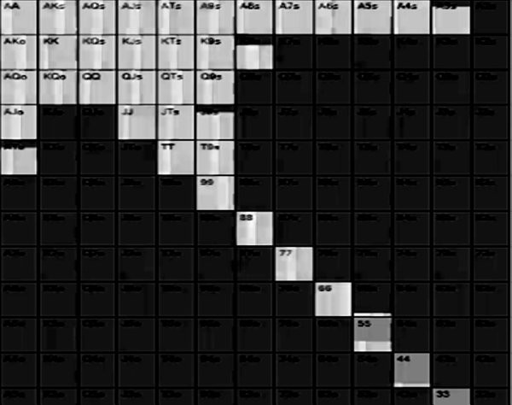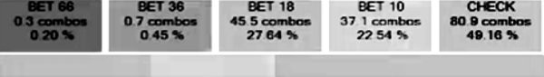

And this is the 100 big blind strategy:

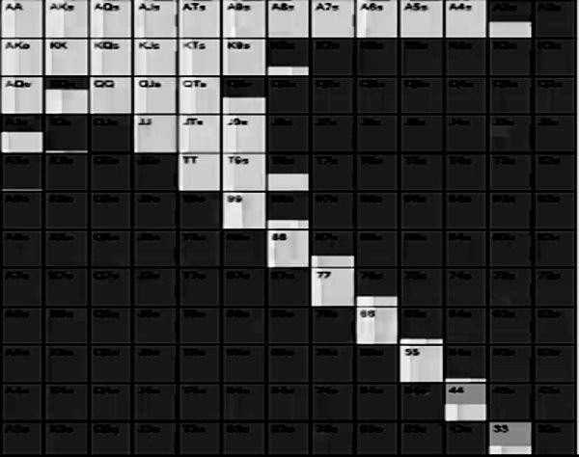

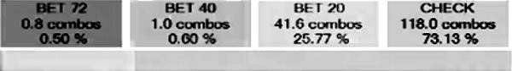

Broadly speaking the same types of hands bet in each scenario, but at 40 big blinds they bet at a much higher frequency. In both cases the bet sizing is relatively small because as we have already seen, this is a more static flop than most would think, but there is some slightly bigger betting at 40 big blinds. Some of the Ax hands are pure checks at 100 big blinds, whereas they all get bet at some frequency at 40 big blinds.

At 40 big blinds the SPR is much lower and as such, we would be exploitable if we folded top pair type hands too much on these flops. The best hand on this flop is usually the best hand by the river and in these spots if they have a flush, we are just unlucky. Also, there is more value to taking down the pot because the 6 big blinds in the middle are 15% of our stack, so that is another reason to bet.

We are much less happy to put a lot of money in the middle in the 100 big blind example because it is much more a case that if we get action, we are up against a much stronger range. At 100 big blinds you need a much stronger hand to go broke with because the SPR is higher. The 6 big blinds in the middle is only 6% of our stack, it is not worth fighting for as much.

Let’s look at another side by side comparison, this time with the emphasis on the response to a bet. We are comparing 40 big blinds to 100 big blinds, this time it is a 3- bet pot where the Small Blind has reraised and the Cutoff has opened and called a 3- bet.

Once again, we are going to skim over these ranges for now, but this the the Small Blind’s 40 big blind 3-bet range:

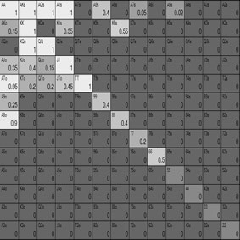

This is the 40 big blind Cutoff defend range:

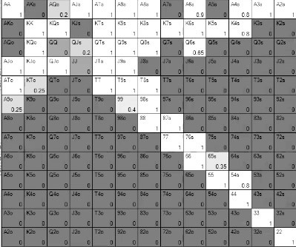

This is the Small Blind’s 100BB 3-bet range:

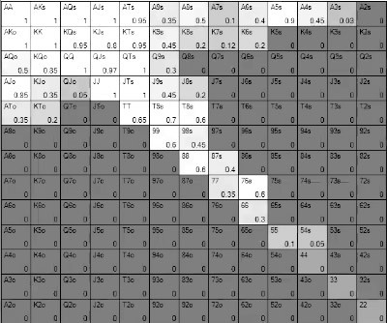

And this is what the Cutoff defends with:

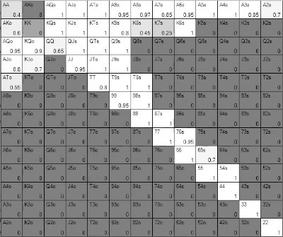

Both ranges are essentially a polarised 3-betting range against a somewhat condensed defending range. However, the 40 big blind 3-betting range is tighter overall. Both defending ranges include some very strong hands some of the time to protect their range.

In this example we are going with a 7♣ 4♦4 flop.

This is what the Small Blind bets at 40 big blinds effective:

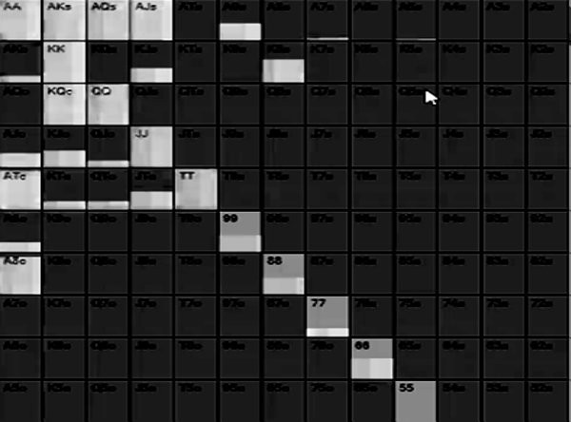

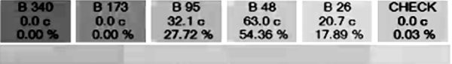

This is a range bet with a mix of sizes. The Small Blind has a very strong range here with all the overpairs and a full house, with Ax and Kx that is potentially quite strong too. There is a small, big and overbet sizing in this range. When they bet big, this is how the Cutoff responds:

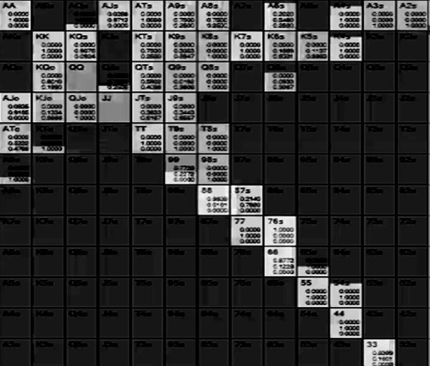

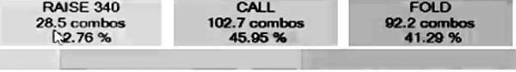

The Cutoff has to fold 41% of the time and calls 46% of the time, including calling with a lot of broadway hands that can make good pairs, might be ahead and has backdoor flush draws. To protect the range they call with AA/KK and their 77/44/A4/54.

They also raise 13% of the time with an interesting range. They raise with 99/88/76s/66 and 33. These are hands that figure to be ahead right now but do not want to see two more cards. The bluff is from A6s when it has a backdoor flush draw because it can hit runner runner flush or straight, as well as the best top pair. This is yet another example of solvers heavily favouring double backdoor type hands as bluffs on the flop.

Let’s contrast this with the 100 big blind example, this is what the Small Blind does on this flop:

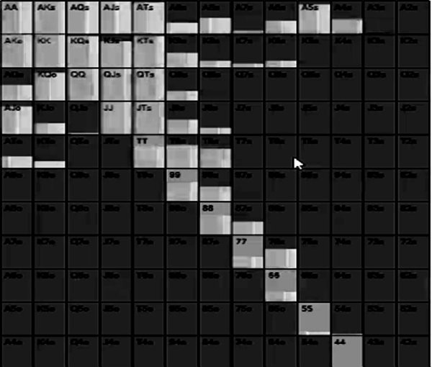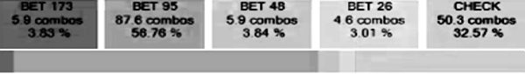

They no longer bet 100% of the time, they now check 33% of the time. They still bet pretty much their entire range but mix in checks with most hands. This is because they do not have the same amount of range advantage as before, it was 57% in the 40 big blind example and it is 52% here. A good one pair hand is a monster on a low paired flop when the stacks are shallow, but you don’t like stacking off for 100 big blinds with them. Also they are out of position and that matters much more in deeper pots.

When the Small Blind does bet, they overbet. When you have to check a lot of the time your betting range leans towards the bigger sizes. Your medium strength hands (and some big hands for protection) check, your value is strong so it bets big, as does your bluffs.

This is how the Cutoff responds to the overbet:

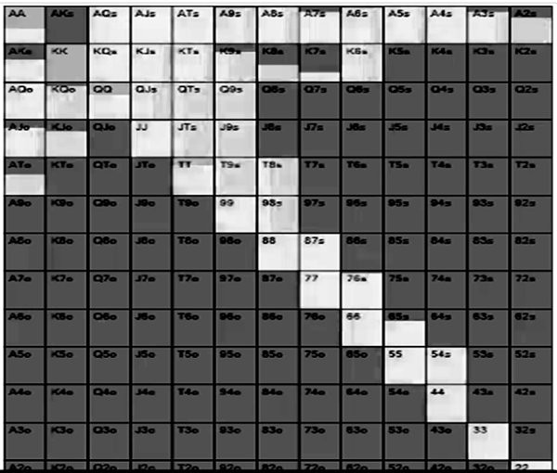

The first thing to notice is that even though the bet size is bigger, they fold much less than in the 40 big blind example. The 40BB Small Blind range was much stronger overall so it got folds 41% of the time, but here it is only 30% of the time because there are more bluffs in the betting range. Go back and look at the 40 big blind betting range,

even the bottom of the range was decent Ax/Kx, but in the 100BB example there is 9x, Jx, Qx etc.

The other big change is there is no raising this time around. We stay in the pot more often but we play it passively. This is because we have a capped range vs a polarised range. The correct way to defend against a polarised range is to call them down at the right frequency. Anything else would fold out all the bluffs and keep in only the very strong hands.

## Check Raising The Flop

We have seen a very useful heuristic about when to check/raise the river, which should be easy to implement in your game because the action ends on the river with no future street considerations. That heuristic is based on blockers and unblockers - we bluff when we have blockers to strong hands, we check with nutted hands to induce a bet when we unblock other strong hands.

Let’s look at how check/raising strategy differs on the flop when two cards are yet to come.

In this example it is Button vs Big Blind with 40 big blinds effective. The flop is 7♥4♠4♣.

This is the Button’s range:

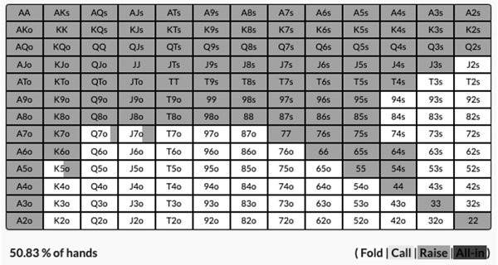

This is the Big Blind’s defending range:

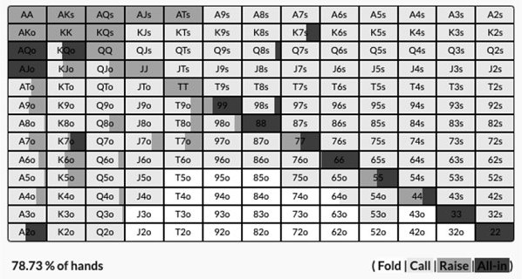

Both have wide ranges with plenty of nutty hands but the Button has a 56% range advantage because they also have overpairs. As such the Big Blind always checks.

When checked to this is what the Button does:

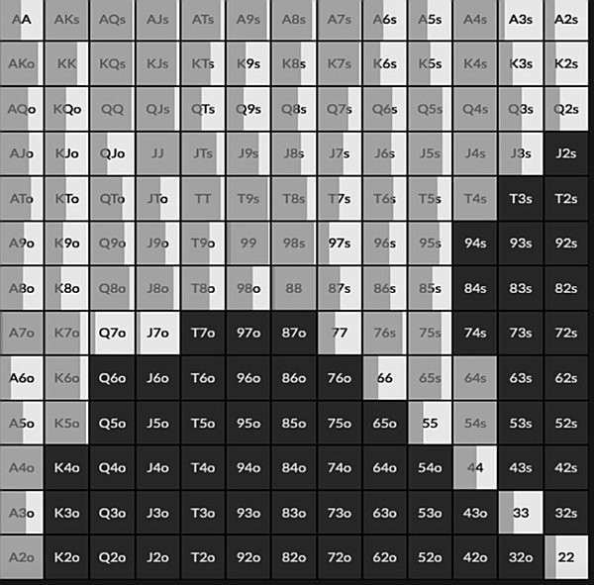



It’s a mix of checking and betting, with the small sizing favoured. The small sizing is because this board is hard to hit, there are not many nutted hands and there are not many draws possible. We check half the time, however, because we have a lot of misses.

This is how the Big Blind responds to the bet:

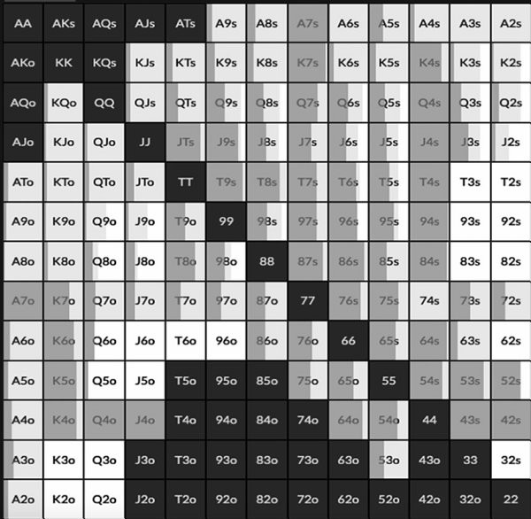



There is actually a high prevalence of check/raising on this board, 29% is very high. This is generally the case against a wide non polarised small bet. Our strong hands want to get more money in the pot right now, our vulnerable hands want to deny equity and our bluffs profit from getting the weaker part of the small bet range to fold.

Most of the 4x is check/raising here because it is very strong and most of the 7x raises, mostly for equity denial purposes - we have the best hand but we don’t want to see two

more cards. Because we have a lot of value bets on this board we also need a decent amount of bluffs, so where do they come from?

There are not many immediate good draws on this board - only 56, 53 and 86 - all of which check/raise. We need more bluffs than this, however.

The most frequent bluffs are hands like JTs, J9s, T9s, T8s, T6s, 97s and 95s. These are all hands that look quite weak on the surface but they all have a lot of ‘double backdoor’ equity that make them very profitable bluffs. They are not quite strong enough to try and get to showdown like a hand like A5s that always checks, so they make better bluff candidates in that they likely won’t win without improving. These hands also do not mind folding to a raise.

They do, however, play very well across three streets. A hand like JTs could get a fold when it check/raises the flop. It can hit a good top pair on the turn or river, or it could turn a flush or straight draw to give it a second profitable bluff. The dream card for a hand like J♣T♣ would be the 9♣ on the turn as it would give us a flush draw, a gut shot and our potential top pair might be worth something, so we can bet again on the turn. We may also have a profitable bluff on the river if we miss, however we can make a very strong hand too which we can bet for value. When we get aggressive with a ‘double backdoor’ on the flop and runner runner a straight or flush on the real life tables we also have the advantage that our hand is very well disguised.

Take also a hand like 95s which check/raises here when it is of the same suit as one of the flop cards. This looks like a pure garbage hand but it can hit a 3 and a 6 or a 6 and a 8 to make a straight, as well as a runner runner flush. Again the Gin card for 9 ♣ 5 ♣ would be the 6♣ on the turn to make a very profitable semi bluffing card and any 3, 8 or club on the river gives us a powerful value betting hand.

This is a common trend you will see in GTO. Solvers prefer double backdoor hands for the check/raise bluffs because while they look very weak, they give you good bluffing spots on the turn and good value betting spots on the river. They are also the easiest hands to give up with either if you get 3-bet on the flop or the turn is a blank.

A common error many players make is using difficult to play hands for their check/raises. Either they will use medium strength hands that play better as bluff catchers or they use stone cold bluffs with no equity. In both cases you have a difficult decision on the turn if you get called. It is much easier, more profitable and less stressful to mostly have a mix of very strong hands and well disguised bluffs that can pick up equity across the streets. This also acts as a natural stablisier for your bluffs to

ensure you do not end up bluffing too much or too little on later streets because you decide on the fly whether to fire a second barrel. By choosing bluffs that can pick up equity and only continuing when they do, and giving up when they don’t, this keeps your frequencies in check naturally.

Just because these hands play well as check/raise bluffs, it does not mean that they play well as calls. The power in them and the primary goal is to take down the pot before the river. Consider the potential to make a strong hand by the river more as an insurance policy for if you get called rather than the goal itself.

## Heuristics For Real Life

*What makes a flop dynamic*

Hopefully the big takeaway from this chapter for many of you is just how significant how high the biggest card on the flop is. A nine high flop is much more dynamic than most players realise because fortunes change so quickly on the turn and river.

When range advantage can change dramatically on the turn, bet big with your value and best bluffs. Whether that is because of a potential flush, potential straight or simply an overcard that can come. When the flop is already quite high or there is already a potentially massive hand out there, bet small with your betting range. It’s the only way to get value for your big hands and you risk the minimum with your bluffs, which will work more than usual in real life because of the ‘scary’ board.

*Playing top pair*

When stacks are shallow and SPR is low, don’t fold top pair type hands too often otherwise you will be exploitable. There is also a lot of benefit to ‘taking down the pot’ even with a good hand. If you can increase your stack by 20% with a flop bet, that is not the worst result. When stacks are deep, tread very carefully with top pair type hands. You need much stronger hands to stack off.

A lot of modern players scoff at the idea that you bet to ‘take the pot down’ or ‘protect’ your hand. It fell out of favour during the poker boom. GTO has shown us that sometimes the best outcome is to avoid having to see a turn or river, even if you are clearly ahead right now. Always ask yourself if your hand benefits from folds and adjust your strategy accordingly.

*Check/raising strategy on the flop*

The best hands to check/raise on the flop are your strongest hands and ‘double backdoor’ bluffs that can turn profitable bluffs, and make very strong hands by the river. They are also the easiest hands to play as check/raises because you tend to know exactly where you are on every street.

# CHAPTER 9: THE TURN

The turn is a street where things tend to change, the biggest error you could probably make on the turn is playing your hand exactly how you did on the flop without acknowledging what has changed.

Range advantage often changes by the turn. That doesn’t mean it swaps around in favour of the other player, but it rarely stays the same. Whatever happened on the previous street, you can usually eliminate a big portion of one or both player’s ranges by the time you get to the turn because money went in the middle of the table on the flop, or because it didn’t. Bet sizes sometimes go up on the turn and river when one or both ranges become more polarised and you can remove some middling hands from a player’s range.

## Static Board Examples

Let’s go back to that A♠9♠6♠ example from the last chapter. In this hand the stacks are 40 big blinds effective, UTG has raised and the Big Blind has called. We are using Range Trainer Pro.

This is the UTG open range:

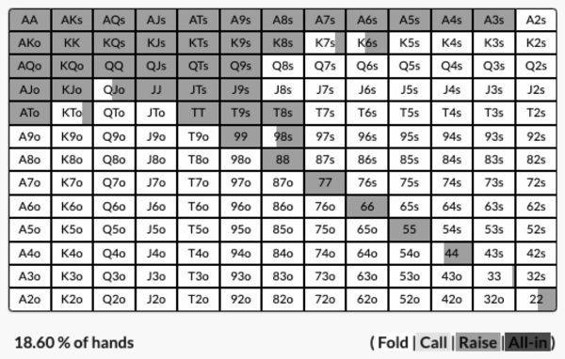

This is the Big Blind response.

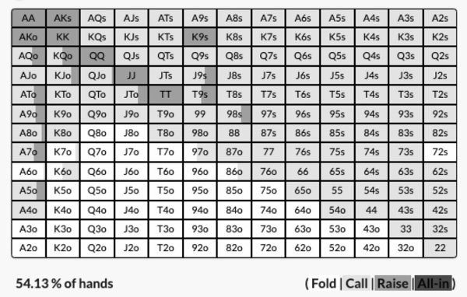

After defending, there is some leading from the Big Blind because they flop some flushes, but 90% of the time they check. When the Big Blind checks, this is what UTG does:

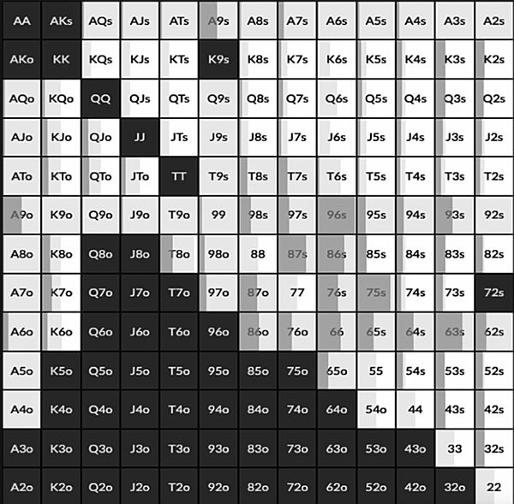



It’s a 50/50 split of bet or check, but the primary bet size is small because this is a static board. Most hands mix their actions close to 50/50. It is essentially like a range bet, but half the time. This is because betting big on a ‘way ahead, way behind’ type of board like this would mean you only get action against very strong hands, but UTG does not have enough value to range bet, so instead the solver uses a mixed strategy with small bets. The reason we mix everything between betting and checking is board coverage. If

instead we always bet certain types of hands and checked other types of hands, observant opponents could exploit us on future cards that don't hit any of our range based on our action on previous streets.

This is what the Big Blind does in response to the small bet:

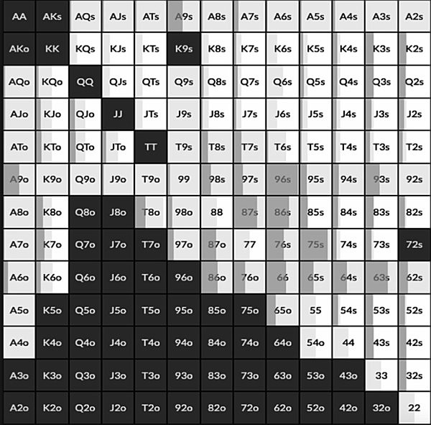

The value raises are two pair, sets and flushes. The bluffs include some offsuit Kings that can make the nut flush, and hands like 64 and 63 that are pretty much worthless but block two pairs and a set. Despite their pair they aren’t really strong enough to call down the whole way, while if they are the best hand right now they benefit strongly from folds. Half the time the Big Blind calls with 9x and Ax mostly, some flushes and King high flush draws.

Let’s now look at how the strategy changes on certain turn cards when the action went check/bet/call. First of all let’s go with the 2♥ which is basically a blank.

The Big Blind checks 100% of the time and this is how UTG responds:

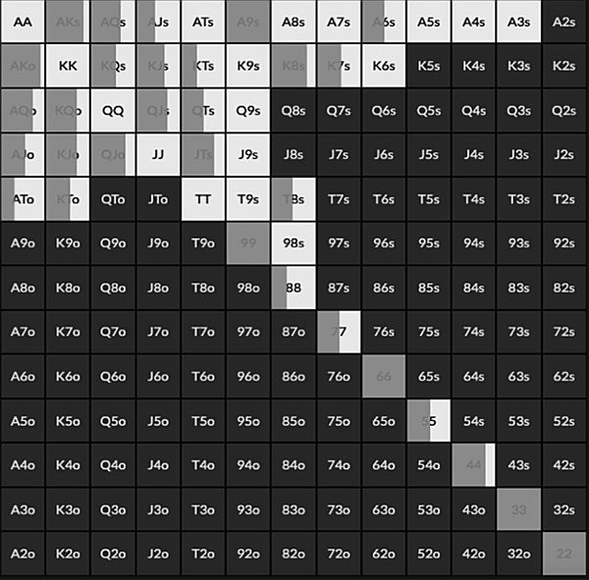



UTG now bets 57% of the time compared to 50% of the time, however two other significant things have changed. One is that there is much less of a mixed strategy, we are now favouring specific hands to bet with compared to the whole range, half the time. We are preferring our stronger Ax, sets and big flushes for value now and our offsuit broadway with a spade for our bluffs. We check back our weaker Ax and 9x, as well as hands like KK-TT.

The other big difference is that when we do bet, we favour a bigger sizing. We bet 67% of pot instead of 25% of pot.

What has happened here is UTG’s betting range has become more polarised, it now contains the best bluffs and the best value, but the middle portion of the range has gone into check down mode. The reason why UTG has become more polarised is because the Big Blind’s range has become stronger. On the flop the range contained a lot of complete misses, so a small bet with the whole range, half the time, was effective. By calling on the flop, the Big Blind will have jettisoned all their complete misses and now at worst have a spade draw or one pair. UTG needs a much stronger range to bet now, but because they have a stronger but smaller range they can bet bigger. If UTG had continued the small bet strategy on the turn with hands like TT or A3s, they would only fold out the few hands they beat and get called by better.

This is how the Big Blind responds to that larger bet:

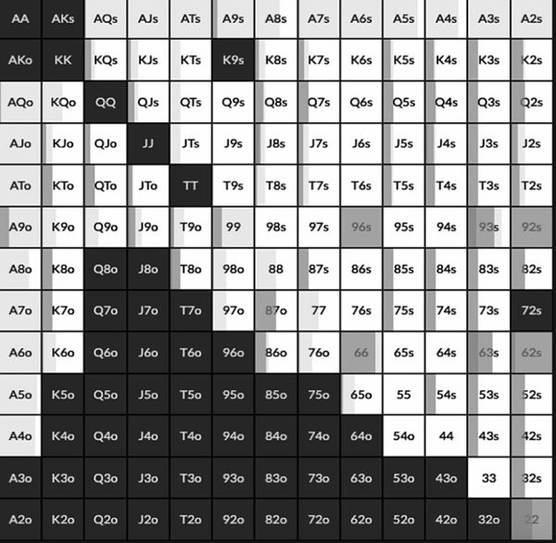



Let’s rewind back to the bet/call on the flop but this time the turn brings a 5 ♠, which obviously completes any spade flush draw.

The Big Blind checks 100% of the time here and this is what UTG does now:

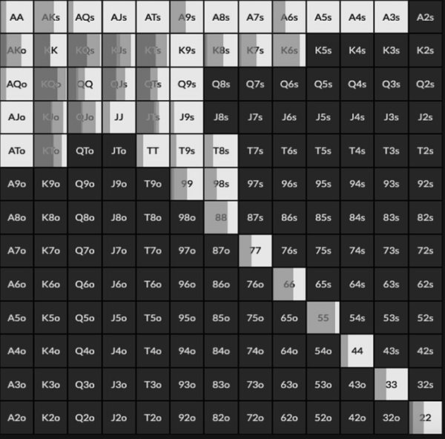



They check half the time like on the flop, but this time have two bet sizes, a small bet range of 25% pot and an overbet range of 100%. The big bets tend to have K♠ for the nuts and the bluffs are hands like QJs/QTs that don’t hit, but do block hands like KQ and KJ that could include K♠. The rest of the betting range uses a small bet because it is the only way to get value on such a static board.

This is how the Big Blind responds to the more common bet of 25% pot:

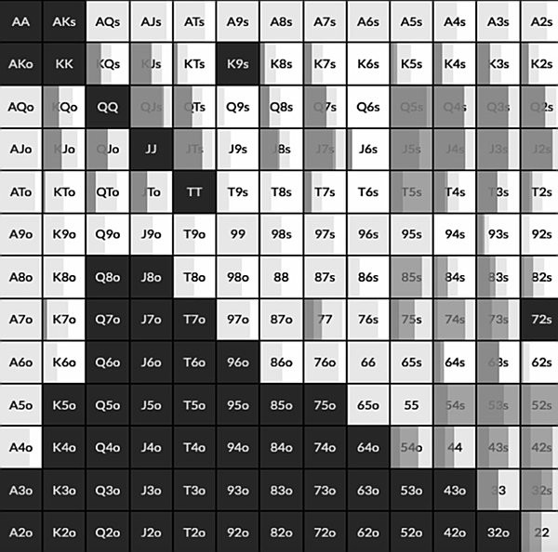

Let’s go back again and change the turn, this time it is the K♠ which also completes the flush.

This time the Big Blind does NOT check 100% of the time, they in fact lead out 20% of the time with this range:

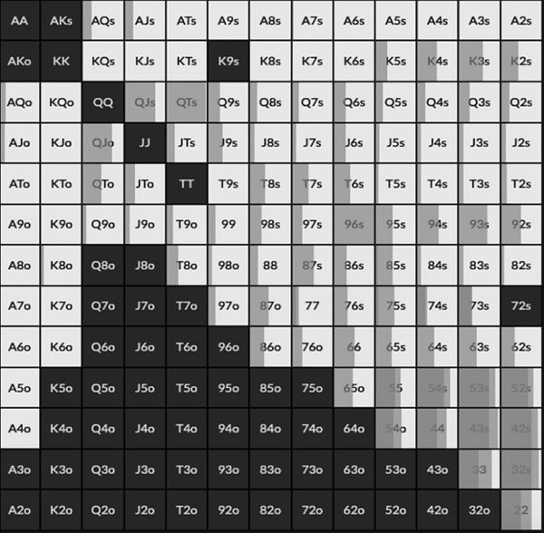



They value bet all their high flushes and some two pairs/sets. Their bluffs are some complete misses like broadway hands without a spade like Q♥J♥.

Why is it that the 5♠ is a pure check for the Big Blind, but the K♠ means they can lead 20% of the time? The reason is that because a lot of UTG’s flush equity was centered around them having the K♠ in their hand with holdings like A♠K♠, Kxs and offsuit Kx. When that card hits, it shifts range advantage around. Now the Big Blind is much more

likely to have the flush, which is why they can lead out. When they bluff with Q♥J♥ it is because they block hands like Q♠J♥ that would now have the nuts.

It’s also interesting to note that when the Big Blind has the Q♠ they check a lot of the time. They check, for example, most of the time with Q♠J♠ and A♦Q♠.

When the Big Blind checks, this is what UTG does:

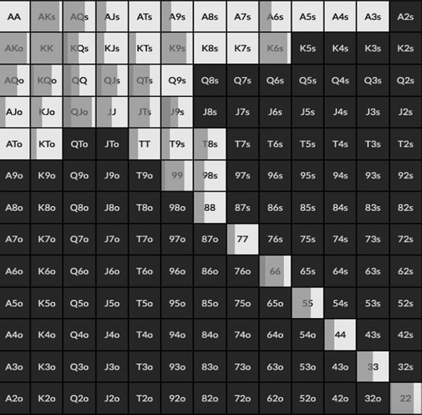

They can no longer bet big because the Big Blind has checked the nuts a decent portion of the time. They still bet for value with their good flushes but it is a mixed strategy for most combinations of hands that include spades in them.

## Paired Flop examples

Let’s use the same ranges as we have been doing but return to that 7♠4♦4♥ flop from the last chapter. The Big Blind checked and you will recall that UTG bets small with their entire range:

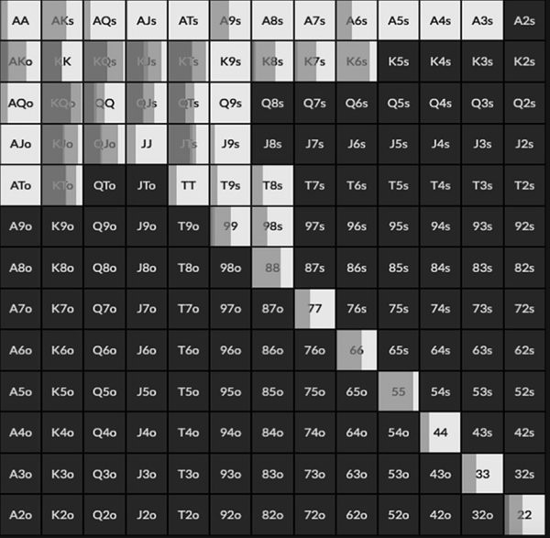



This is what the Big Blind calls with:

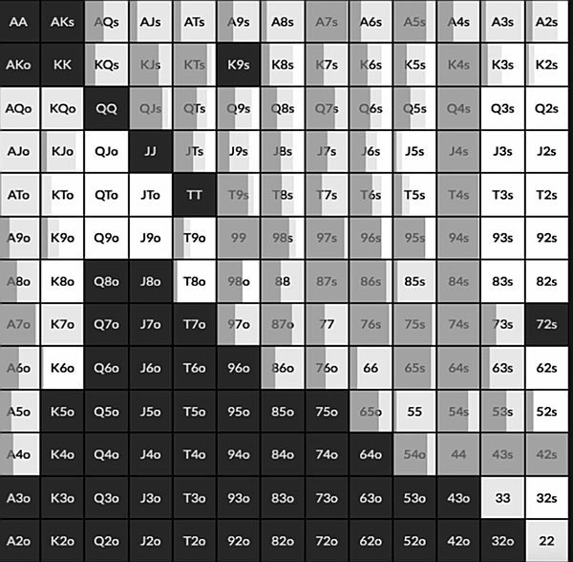

First of all let’s see what happens when the turn is a J♠. The Big Blind always checks and this is what UTG does:

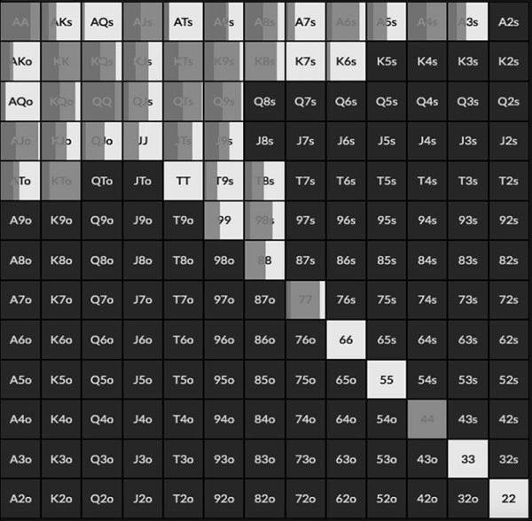



They have gone from betting their entire range on the flop to checking 43% of the time on the turn. The solver prefers an overbet sizing, 100% pot 25% of the time and 67% pot 32% of the time. For practical purposes we can just assume this is a 67% pot bet 57% of the time as in practise it’s difficult to split your betting range, and any EV gains from doing so are marginal at best.

Once again it is no longer a range bet, the medium hands like 99/TT check back now some of the time, they will only be called by better. The big bet range is made up of very strong two pair hands and sets. The bluffs are the draws like 8♠9♠ as well as hands like KTo that block JT/KJ.

UTG moves to a polar strategy and plays his middle hands passively because he has been called by lots of 9x or better hands, as well as plenty of Ax that figures to be ahead some of the time. The Big Blind has dumped all their complete misses so has a much stronger range now.

What happens when the turn is a 5♦?

This time the Big Blind does not check 100% of the time, this is what they do:

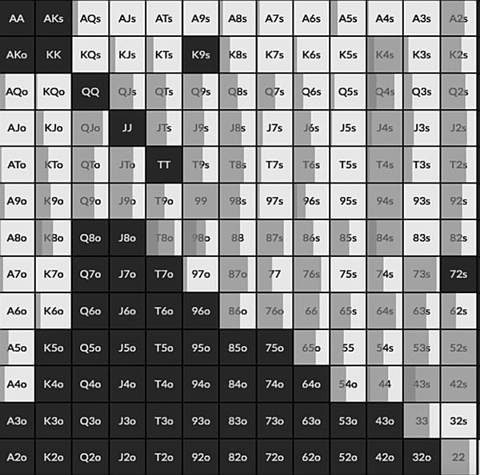



They now lead out 32% of the time. The 5♦ is a really good card for their range, they have most of the straights and more flush draws, as well as 55, 44, 54, 75, 74 etc. They do not quite have range advantage because they still have a lot of misses, but they have a significant nutted advantage meaning they can lead out now.

## Dynamic Flop examples

When your opponent calls a bet on the flop, it tightens their range making a polarised turn strategy the correct one. What about when there is no bet on the flop?

This example is the same 40BB effective ranges as before, but this time we have a 9♠6♥4♦ flop. The Big Blind checks 100% of the time and this is the UTG strategy:

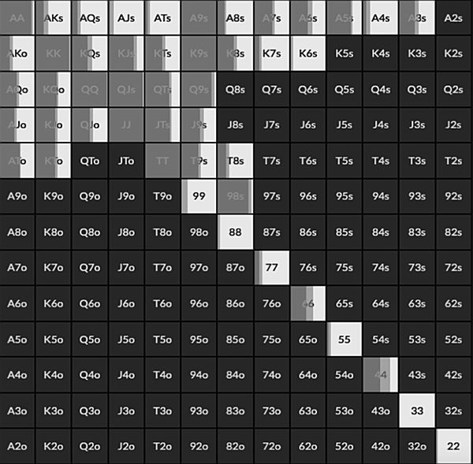



Here UTG has adopted a polarised betting strategy, they check 43% of the time and when they do bet they favour the overbet of 100% pot. This is because, as we saw in the last chapter, this is a very dynamic flop, any high card can change the range advantage and there are some potential draws/backdoor draws out there. It doesn’t hit UTG much so they can bet their whole range, but they do have a lot of overpair type hands that like to bet big here as well as overcard bluffs.

Having said that, UTG checks back with most of their medium pairs and suited Ax type hands. Let’s see what happens when they do.

First of all this is what happens when the turn is a 2♣ , which is pretty much a blank, only 53s gets there for a straight. This is not a 100% check for the Big Blind, far from it:

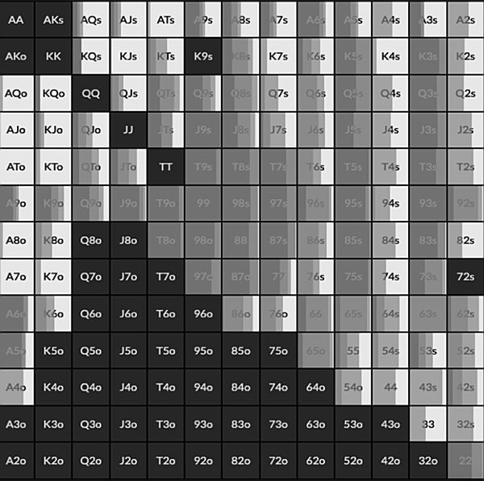



The Big Blind only checks 34% of the time and leads the rest of it. The most favoured lead size is the 100% overbet, which is mostly done with 9x or better, and draw hands.

The Big Blind’s range has not changed, because they checked 100% on the flop. They still have lots of misses as a result, but lots of big hands too, so they adopt a polar betting strategy. With this in mind, why didn’t they do this on the flop?

It is because on the flop they would have been leading into a strong range that included a lot of overpairs. However, by checking back the flop, UTG has weakened their range considerably. Most of their overpairs and 9x would have bet the flop. This means UTG has gone from having a polarised range to a capped range. By checking UTG has discounted most of the big hands from their range, but the Big Blind has not. As such the Big Blind has taken over the range advantage. This is how UTG responds:

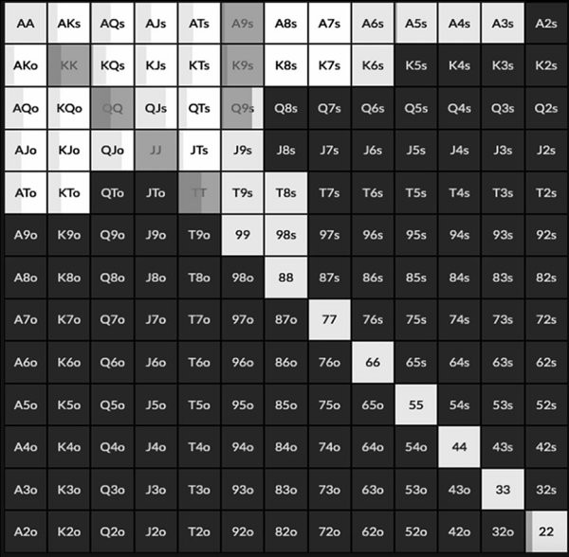



They now have to adopt the passive strategy of calling down with the best bluff catchers and that includes when they have 99/66/44/22 for a set. This is to protect the rest of their range.

That was on a relative blank of a turn card, what about when the turn is a 7♣ which is a much better card for the Big Blind? Two straights get there and more combinations of two pair, as well as more draws that hit the defender.

This is what the Big Blind does:

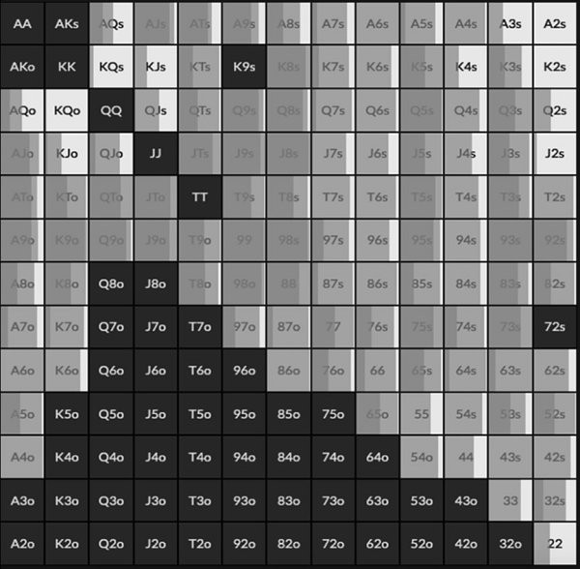



Now the Big Blind bets 83% of the time, with both a big bet and small bet range. They have such a big range advantage that they can almost bet their whole range, but they also have a significant nutted advantage meaning they want to bet big with some hands.

In this hand we have the double whammy. UTG has capped their range by checking back while the turn card has strengthened the Big Blind’s range. As such they can be very aggressive on the turn.

This is how UTG responds to a small bet:



They still play passively because they are at a range disadvantage, but there's some reraising here because UTG does have a small amount of straights and sets that want to raise now on a dynamic board.

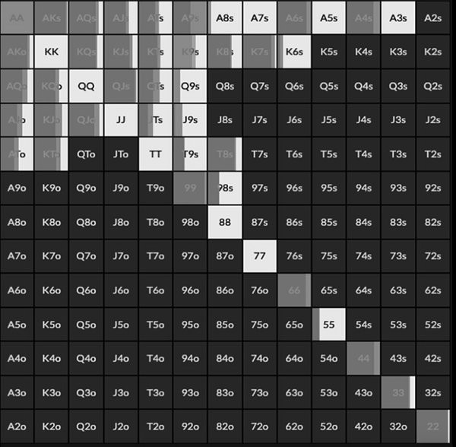What happens when UTG checks back but gets a favourable card for them, like the A♦? Now the Big Blind checks 100% of the time and this is what UTG does:



They still have to check 40% of the time, because they still have a weakened range compared to on the flop. When they bet they adopt a polarised betting strategy of 100% pot. They do this with their Ax hands, sets and the bluffs are broadway hands that

missed that include diamonds. UTG still checks back with hands like 88 and 77 which will only be called if they are beaten.

This is how the Big Blind responds to the big bet:

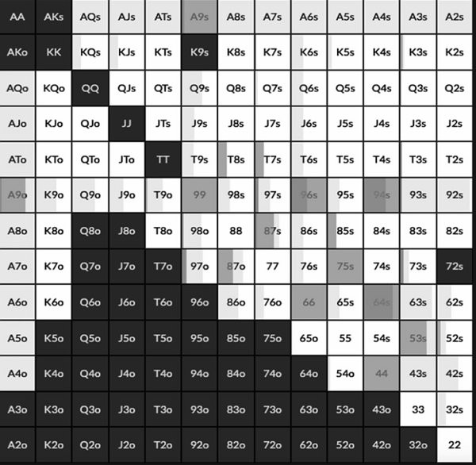

Now they mostly fold because their range is still very wide with lots of junk in it.

If you looked at the flop chapter and saw that the player with the stronger range preflop can usually continue to be the aggressor on the flop, you might be forgiven for assuming this continues on the turn. This is actually a leak that players got away with in the early days of online poker, they would simply pot every street and that worked fine because bad players did not like aggression. That doesn’t work in the modern game. On the turn, ranges change. Whether it is because they have volunteered money to stay in the pot or because they haven’t. They change when it goes bet/call or bet/raise/call because it is more likely both players have a strong hand, so a polarised betting strategy is appropriate. They also change when it goes check/check because that caps the in position player’s range, meaning that often the out of position player can take the initiative in betting while the in position player has to adopt a bluff catching strategy.

The turn card itself changes the strategy too. It is a very useful habit to get into to always ask yourself if a card is good or bad for your range, or your opponent’s range. Even if the card itself gives you a very strong hand, if it is bad for your overall range you might need to protect your range by trapping with it.

## Overbets

The turn is the point in the hand where the overbet first comes into play most of the time, so this is where we are going to discuss it for all three streets, with the most emphasis on the turn.

The overbet is one of the more common moves in GTO where good players struggle to know when to incorporate them. One thing in particular people struggle with is understanding that the bigger your overbet, the more you can bluff, not less. If you make a 2/3rds pot bet on the river you need to be value betting 72% of the time and bluffing 28% of the time to avoid being exploited. If you make a pot sized bet the ratio goes to 67% value and 33% bluff. When you bet 200% the size of the pot, you now need 60% of your range to be value and 40% to be bluffs.

Overbets are best employed when you have a polarised range, where you either have a nutted hand or nothing.

I have three big criteria for deciding whether to overbet or not.

*Do you have nutted advantage?*

Do not overbet if you have a capped range, you need nutted hands in your range to make a big bet. If you don't, your overbet bluffs should not work often enough (unless of course you’re playing a very weak opponent who overfolds to them). This doesn’t mean you need range advantage, if you have enough nutted hands in an otherwise weak range you can overbet. You can also overbet when a bad card for your range comes if it promotes a small portion of it to nutted.

## Stack To Pot Ratio

You want to get as much money in the pot when you have range advantage and sometimes that might mean having to overbet. If you get a good flop, turn and river you want to bet, bet, shove to get all your money in the middle of the table.

When stack-to-pot ratio is low (2-3) you won’t need to overbet, it will be easy to set up a pot sized bet (or smaller) by the river you get all the chips in. If you are much deeper, at some point in the hand you are going to have to overbet one of the streets if you want to get all the money in.

When SPR is low, 2-3, you don’t need to overbet, you just go bet bet shove.

## The Street Itself

There are more overbets on the river than the turn, and more overbets on the turn than the flop. This is because you are typically more polarised on the river than the turn, and more polarised on the turn than the flop. Every action, whether it is check/bet/call removes some hands from yours and your opponent’s range, meaning the hand values get more static as the streets progress.

On the river the nuts will always be the nuts, on the flop the nuts is usually just the nuts right now. On the river an overbet is based purely on hand strength for value and blockers for bluffs. On the turn we will overbet the nutty hands and our strongest draws, because they turn into river value bets more often than weak draws.

The classic turn in position overbet comes after a very dry favourable flop for the preflop aggressor when they make a small bet on the flop and the Villain check/calls. In this spot the in position player still has all the nutted hands but the out of position is much less likely to have them. When the turn is a brick for Villain’s range, it is a good spot for an overbet because the bluffs will work more often.

The classic out of position overbet situation is when you defend a raise and get a favourable dynamic flop for your defending range, then the flop goes check check. This is a good spot for an overbet, because the in position player would have likely bet a dynamic flop with their nutted hands. The out of position player, however, could have been setting up a flop check/raise so they will have nutted advantage. A good in position player will protect their range by checking back big hands sometimes, but either way the range advantage has shifted. This is a great spot to overbet the turn out of position.

There are times to overbet the flop but we don’t do it as much because our good draws have so much equity it would suck having to give them up to a reraise. We have much less equity with draws by the turn so that makes it a good time to overbet.

## In Position Overbets

In this hand the stacks are 60BB effective and UTG opens with this range:

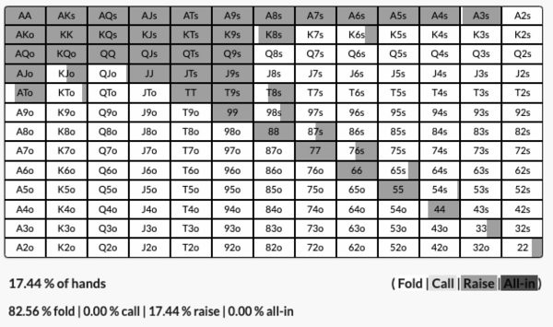

And the Big Blind responds with this range:

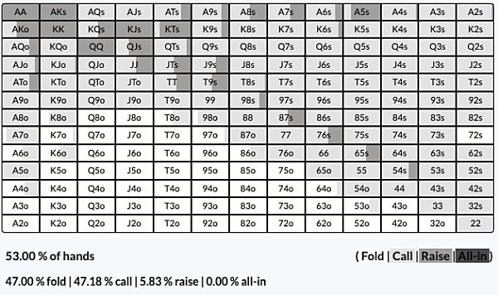

The Big Blind calls.

The flop is K♠7♥2♦.

The Big Blind checks 100% of the time and this is what UTG does on the flop:

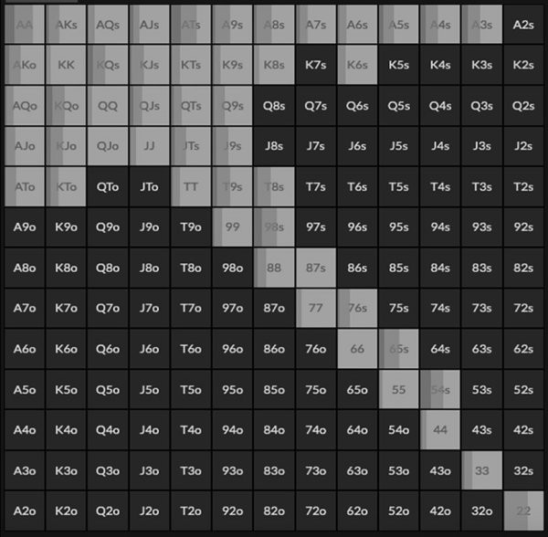

As you can see there is already some overbetting here with the nutted part of the range, because this is a very dry static flop. It’s hard to hit this flop and there are no immediate draws, so a polar betting strategy with a small portion of the range can overbet to 67%

or 100% here. Top pair and 22 overbet for value and double backdoor hands like A♠T♠ and 9♠8♠ are the overbet bluffs.

The primary flop bet, however, is the small 25% pot bet which is used 70% of the time. This is the classic range bet with the whole range, because UTG has significant range advantage. This is how the Big Blind responds:

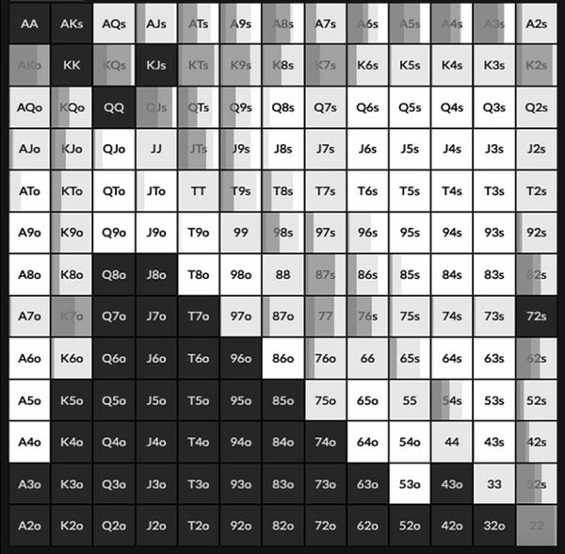

They do have some check/raises with the nutted part of the range but most of the hands here just miss completely and almost half the range folds to the small bet. It is mostly flopped pairs that call here and some Ax.

When we make the turn a 3♣, which is mostly a blank, the Big Blind pretty much checks 100% of the time after calling the flop. This is what UTG does:

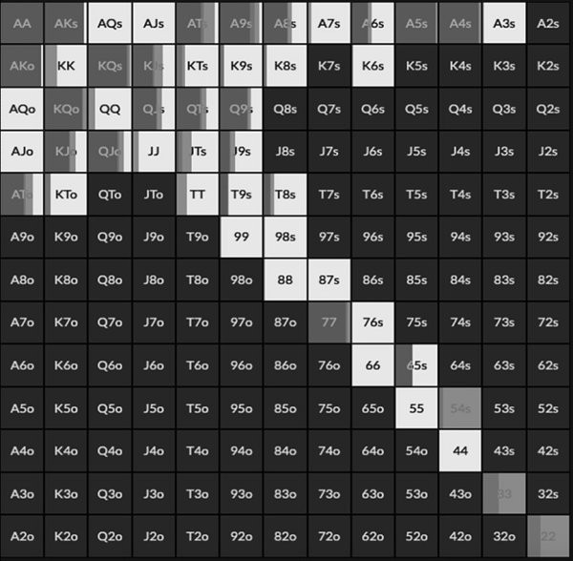

The first thing to note is that they go from betting range on the flop to checking 64% of the time on the turn when called. This is what we have just discussed about range advantage shifting when it goes bet/call in favour of the defender. The Big Blind has mucked all their junk and now almost certainly can beat a bluff, so now hands like QQ downwards, Ax and some of the Kx become check backs. If they bet, they will only be called by better hands and will fold out all the hands they beat.

However, just because the Big Blind’s range has got stronger, it does not mean UTG has to shut down completely, far from it. The primary betting range has now become a massive overbetting range. 27% of the time UTG bets 200% pot on the turn.

The value bets are sets and the better Kx hands. As you can see, because of the large bet size UTG has a lot of bluffs. With a 200% pot size you need 60% value and 40% bluffs, so you can bet much more than you would a typical 2/3rds type bet. They bluff with Ax including A4s/A5s all the time because it can make a wheel. The other bluffs are hands like AT/QT/QJ/A9/T9 mostly because they block the Big Blind having hands like KQ/KJ/KT/K9.

This is the Big Blind response to the overbet:

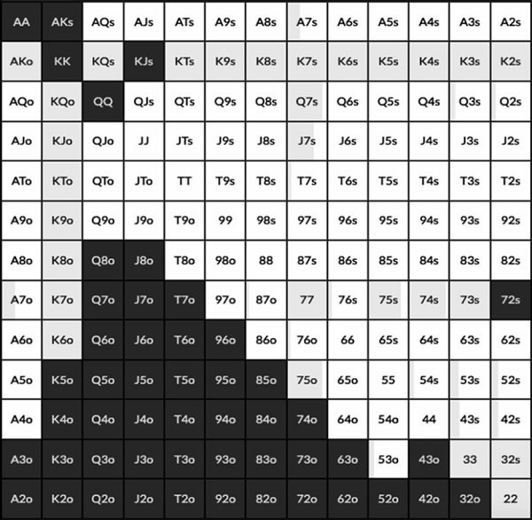



They call all the Kx and then one pair hands that also block a value hand. Hands like Q7 and J7 are good bluff catchers because as we know, UTG is not betting middle hands like TT, so the pair of sevens beats any bluff. These hands also block hands like KQ and KJ, which will make the bluff catch better than breakeven. The Big Blind folds much stronger hands like TT-88 because they are effectively the same hand as Q7, without the good blockers.

There is also no raising from the Big Blind which is an important adjustment you need to know against overbets. Because the betting range is so polarised, raising would only fold out bluffs and keep in very strong hands, so bluff catching with hands is the correct strategy to employ.

Let’s jump into another example, this time the 7 ♠ 4 ♥ 4 ♦ paired board we looked at earlier. This time the stacks are 60BB effective and the ranges are the same as the last example.

On this board the Big Blind always checks and UTG bets 100% of the time, using a 25% pot bet size. We have discussed this already, on such a hard to hit flop, the stronger preflop range has range advantage. When they bet, this is how Big Blind responds:

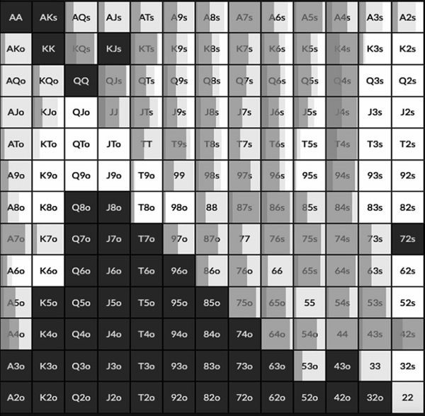



Lots of raising with overpairs, 7x, 4x, boats and overcards that have double backdoor draws. The complete misses get thrown away and Ax and one pair hands mostly get called. However, some overpairs or better get kept back to protect the range.

When the Big Blind does call and the turn is a 2♣ , the Big Blind checks 100% of the time again, and this is how UTG responds:

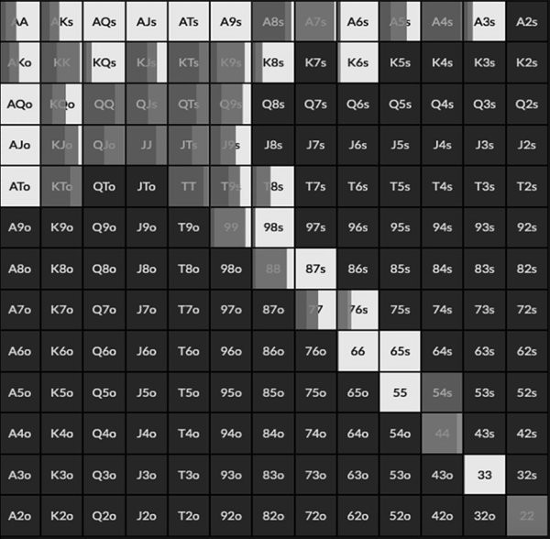



Again, UTG can no longer range bet because the Big Blind has jettisoned all their junk hands. Hands like 66/55 and Ax make bad bets now because they only get called by better, so UTG checks 50% of the time.

Once again though, when UTG does bet, it is an overbet. 25% of the time they bet 100% pot and 25% of the time they bet 200% pot. It is a mix for each bet size, but the value overbets are overpairs, boats and quads. The bluffs are mostly KJs-T9s broadway type

hands because they block the suited 7x hands that would call like Q7s and T7s. Again, look at how many bluffs we have here, it is a lot of hands, almost all our misses with no showdown value.

When UTG does bet 200%, this is how the Big Blind responds:

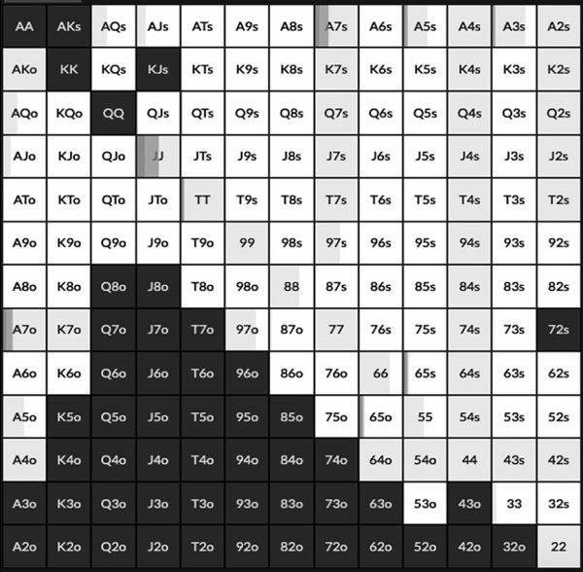

Again the adjustment is to adopt a pure bluff catching strategy. There isn’t much of a blocker based approach here because it is such a dry board that it’s hard to have a hand here to block. Instead we see hands like A3s and A5o favoured instead of a hand like 55 and 33. This is because A5 and A3 beat complete bluffs just like 55 and 33 do, but they also have a gutshot which is worth more and they also block AA.

Going back to the two overbet sizes of 100% and 200%, you will often see spots where two overbets are used, so it’s worth briefly explaining when to go with the larger of the two. The bigger the bet, the stronger our opponent’s hand has to be to call. If a 200% bet can only be called by the nuts or second nuts, we should only bet the nuts for value and bluff with a nut blocker. A 100% bet, however, might get called by middle pair with a good blocker, meaning we can overbet top pair for value. How many bluffs we have is also a limiting factor, if we cannot find enough good bluffs to balance the range we might have to use a smaller size.

Finally, the stack-to-pot ratio is a factor. The deeper the stacks, the more we will have to overbet because we do not want to leave money on the table. If the effective stacks are 40BBs preflop it is easy to set up a pot sized bet or smaller by the river, but if the stacks are 200BBs we need to take some more creative lines to get stacks in by the final street.

The big takeaways before we move on is that we can bluff a lot more when we overbet and the correct strategy to counter them is to bluffcatch with good hands. The correct situation for overbetting in position on the turn is when you get a favourable dry static flop and have a small bet called. You will be facing a much stronger range on the turn, meaning you should check back all your medium strength hands, but can now adopt a polarised overbetting strategy with your biggest hands and best bluffs.

## Out of position overbets

If dry boards favour in position players with range advantage, let’s see what happens when the out of position player flops a dynamic favourable board. The stacks and ranges are the same as above, 60 big blinds effective. This time the flop is a very wet 8♠7♥4♥.

This flop gives the Big Blind a lot of nutted hands but also a lot of misses, as such they still check 100% of the time. This is how UTG responds:

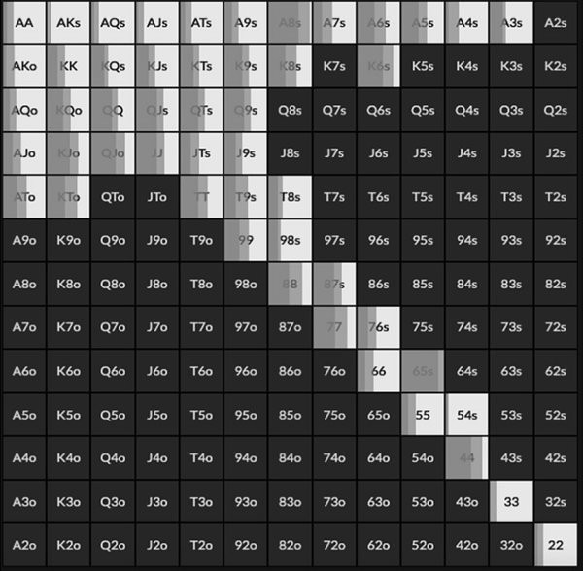



They check back more than half the time because this board hits the Big Blind a lot. It’s a dynamic board meaning that when they do bet, they mostly use the bigger 67% pot bet, especially with hands like QQ-99 that benefit from protection and 56s which is the nuts but also benefits from protection because of the flush draw, the same goes for sets. They check back with the good Ax hands and a mix of the overcards, plus the worse pocket pairs.

When they do check back and we make the turn the 2♣ , which is mostly a blank, this is how the Big Blind responds:

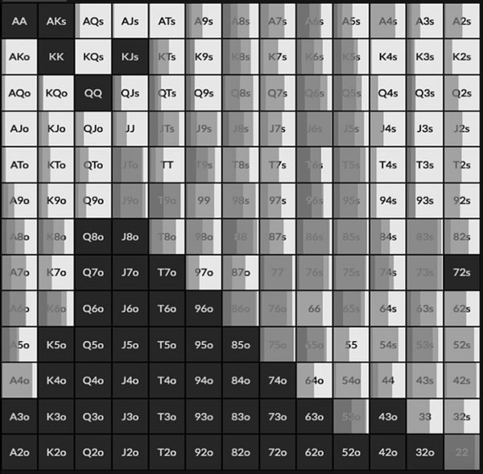

More than half the time they lead out, which should not surprise you by now. The Big Blind has a lot of nutted hands here and because they check flop 100% of the time they have not removed any hands from their range. UTG, however, has removed a lot of big

hands that always bet for value/protection from their range, so range advantage has shifted considerably in the Big Blind’s favour.

10% of the time the Big Blind favours an overbet of 100% pot. They do so with sets, straights and the better top pair hands. There are a lot of bluffs, the beauty of being able to bluff more with the overbet is you can really pick the best bluffs. Hands like 96s, T9s and JTs which can hit straights, flushes and OK top pair type hands.

What about if we make the turn a ‘wetter’ card, like the 5♣?

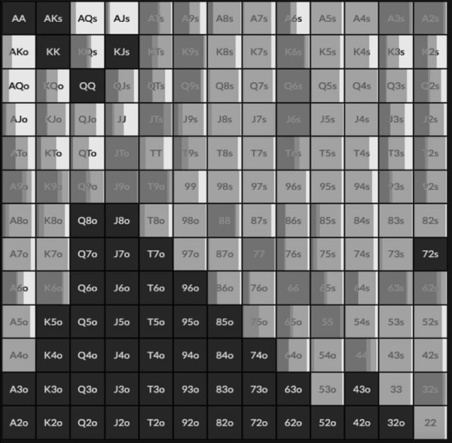



Now the Big Blind bets 85% of the time, they have tremendous range advantage. The favoured bet is 25% pot, which is essentially a range bet because they are at such an advantage. There is, however, a sizeable overbetting range too, 30% of hands bet 100% pot. All the sets overbet as do the straights. The bluffs are mostly based around 9x hands because they can make big straights by the river and also block the nut straight.

In response to the overbet:

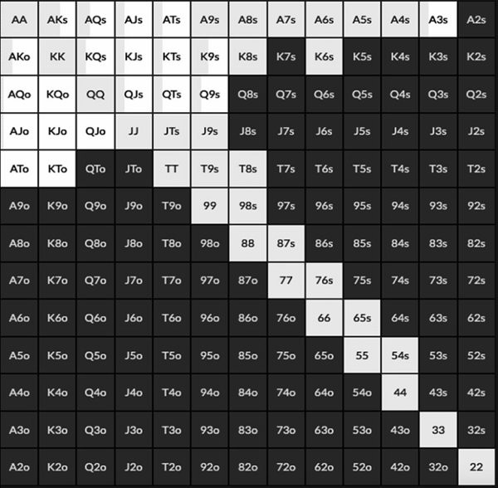



UTG has to call almost half the time, they cannot raise because they are up against a polarised range. They have to call with so much of their range that unpaired hands like J9s and JTs are calls here because they are good draws and actually beat some of the bluffs like T9 and J6s.

What about when we pick an even wetter turn card, instead of the 5♣ we make it the 5 ♥? Now not only is there a straight already out there but also a flush/straight flush. This is what the Big Blind does:

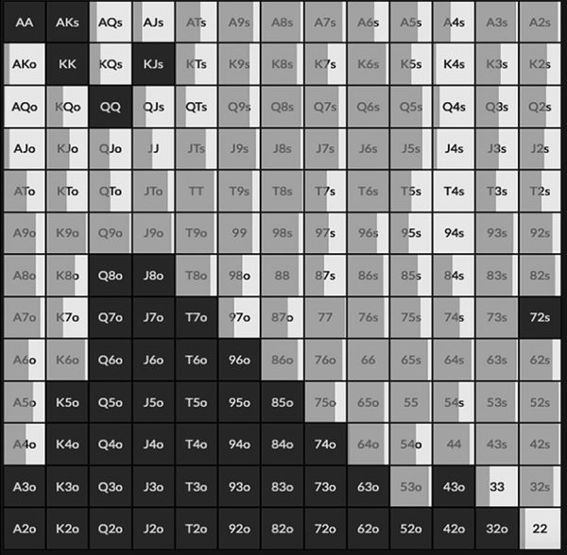



You probably assumed that such a wet card would yield an even bigger overbet, but that is not the case. The Big Blind bets more, but they bet small.

This is close to a range bet situation, the Big Blind no longer has a polarised range, they have significant range advantage. The board is also a lot more static than many would assume, like we explored in the previous chapter - at this point the best hand now is likely to be the best hand on the river too. We picked this hand as a reminder that the

conditions for a turn overbet are a polarised range, you have a very strong hand or a miss. The Big Blind has too many big hands now and an overbet is not going to get called enough to justify it, much better to make a small bet that will get called.

## Heuristics For Real Life

*Was the turn card good for me or my opponent?*

Hopefully the first big adjustment you will make after reading this chapter is you don’t mindlessly barrel the turn for the same bet size when you get called on the flop, unless you have a strong read on your opponent.

The most useful habit to adopt on the turn is to look at the card that has been dealt and ask yourself if that is a better card for you or your opponent. If it is good for you, this might be worth firing a big bet even if you don’t have a great hand. If it is a bad card for you, you have to be prepared to check back or adopt a more polarised strategy.

*Range advantage shifts on the turn*

Broadly speaking when the out of position player check/calls a bet, their range becomes stronger and you can assume they have folded all their junk. You, therefore, should not bet your medium strength hands on the turn, but instead adopt a polar strategy of betting big with the best hands and the best bluffs, checking back the rest.

When they check/raise their range becomes polarised, they have a big hand or are bluffing. The correct response is to playing against a polar strategy is to bluff catch. You keep in all their bluffs and lose the minimum when you are behind.

When the flop goes check/check the in position player has capped their range. Other than some big hands checked back for protection, they won’t have much value. On favourable boards for their range, the out of position player should take the betting initiative and the in position player has to play a bluff catching strategy.

**Overbetting the turn**

The best time to overbet the turn as the in position player is on dry static boards when the out of position player has check/called a range bet. The out of position player has strengthened their range but the in position player has nutted advantage, so they can overbet their monsters/best bluffs and check back the middle portion of their range.

The best time to overbet the turn as the out of position player is on a wet dynamic board that favours their range when the in position player has checked back the flop. They have usually weakened their range by checking back meaning the out of position player can take the betting initiative.

The only way to deal with turn overbets is to bluff catch with the best hands. Raising would only fold out the bluffs.

*Playing against recreationals on the turn*

Finally, all of the above refers to the best theoretical approach to playing the turn, but how should we play against weaker players who are not playing anything close to GTO. The answer as always is to identify their leaks and then exploit them. Some very common player types you’ll run into, particularly live:

**The betting station:** these players love betting and they’ll keep doing it til they get raised. The exploit is simple therefore: don’t donk into them and don’t raise them with your value hands before the river, but raise more often as a bluff or semi bluff.

**Players who don’t check raise enough with their value:** the trappers. These players have stronger check call ranges than they are supposed to have, so don’t value bet as thinly or bluff as much as you would against more balanced players. Many of these types in particular adhere to the old stratagem “if you call the turn you must call the river” (which is terrible poker), so if they do call the turn don’t try to bluff them on the river. On the other hand, bluffing strong draws on the turn to a big size can be good as apart from getting more folds from the weaker part of their value range (they will be less inclined to hang on with weak one paired hands that they don’t want to call a river

bet with), you also have more implied odds because if you do hit the river, they’re calling again.

**Players who don’t check call enough strong hands:** these guys hate getting sucked out on and are overly obsessed with protection, so they tend to check raise all of their strongest hands on the flop and/or turn. My friend Niall Farrell refers to this as the “American theorem” because it’s particularly prevalent among live American players. This means when you get to the river and they haven’t check raised yet, their range is very capped (unless they’ve hit an unlikely set or two pair or a more likely draw) so you can profitably shove as a bluff knowing they have few if any hands that can call. Conversely, if you are betting for value, you may want to go smaller, using the largest size you think most or all of their condensed range will call.

# CHAPTER 10: PREFLOP

Now that you understand more about the flop, turn and river you probably have a greater sense of what makes a good preflop range. A lot of modern players start learning poker from a preflop first perspective and somewhat blindly follow preflop charts that have been approved by a coach. This is good from the perspective of tightening up hand selection but doesn’t provide much of a blueprint on how those hands should be played down the streets. Preflop is much easier to understand when you know the kinds of situations you want to be in from the flop onwards.

For example, you want board and runout coverage. You do not want to be in the situation where it is not possible for you to have a strong hand on a 3♣ 3♦5♠ flop, so at a minimum you add the suited wheel Aces to your range. You know that double backdoor hands potentially set up profitable turn bluffs and strong river value bets, so you might put more suited gapper hands in your defending range at the expense of small pairs and offsuit Ax. In deep stack pots you are now aware that you need a very strong hand to stack off post flop, so you muck hands like ATo and KJo from your early position 100 big blind opening range because they will only get you in trouble.

GTO preflop ranges are constructed by solvers in a trial and error fashion. The user starts with a range that is likely quite good, then the solvers literally run thousands of simulations on every possible flop type, weighting the more common boards over less common boards (there are more combinations of A72 rainbow flops than 444 flops, for example), then looking at which hands do not make back the required EV to justify being in the range. It is a long and rigorous process that is far from perfect, because every scenario has to be accounted for. When a player opens under-the-gun there are near infinite possibilities for what can happen before a flop is reached, from everybody folding except the big blind, to everybody calling with a few reraises thrown in. For this reason preflop ranges are still constructed with lots of broad assumptions and simplifications, they are far from perfect ranges and do not be surprised if ranges that claim to be GTO today become outdated as the solvers improve.

The factors that influence your preflop ranges are stack depth, position, pot size and the tendencies of the players at your table. This is a GTO book so we are starting from an

assumption that the players at your table all play perfectly, but we will mention some exploits along the way.

The key consideration where position is concerned is how likely is it that the players left to act will wake up with something. UTG always opens tighter because they have a whole table to get through. The Button can always open much wider because they only have two players left to act and they are guaranteed to act last on every street. The Small Blind tends to play tight and aggressive, because they are at the biggest positional disadvantage so they want to decrease the stack-to-pot ratio to make position less of an issue. The Big Blind will tend to play more passive and call wide because they get to close the action and see flops for an enticing price.

Stack depth probably produces the most variation in how we play pre and post flop, it is all about stack-to-pot ratio. When stacks are shallow we are happy to get our money in the middle with relatively weak holdings. You will see more preflop shoves at shallow stack depths and more stacking off with one pair post flop. As such the ranges tends to be weighted towards hands with good raw equity, high cards and pairs essentially.

When stacks are deep, you need a much stronger hand to stack off with. You will see very little 4-betting, but you will see more 3-betting to build the pot. The ranges are much more weighted towards hands that can make very strong hands after the flop and cover the board. Expect to see more small pairs, suited connectors and very strong premium hands. ‘Raw equity’ hands (strong hands that are hard to play postflop, like A6o) go in the muck.

At medium stack depths you sometimes see the widest ranges. This is where stacking off with one pair hands is still usually not terrible but you have enough maneuverability to play across three streets, so suited high card hands, hands with double backdoors and Ax hands go up in value. A lot of hands realise equity the best at the 30-60 big blind mark and it is important to study this stack depth if you play MTTs as this is usually the average stack size you will play most of the time.

Pot size also plays a big role in the ranges we play preflop, most notably whether the pot has antes or not. Despite what some think, a 100 big blind cash game range is not the same as a 100 big blind MTT range. Antes widen ranges because there is more money in the middle to play for. As such you can open wider and defend much wider in MTTs than in cash games, all other things being equal. Cash game rake is also a factor in preflop ranges and we will explore that further in the next chapter.

Preflop is probably the street you know the best already and we deliberated over whether to cover it from first principles and cover every position at every stack depth in every situation. As mentioned already, the landscape of poker is one of ‘preflop charts’ where most regulars follow a prescribed preflop strategy in a ‘cookie cutter’ fashion, without necessarily knowing the why behind their actions.

We don’t want to do that here, instead what follows is some broadly selected preflop ranges and the responses to them. We will explain the why behind the range, then compare them to other ranges and explain why the differences exist. It is much more valuable to know why a 20 big blind Button opening range might include some limps but the 60 big blind Button opening range does not, than it is to simply list all of them here.

There is already a wealth of preflop charts available in poker and you probably have access to your own. These ranges are GTO approved ranges from our friends at RangeTrainerPro.com which we highly recommend as a starting point. Rather than construct your own preflop ranges from scratch we suggest you use GTO preflop charts as a baseline and use the lessons that follow in this analysis to help you understand what factors should widen or tighten a range, what hands work best for different actions and when to throw out the rule book entirely.

## UTG Opening Ranges

Let’s start by looking at the same position, but vary the effective stack depths. These are tournament ranges, so they account for antes. All these ranges are an early position raise first in, they are all GTO ranges, first up is the 10 big blind range:

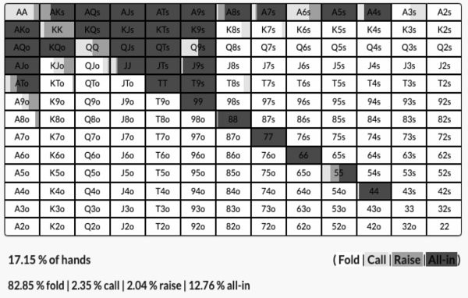

You are probably not surprised to see the vast majority of hands are shoves. At 10 big blinds shoving is very profitable with antes. If there are 2.5 big blinds out there already you can add 25% to your stack in a relatively effective low variance way, as you can expect plenty of folds. Also raising and folding is costly, do that and you lose 20% of your stack.

There are opens, because even at this depth we have some hands that are so strong we prefer to induce a reraise rather than simply take down the blinds. We therefore open the strongest hands AA-JJ (note that even a hand as strong as AKo prefers to simply take down the blinds and even hands like AKs and JJ mostly shove). We need to balance, however, otherwise we will never get shoved on, so we open with our worst Ax (which blocks hands that will reraise us and don’t mind raise folding) and 55.

We also limp some hands. It goes against conventional poker wisdom where most players consider limping to be something we do at deep stack depths with speculative hands. We limp at shallow stack depths because it allows us to play more hands. It is less profitable to shove over a limp than an open (the pot would be 3.5 big blinds rather than 4.5 big blinds) and less costly to limp/fold. The primary limp is AA as a trap, as well as some KK-QQ, we want to get action with Aces and we do not want folds, if we allow the Big Blind to flop an unlikely two pair as a result, so be it. To balance this

limp trap we also limp hands like A3s/Q9s/T8s. This array of different limps gives us some semblance of board coverage too in case we have to play postflop. Notice that both the open and limp ranges are polar: they contain the strongest hands in our range hoping to induce action, and the weakest that sacrifice the least if they have to fold to a preflop raise.

To balance our opens we mostly raise/fold or limp/fold hands like A9o and KJo, these are hands that block the likely Ax/Kx type hands our opponents most likely shove with. The limp balances are a little different, they are still high card heavy but they can flop straights and flushes. When we open with the bottom of our range we want to take the pot down, so the best hand to do that with are offsuit blocker hands. When we limp the bottom of our range, we want to flop well, so hands like Q9s achieve that.

Despite the limp/open range being such a narrow range, it surprisingly has a smidgen of board coverage, in that combined every class of hand is covered other than the 2. Board coverage really doesn’t matter that much at 10BBs because we are basically going with most flopped pairs, but it is interesting to note that even at such a limited range in terms of playability we are covered for almost any runout.

Hands like Q9s are particularly useful when endeavoring to achieve board coverage this shallow. Not only do they provide us with hands that can stack off on boards with a Q or a 9, but they can flop flushes, flush draws or backdoor flush draws, and straight draws on boards with a J or a T that could potentially provide good bluffs to balance our AA type hands.

Let’s compare that range to the same position but with 20 big blinds:

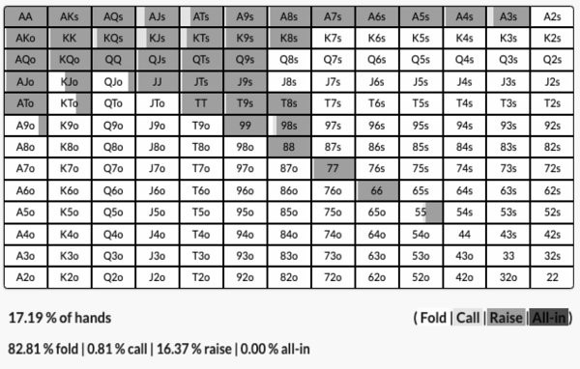

Almost exactly the same amount of hands and essentially the same range of hands, but this time almost all the hands are opens and very few limps. We have got rid of A8o and 44, and replaced it with K8s, T8s and T9s. A8o and 44 work well as shoves but do not flop so well, but with a 20 big blind stack we are going to see more flops, so we need more robust hands that can win a few ways.

Notice this time that AA-QQ are never really limps. This is because with 20 big blind stacks we want to build a pot with these hands. It is pretty easy to get 10 big blinds in the middle by the river with AA but not so much at 20 big blinds, so we want to build the pot right away rather than giving our opponent rope.

The limps this time are mostly suited high cards - AJs/ATs/KQs/KJs/A3s, hands that flop well and block reshoves. 0.81% of the hands are limps and their purpose is just to allow us to play a few more hands. Practically speaking, shaving the bottom of your range off and just opening the entire range is not going to lose you significant EV, so it’s perfectly fine to simplify your strategy in this way.

Let’s jump ahead to 60 big blinds, this is the new range for early position:

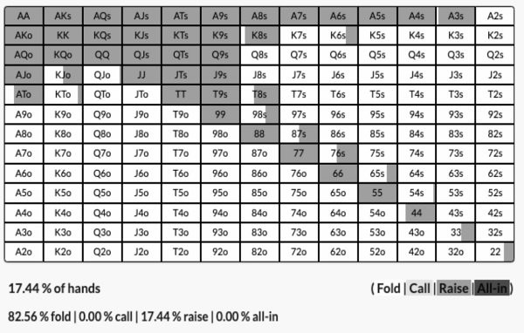

Once again it is roughly the same percentage of hands, around 17%, but the shape of the range is changing. There are no limps now because with 60 big blinds we want to build the pot from the get go. We are removing or playing hands like A9o/ATo/KTo/KJo less of the time and replacing them with more speculative hands like 87s/76s/65s and 33/22 some of the time.

We include hands like 76s and 33 because of their implied odds and board coverage. These holdings can make very big hands and they also protect us on lower connected boards. If we are going to get 60 big blinds in the middle of the table we need two pair/sets/straights/flushes across any potential runout.

We remove hands like A9o and KTo for the same reason. These hands have reverse implied odds. If we hit top pair with any of these hands we hate it when we get 60 big blinds in the middle of the table because we are usually outkicked or up against a bigger pair. A hand like KTo works great as a bluff at shallow stack depths because taking down the pot preflop is really profitable and thus having two good blockers makes doing so more likely. It’s harder to get folds with this hand at 60 big blinds, less of a win when we do in terms in % increase to our stack, and it tends to get you into trouble post flop.

Now let’s look at 100 big blinds:

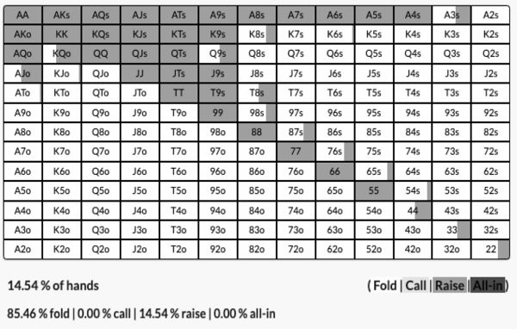

Very similar to 60 big blinds with one notable difference. The shape of the range is about the same but in general it has gotten much tighter. In this example we can play 14.54% of hands instead of 17.44%. No hands have really been added, but even more offsuit Ax and Kx have been removed.

This goes against another conventional wisdom in poker which is that you can play more hands preflop at deep stack depths. In reality you need a much stronger hand that can flop very well at 100 big blinds compared to 20 big blinds, because you want to be confident you have the best of it. It is much easier to stack off with top pair on a nine high flop with 20 big blinds because the stack-to-pot ratio is low. You will get called by much worse at shallow stack depths and it would be a mistake to fold, but at 100 big blinds you want a very big hand to get it all-in after the flop.

One last thing to note, a lot of players assume that at 100 big blinds in an MTT you are essentially playing a cash game. They think that a 100 big blind range in a tournament is the same as a 100 big blind range in a cash game. Let’s test that theory, this is a GTO opening range for the same position in a cash game:

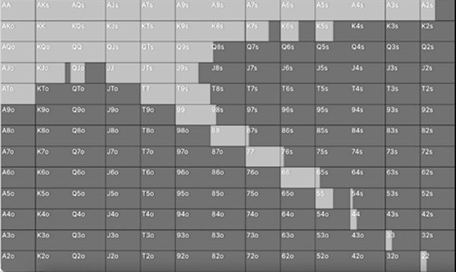

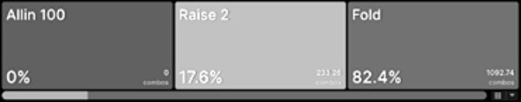

It is virtually the same but with a few minor changes. The cash game range has slightly less speculative hands like T8s and a few more Ax hands. This is because of the presence of the antes in MTTs that make opening and defending more profitable. In a cash game you will get 3-bet more often and as such the Ax hands go up in value a little bit because they block the top of a 3-betting range, but you will also win the blinds uncontested a bit more often. We will look at the difference between cash game and MTT ranges more in the next chapter.

## Defending Ranges

Speaking of which, let’s now take a dive into the preflop ranges of the players facing the open from the early position player. We are going to look at what the Small Blind and

Big Blind do against the open from the early position player at 20/60/100 big blinds, when it is folded to them.

This is what the Small Blind does against an open from early position at 20 big blind stacks:

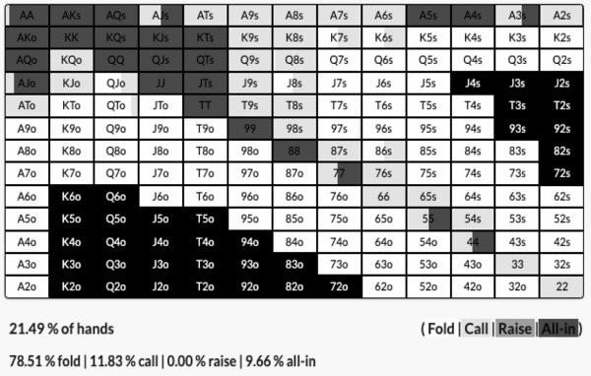

And this is what the Big Blind does when the Small Blind folds:

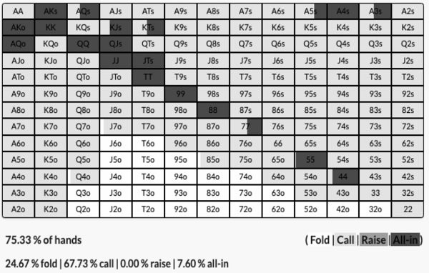

There is a lot to dissect here so let’s start with the Small Blind.

There is an almost even split of calls and shoves, and broadly speaking the Small Blind can play more hands than the early position opener. This is because shoving is very profitable at this stack depth, the opener has to fold a lot and on average shoving for 20 big blinds can win us 4.5 big blinds if they fold, which is a 22.5% stack increase.

The hands that shove are mostly the best hands like AK and AA-88, with some QJs and A5s hands for balance. Hands like A5s work well as bluffs because they block the calling range of Ax hands, but if called they can flop straights and flushes.

The calls are mostly the middle part of the range, the medium strength Ax, the medium pairs and the bottom of the suited unpaired hands. For the most part you want the calling range to be able to flop well which is why it is more suited card heavy. We protect the calling range by occasionally calling with AA but for the most part we don’t trap with our strong hands as going two way or worse three way to a flop out of position on every street is not that attractive at this stack depth.

Compare this to the Big Blind defending range.

First of all, the thing that surprises most players is how wide it is. The Big Blind is supposed to play 75.33% of hands and flat with 67.73% of them. Even experienced players would be flabbergasted to learn that K2o, 96o and 72s are profitable flat calls here. This is for three reasons. One is that we get to close the action, we are not worried about a third player coming over the top of us. Secondly it is just profitable from a sheer pot odds perspective to call here. It costs us one big blind to potentially win a 5.5 big blind starting pot, meaning we only need 18% equity to call. Finally, hitting any top pair is usually good enough to stack off with at this stack depth.

You won’t be making a huge mistake by mucking Q4o here, but you will be making a big error by not defending wide.

The Small Blind reraises much more and plays a tighter range because they don’t want the Big Blind to come over the top of them and with one player left to go they can safely get them to fold a big portion of the time. They also do not want to be the first person to act in a multiway pot.

The Big Blind reraises a tight range, it’s actually most of the same hands as the Small Blind. They always flat AA though, because against a tight opening range it is much easier getting 20 big blinds in post flop and you are usually happy to do so on most flops.

Let’s take a look at the Small Blind and Big Blind ranges against an open at 60 big blinds effective.

This is the Small Blind:

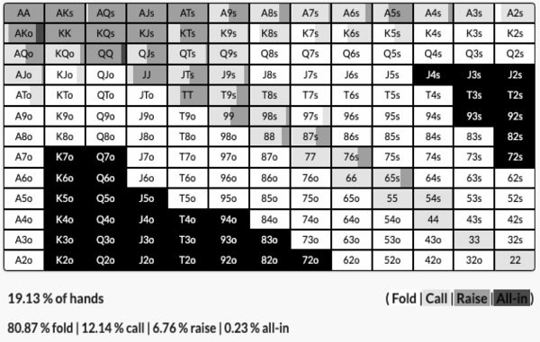

This is the Big Blind when the Small Blind folds:

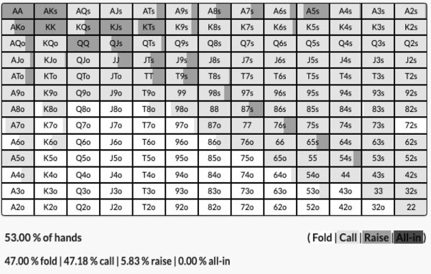

The first thing to note is that the ranges are tighter overall and the shoves are essentially gone, replaced by a standard raise size. The opening raise from early position wasn’t much tighter in this example than 20 big blinds, so the reason these defending ranges are tighter is because you need a much stronger hand to potentially stack off with at 60 big blinds. The stack to pot ratio is bigger, so as such you cannot simply stack off with top pair anymore. You need hands that have the potential to be quite strong across multiple streets to justify playing post flop. Position is more valuable at deeper stack depths and being out of position more punitive.

There are not really any shoves in these ranges because we want to build a pot. It is no longer a good result to win 4.5 big blinds preflop when there are 58 big blinds remaining left unclaimed. In the 20 big blind example a shove can win us 22.5% of our stack, in this example a shove that gets us a fold only wins us 7.5% of our stack.

Let’s see how things change at 100 big blinds effective. This is the Small Blind:

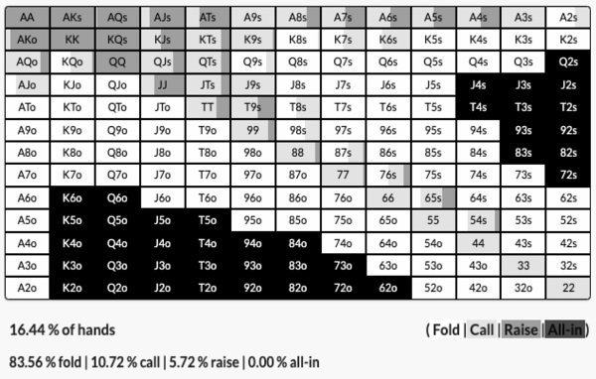

This is the Big Blind:

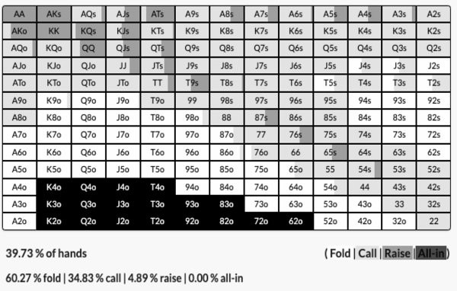

Again, the ranges are tighter overall because we need much stronger hands post flop that play well across all the streets. Roughly speaking the hands each position chooses to raise with remain the same, but raises are a bigger overall percentage of the range. This is because we want to build the pot more when stacks are deep.

## Facing A 3-Bet

We will now return to our original raiser from early position and what they do when they face a 3-bet. First of all this is how the opener responds to a 20 big blind jam from the Small Blind:

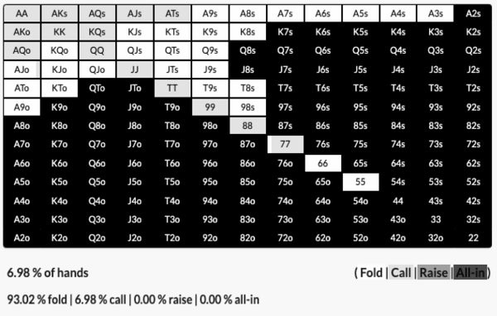

This is purely a call based on hand strength preflop because it is a shove, there is no need for bluffs/balance/board coverage.

At 60 big blinds, the Small Blind was raising to 5.5 bigs, not shoving, this is how the opener responds:

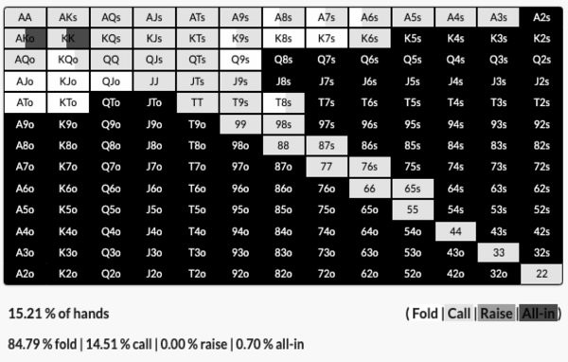

This is essentially a linear range with good board coverage, there is no real 4-betting. There is a shove range but it is just KK balanced with AKo as the bluff, but in practice it’s easier to play a pure flatting strategy with the continues. Even the biggest hands want to flat here.

A lot of people would expect the AK/QQ+ portion of the range to want to 4-bet here and maybe throw in some A3s as bluffs. In GTO though you will rarely see 4-bets, because they force the opponent to narrow their range too much. You want to keep your opponent’s range wide with your big hands like AA, so 4-betting will fold out too many hands. Also by flatting AA it means we protect hands like 65s. Flatting means we can play more hands against a 3-bet.

This range also gets to play in position which is why it likes the more speculative hands like 65s, which are much easier to play when you get to act last.

This is how the opener plays against a 3-bet at 100 big blinds:

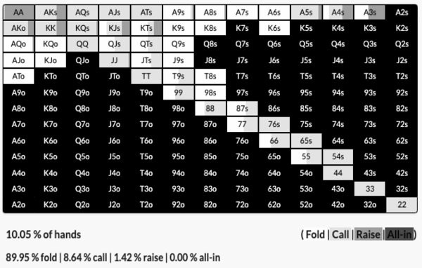

Again, this may surprise you given how wide we can call at 60 big blinds that we have to play a much tighter range at 100 big blinds. This highlights a common misconception poker players have, which is that hands struggle to realise equity at deeper stacks. At 60 big blinds against a 3-bet the stack to pot ratio is still quite low, so a hand like K9s is still profitable when it flops a pair. There is an inflection point soon after where it becomes hard to get your money in with K9s after the flop and still be good.

We also see some 4-betting at this stack depth. This is because we need to build the pot if we want to get 100 big blinds in by the river. Generally speaking solvers are always looking to win the maximum. When stacks are shallow they can flat more because a check/raise on the flop might be all you need to get your opponent all-in. When there are 100 big blinds behind you have to pump the pot up early to be able to get all-in by the river (this is also why you see more overbetting post flop when stacks are deep).

## Button Vs Blinds

We have looked at an UTG opener vs the blinds, where for the most part the opener has had to play tight and the blinds are incentivised to flat. Let’s look at the same stack depths but this time when the Button is the one to open into the blinds. This time instead of comparing stack depths, compare the Button to the examples we have already seen with an early position open.

This is the opening range for the Button at 10 big blinds:

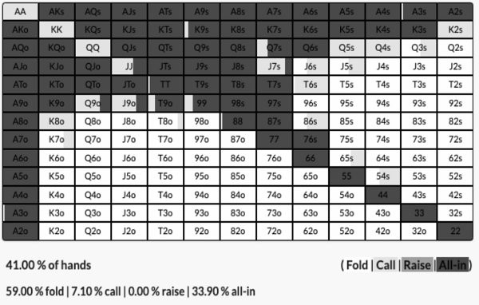

The early opener was only able to play 17.15% of hands compared to the 41% here. The Button only calls or shoves, there are no opens this time around.

This is all because they only have to worry about two other players, compared to the whole table. Shoves will work much more often with only two players left to act, plus they will get called by worse hands more frequently too. There is no normal open raising either because we do not want to have to bet/fold hands when it is such a big part of our stack. Our EV comes from making our opponents fold first and foremost, because in late position and only two players left to act they are more likely to fold, so we put the maximum pressure on by shoving. It is so likely that our opponents have nothing that we are forced to limp AA-JJ and give them a chance to catch up. Again we also limp our speculative hands we don’t mind limp/folding to balance the range.

This is the Button’s range at 20 big blinds effective:

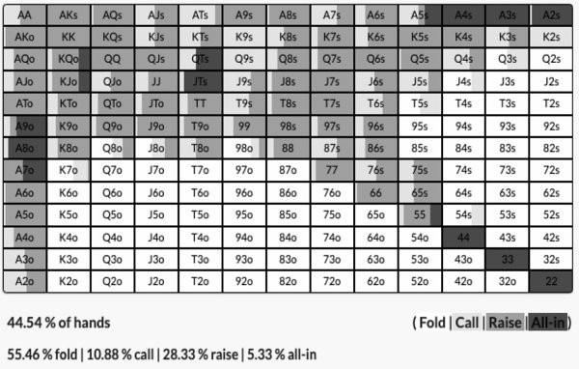

Again, much wider than the early position example. 44.54% of hands compared to 17.19%. There is quite the mix of actions too. AA limps sometimes, but KK/QQ always opens because it unblocks the likely reshove range of Ax. The shoves are actually more the bottom of the range, Ax, some broadway and small pairs. These are mostly hands that have good raw equity but play poorly postflop, so the best option is to force a lot of folds, block the calling range and with the small pairs you are flipping a lot of the time when called.

This is a much more complicated range than the UTG range, in practice you won’t lose much EV by opening all of it and shoving the same range.

This is the 60 big blind Button range:

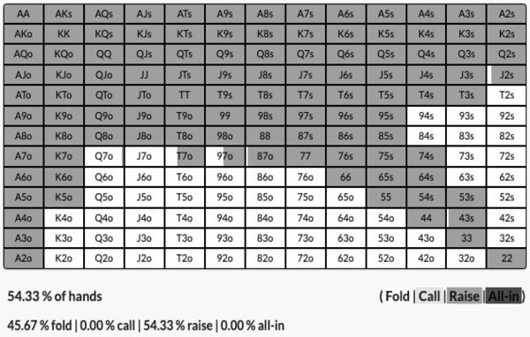

Now we open all our hands because we want to build the pot, taking it down for a shove is no longer an enticing option. We can actually play a much wider range of more than half the hands here.

This is the same range for 100 big blinds:

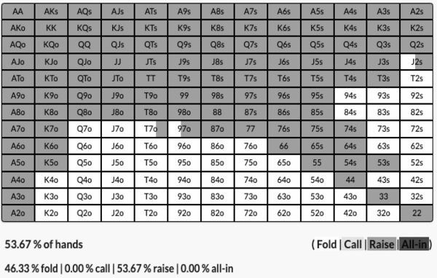

This is practically the same range as 60 big blinds, whereas the 100 big blind range for UTG was much tighter. This is a positional factor, the wideness of the range is mostly based on the fact that only two players remain and they most likely will have a weak wide range too, but we have position.

Speaking of which, this is the Small Blind 20 big blind range against the Button open.

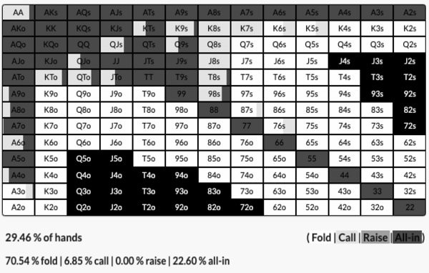

It is similar to the same range against the UTG opener, but wider because the Button range is wider. There is also much more shoving, relatively, in this range because it will work more often. Against UTG you are shoving into a tight range so the 3-betting range has to be polarised and blocker heavy. Against a Button range you can adopt a more linear shove range because you will be up against weak hands more often.

This is the Big Blind’s 20BB response to a Button open:

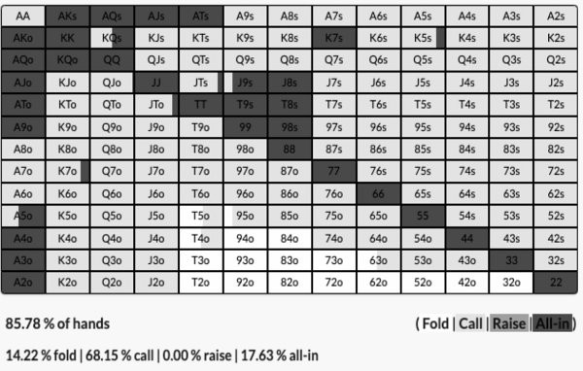

It is wider, it is almost all hands in fact. Again there is more shoving because it will work more often and again it is a much more linear 3-betting range compared to a polarised one against UTG.

This is the 60 big blind Small Blind range against the Button:

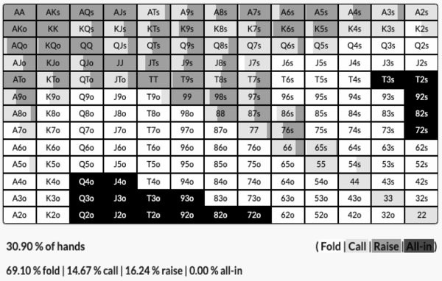

The shape of the range compared to the UTG response is very similar, but it is wider with a more linear 3-betting range. Again no shoves here, we want to build a pot not take it down.

This is the Big Blind response:

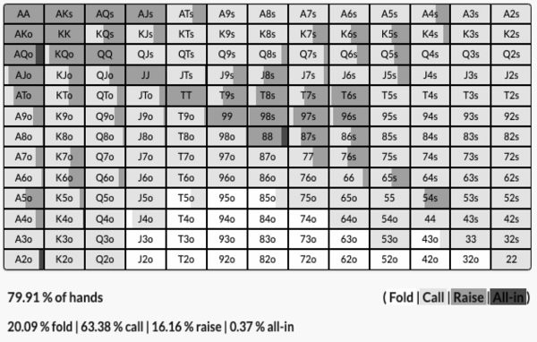

After this the 100 big blind response range doesn’t look much different. Again, the later you are in position the more similar the ranges will look at different stack depths.

## Heuristics For Real Life

*Defend more hands*

First of all you are probably not defending wide enough. If you are anything like most regulars at the tables, you are not defending opens in the Big Blind anywhere nearly as wide as you should. In some of our examples Q4o is a defend. This is of course based on the assumption that your opponents are opening wide enough, which they may not be, but to begin with just widen your calling range in the Big Blind. Add all the better suited cards and broadway cards, you will be surprised at how much more often you win the pot after the flop.

*Don’t bother limping*

We have shown you the why behind limping, but don’t bother. GTO limping ranges tend to be complicated and they only add a small percentage of hands to your range. It is much better to tighten your range and have a 100% open strategy. It will be much easier to play, one less thing to think about and in real life games your opponents will probably overfold anyway.

*When to shove*

We shove more at shallow stack depths mostly because it is profitable and effective. Shoving 20 or 30 big blinds over a late position open can add 20-25% to your stack, which is always a good result even if it was with a big hand that you would have happily had called. Shoves work more against late position opponents, whether they are in the blinds or they opened on the Button, because it is much more likely that they will fold.

*3-betting avoidance*

A lot of preflop range construction is about avoiding being 3-bet, which is particularly important at the shallower stack depths because shoving is more profitable. This is why you simply cannot open any hand in your range, especially from early position. If you tighten or widen your range from the GTO baseline it should primarily be based on whether your read of your table says you are going to be 3-bet more or less than usual. This is more important than the perceived tightness or looseness of your opponents. At a timid passive table you can exploit the lack of 3-betting by opening more hands and realising more equity with them, at an aggressive table you can exploit habitual 3- bettors by opening up a tighter range and punishing them with good hand selection.

*Study charts but deviate*

Familiarise yourself with preflop charts for the games that you play and use them as a baseline, but do not follow them blindly in a cookie cutter fashion. There is a lot of value to be gained preflop from widening/tightening your ranges based on the player tendencies at your table, value which would be missed if you followed preflop charts exclusively.

*A mix of stack sizes*

Finally, you will often find yourself in the situation where, for example, you might have 40 big blinds on the Button, the Small Blind has 50 big blinds and the Big Blind has 12 big blinds. The question is, do you use a range constructed for 40 big blinds effective or 12 big blinds? A 40 big blind range against a 12 big blind opponent is not going to be optimal, but what can you do?

This is why following ranges blindly is a bad idea, you have to be creative and adjust the ranges to meet somewhere in the middle. If it is a 60BB stack and an 80BB stack left to act, you won’t need to change much, but if it is a deep stack and a short stack you will.

My broad advice is to lean towards the stack that is more likely to act in the hand. If, for example, in our example the short stack is aggressive they will know they can profitably shove over a lot of opens, making playing a 40BB strategy exploitable. Much better to lean towards the short stack ranges. If that isn’t the case and the Small Blind is likely to flat a lot, then the Big Blind is getting a great price to call and therefore you are better off tailoring your ranges to them.

# CHAPTER 11: OTHER GTO CONSIDERATIONS

The purpose of this book is to present some of the most important and practical concepts found by solver technology, in as easy to digest a manner possible. This is by no means a complete book on GTO, we haven’t even scratched the surface.

As such, there is a lot we have not covered because it would be beyond the scope of this book. Some of these topics deserve a book or two of their own, other topics the book has already been written (by us). What follows are some of the areas we haven’t covered, with some rough guidelines about what to expect if you continue your study in optimal poker theory.

## ICM

The majority of this book has been written using ChipEV examples, even though they have mostly been tournament hands with antes. We wanted the book to have the broadest appeal possible and also our last book was exclusively on the Independent Chip Model, which included a post flop chapter. So for endgame tournament hands, we would point you to *Endgame Poker Strategy: The ICM Book*.

However, we will quickly outline some of the key differences you will encounter where GTO is concerned with post flop ICM.

*The covering player can be more aggressive*

The biggest difference is perhaps that the covering player gets to be more aggressive, regardless of range advantage or position. You will see more donk leads from the covering player, more bets in general and the covered player has to play more of a bluff catching style.

This is for the obvious reason that the covering player cannot be eliminated but the covered player can. The threat of elimination gives the covering player an advantage similar to when one player has a significant range advantage in ChipEV spots.

This factor is influenced by how much a covering player covers their opponent. If Player A has 30 big blinds and player B has 28 big blinds, this doesn’t really change things as Player B is almost as much of a threat to Player A as the other way around. If Player A has 50 big blinds and Player B has 30 big blinds, Player A gets to be much more aggressive. If Player A has 100 big blinds and player B has 30 big blinds, Player A essentially gets to play like a maniac.

*Bet sizes go down*

Whether covered or coverer, generally speaking bet sizes go down when ICM is a factor. This is mostly to reduce variance, the worst thing that can happen post flop when ICM is heavy is if you make a two thirds pot bet and get reraised. Bet sizing also becomes smaller to build pots, because players are more incentivised to fold. The only way to get value is sometimes to bet small.

Not only do bet sizes go down, but generally speaking the range drifts towards more low variance lines. Compared to the ChipEV equivalent spots, big bets become small bets, small bets become checks, reraises become calls, calls become folds.

The one big difference is when the effective stacks are very shallow, 20 big blinds or less. Then sometimes you will see open shoves on the flop, as well as min bets (something we call ‘Min or All-in’). In these cases the solvers like to take the lowest variance lines possible, which is a small bet or an all-in, the all-in being low variance because it should lead to a lot of folds. You very rarely see medium sized bets at this stack depth.

*ICM ranges mirror deep stack ranges*

You can never perfectly compare an ICM post flop strategy to a ChipEV post flop strategy, because the preflop ranges should be different. ICM ranges will shave off some of the small pairs and suited connectors, and replace them with suited Aces, suited Kings and suited Queens.

These hands are put in the range for their blocker value and also because they make very strong hands by the river. Although you are playing low stack-to-pot ratio pots in the late stages of tournaments, because of ICM you still need very strong hands to stack off with.

In this respect, ICM ranges are very much like cash game ranges. They are tight, avoid ‘dominated’ preflop hands and contain holdings that make very strong hands by the river.

*In PKOs the opposite is true*

PKOs are not even close to being solved, so one quick note on them. We also wrote the book on PKO tournaments and while we think they will never be fully solved, one broad adjustment is to do the opposite of what we have just said for ICM. Bet sizings should go up because you are incentivised to get stacks in the middle to win a bounty. You will take high variance lines and play wider ranges. Even as the covered player you can widen your range and play aggressively, because you will get called wider.

We recommend our book *PKO Poker Strategy* if you want to learn more about this format that is taking over online poker.

## Cash Games

We focussed on MTT hands in this book but only for simplicity, as we could highlight the differences in stack depths and also shallower hands are easier to follow. The advice in this book should be immediately applicable to cash games too.

Generally speaking the differences between cash games and MTTs is that the ranges are tighter and you see more 3-betting preflop. This is for two reasons - antes and rake.

MTT ranges are generally wider as both the aggressor and defender, because the antes put more money out there to win. There are usually 2.5-3.5BBs in the middle of the pot at the start of an MTT hand compared to 1.5. With no antes, you need a stronger hand to volunteer money to the pot.

Cash games also charge rake per hand, which reduces the overall pot size. If you open to 2 big blinds and the Big Blind calls, there would be 4.5 big blinds in the pot. If you then checked the pot down, if the rake was 5%, the pot would be 4.2 big blinds.

This also incentivises preflop 3-betting and bigger preflop bet sizes. Most poker rooms have a ‘no flop no drop’ rake system whereby if the pot ends preflop, the winner takes down an unraked pot. They are incentivised to play more aggressively preflop so they can win 100% of the pot now, rather than 95% of the pot post flop.

If MTT hands were raked (for some reason), cash game hands were unraked, MTTs didn’t have antes or in cash games with antes, you would see almost identical ranges and strategies for cash and tournaments when ICM isn’t a major factor.

To highlight these differences, let’s look at an example taken from the solver PokerSnowie. This is a 40 big blind effective button raising range with no rake and no antes:

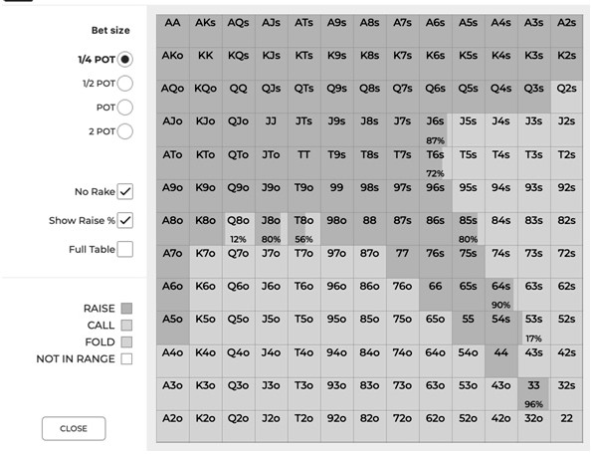

A typically wide range of 41.28% of hands, advocating a minimum opening bet.

This is the same range, but we have included antes that are 10% of the big blind size:

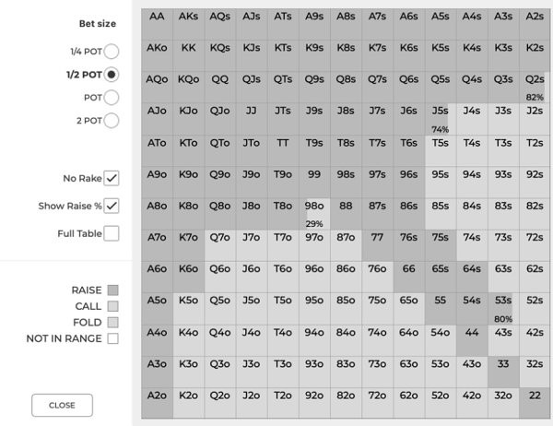

The shape of the range is broadly the same, but it is wider at 47.58 of hands and this time a half pot opening bet size has been suggested.

This confirms what we have already said. Antes mean we can go wider in general because there is more to win. A larger bet size is used too, because a min bet would rarely take the pot down preflop.

Now let’s look at the original range, no antes, but a 5% post flop rake is included:

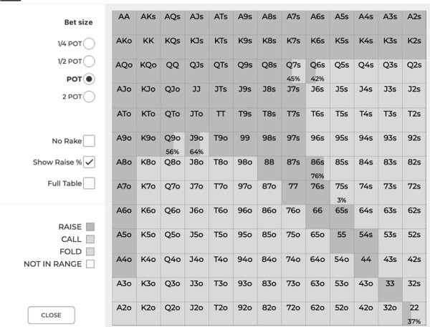

This range is much tighter, just 35.54% of hands and the suggested bet size is pot - much larger than the other two examples.

With no antes to win and the prospect of being raked post flop, we need a stronger hand to justify getting involved and we bet bigger to increase our changes of building, then taking down a bigger pot preflop to avoid being raked.

Let’s look at the same three examples, this time assuming the Small Blind has folded and the Big Blind is pondering their options.

First of all, 40 big blinds, no rake, no antes and defending against a min bet:

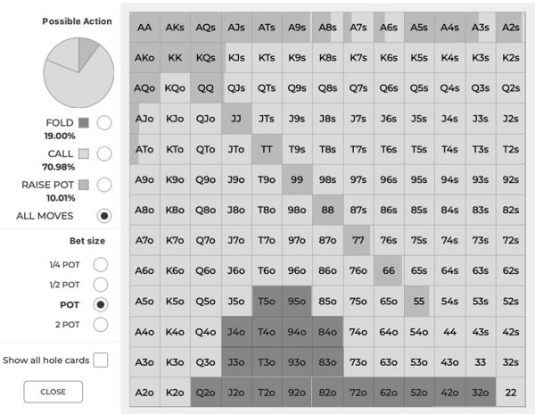

This is a very wide defending range, we continue with 81% of hands, which includes raising 10% of the time with a mostly linear range.

This is the same range, but with antes:

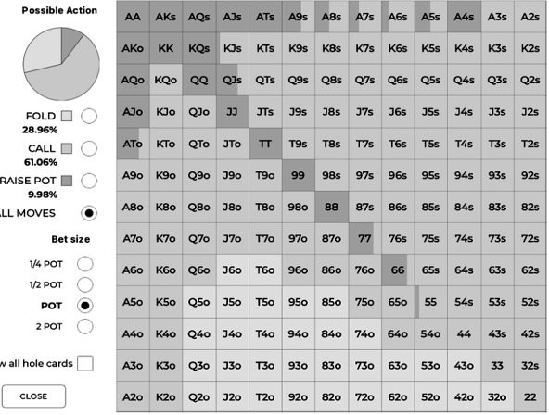

It is actually tighter, just 71.08% of hands continue, but that is because the opening raise size is larger. You will also notice that while it is almost exactly the same percentage of raising hands, the shape of the raising range is a little different. It is more weighted to Ax hands that block the 3-bet call range. This is because, with more chips out there to win, we want to be more confident of taking down the pot preflop, which we are with Ax.

Finally, this is the no ante, but raked, example:

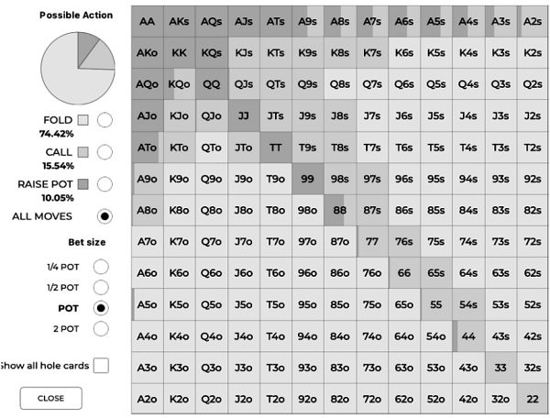

This is a dramatically tighter range, we now fold 74.42% of the time. This is because we are up against a much tighter opening range, a much bigger bet size and because of the rake we need a much stronger hand to justify the 5% hit on our winnings. This 3- betting range is a similar percentage to the other two ranges, but with less small pairs, as this range is more heavily weighted to hands that will win a preflop all-in.

Don’t spend too much of your time studying the effects of rake and antes on your ranges, it is usually enough to learn this once and know it forever. However, it is useful to be aware of these differences whenever a new format is introduced (for example bomb pots in cash games or big ante tournaments) so you can study the adjustments.

## Player Populations

At the risk of dating this book, we wanted to quickly take a look at the current poker landscape to identify the stakes and formats where understanding GTO is more or less important.

Of course it depends where you play, if you play 200NL on Unibet Poker right now you can probably get away with a very exploitative style, but 200NL Zoom at PokerStars might genuinely be one of the toughest games in the world. Play any $25,000 High Roller and you can expect 95% of the field to be well versed in GTO, but play the

$25,000 PSPC which will have around 300 amateur players in it, and you would be losing money not to play exploitatively. A $2/$5 game at the Venetian is going to be much tougher than a $2/$5 game at the Sahara, and so on.

In the live arena I would say that any tournament with a $1,000 buy-in or above is going to have enough solid regulars that playing a GTO style has its benefits. Online I would say from the $50 buy-in level and above the same is true.

If you play online cash, I would make the bold claim that you are best off studying GTO even at the micro stakes, it has become almost essential now. In cash games it is much easier to develop pattern recognition for common spots because they are all at 100 big blinds effective, so GTO is much easier to apply. You will also encounter more good regulars in cash games, even if they are playing across more tables.

Also in cash games the frequency with which you come across the same regulars is much more significant. You will more often face regulars and if it is a site with HUDs, you really want to avoid the exploit/counter exploit strategy.

To reiterate one more time, the best approach will always be to have both GTO and exploit in your arsenal. If you played GTO in the WSOP Main Event on Day 1, when there is so much value out there, you will be putting yourself at a massive opportunity cost.

## Bankroll

With that in mind, another consideration when adopting a GTO strategy is that you need a bigger bankroll to do so. You cap your potential winrate when you do not exploit your opponents, meaning that you need a bigger buffer against variance.

As a ballpark figure I’d say a GTO player has a capped 20% edge in tournaments, even against weak players. In soft MTTs a good player who diverges can have up to a 100% ROI and in high stakes games a good exploitative player might have a 30% edge.

You can run sims to see the sort of bankroll you would need for the two styles for free at PrimeDope.com. In this sim we looked at $50 MTTs with 300 runners on average and 40 places paid. This is a sample of 20 runs a player with a 20% ROI might have:

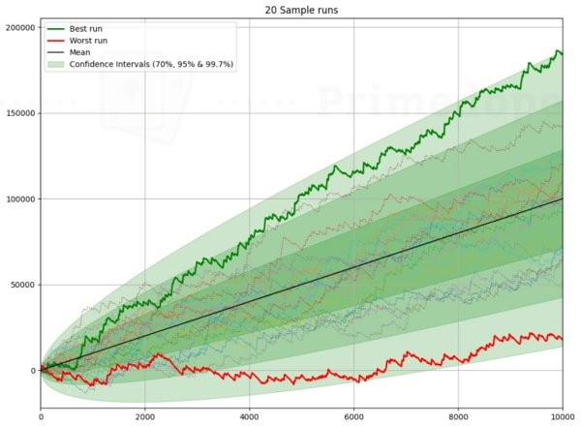

Over 10,000 MTTs this player would win $18,498 in the worst case and $177,285 in the best case scenario. Their risk of ruin was 1% and their required bankroll would be

$14,590.

A good exploitative player with a 50% ROI would fare much better:

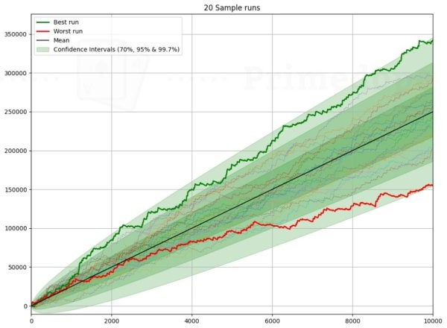

This player would make at least $165,258 and as much as $339,235. Their risk of ruin is also 1% and their required bankroll is $5,595.

With much better prospects for the exploitative player, why even bother playing GTO? At this point we should remind you that GTO is best used against tough players and unknowns, against really bad players you still want to diverge. The other reason to play GTO is because you can increase your tables and stakes without, in theory, seeing a big drop in your winrate.

In theory that $50 GTO player with the 20% ROI could move up to $500 games and see no drop in their winrate. We ran a sim for those games and the worst run saw that player make $226,440 and the best run they made $1,870,674 over 10,000 games. Their required bankroll was $154,137.

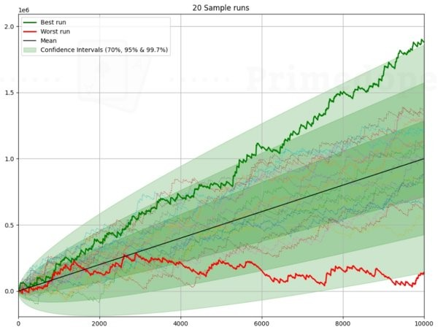

Let’s say our $50 exploit player moved to $500 games. Their winrate would surely drop down and most likely it would go under the 20% of the GTO player. When we ran a sim for this the player ended up down $326,066 in one of the examples and had a best result of $1,196,485.

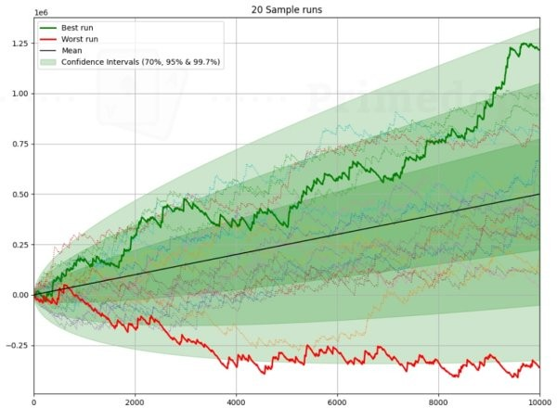

There are lots of assumptions, ifs and buts in the quick examples we gave above, most notably whether a 50% ROI player at $50 MTTs might be a 10% ROI player at the $500 level. The crude point we are making is that as a GTO player you cap your winnings but your abilities scale up. Learn GTO at the micro stakes and in theory you could play in the High Rollers. An exploitative player, however, might crush $10 MTTs but be a fish in $20 MTTs, and moving up in stakes is at least not a linear progression.

## Mindset

Another reason to sacrifice short term EV to play a GTO style is because it is generally much easier to play GTO from a mindset perspective. I am reminded of a quote from Bertrand Russell which sums up the benefits of being a GTO player, he said “what men really want is not knowledge but certainty”.

Exploitative players have to deal with much more uncertainty because so many more things can go wrong. Their assumptions about their opponents might be wrong and they find themselves diverging very far off the game tree. Opponent A might diverge in one direction, Opponent B might veer off a completely different part of the game tree. If an exploitative player thinks their opponent is under bluffing, then that player shows them a bluff, it can be stressful. Were all their assumptions wrong, or was it just the one time the player bluffed out of hundreds of missed opportunities? Exploitative players have to be very forgiving of themselves.

GTO players do not have anywhere near the stress of this, because they can usually run a sim and get an answer as to whether they made a mistake. GTO by comparison is a one size fits all approach where you were either correct, or you are provided with an answer to correct an error for the next time.

There are mindset issues that come from this, however. Because GTO involves mixed frequencies it means that often most plays can be right a small percentage of the time. You might run a hand where you made a seemingly bad hero call and discover, for balance purposes, that the solver does it 12% of the time. You might use this as a crutch to justify all of your bad play.

Just because something is allowed, does not mean it isn’t a mistake. In the example above, if you do the hero call 100% of the time, it is still a massive punt. Do you really call there just 12% of the time? Probably not. So to thrive from GTO you need to be able to make genuine assessments about how often you really are doing the minority mixed actions. As a baseline starting point you should try and stick to the more favoured actions the solver takes.

## Multiway Pots

We haven’t covered multiway pots in this book for two reasons. They are so complex they merit another book and, more importantly, multiway pots can never be GTO.

There is no stable nash equilibrium in multiway pots, it is impossible to play a style that cannot be exploited. I’ll give you a quick example to showcase what I mean.

When I started poker I cut my teeth in Six Max SNGs that paid the winner two thirds of the prize pool and 2nd place one third. Often the bubble would take place with three

players with the same stack size, or thereabouts.

Usually the correct adjustment in these games was to play the opposite way to the other two players. If they were playing too tight, you could exploit them by playing looser. If they were playing too loose, you could exploit them by playing tight.

The simple logic is that when two players are too tight on the bubble, you can accumulate a lot of chips by being loose aggressive. You would bust out a little more often on the bubble but you would also win the game more often. Conversely if two players were too loose, you would guarantee so many more 2nd places by playing tight that it would justify less outright wins.

What happens, however, if one player is too tight and one player is too loose?

If a good player is playing tight and a bad player is playing loose, how do you adjust? If you play loose then the tight player can exploit you both. If you play tight then the loose player exploits the pair of you. Even though the tight player is good and the loose player is bad, you still get exploited whichever way you adjust.

You have to decide on the lesser of two evils, there is no good answer for you. The optimal response always requires you to adjust to the other two players’ tendencies, which is an exploitative strategy, not a GTO one.

So there is no stable GTO solution for multiway pots, but there are some common heuristics that the solvers seem to follow. We recommended PokerSnowie for studying multway pots, and these are some of the most clear cut adjustments to get you started:

*Less bluff catching*

Heads-up if a player bets pot, you have to call them 50% of the time, otherwise they can exploit you and print money by bluffing. In a four way pot, the player betting pot has to worry about the aggregate chance of being called. The first opponent might call 10% of the time, the second opponent might call 20% of the time and the final opponent might call 40% of the time if it is folded to them.

Each individual player will bluff catch less, because they have to worry about the players behind waking up with a hand. But overall they will call more often than the minimum defence frequency.

*Less bluffing*

As such, there is very little bluffing multiway and for the most part the value hands are played more straightforwardly. If the first player to act flops a monster they are much more likely to lead out, because they really do not want the hand to get checked around. In a heads-up pot you can expect more range bets/bluffs/thin value from the initial aggressor, but multiway you want to take the initiative. A big error is checking strong hands expecting the rest of the table to do the betting for you.

*More folding*

Therefore, you should fold much more often in multiway pots, especially when there are players to act behind you. Don’t be surprised to see solvers fold 2nd pair and even top pair type hands to one bet in multiway pots, because generally speaking they do not perform well against the aggregate of two or more ranges, even if they figure to be best hand right now.

*Bet sizings go down*

In GTO we bet small when we have range advantage in part because it is the only way we will get called by players with capped ranges. The same is true in multiway pots, typically the bet sizes go down because it is the only way you will get called when you have a strong hand. Additionally, the fact that other players in the hand have to worry about each other too means they will fold more to small bets than they would heads up.

Let’s look at a simple example, we will compare an UTG opener against the Big Blind, with 40 big blinds effective, to the same spot but the Button and Small Blind have both called too. The flop in both cases is A♦9♥2♣.

First of all, this is the heads-up example. This is UTG’s opening range:

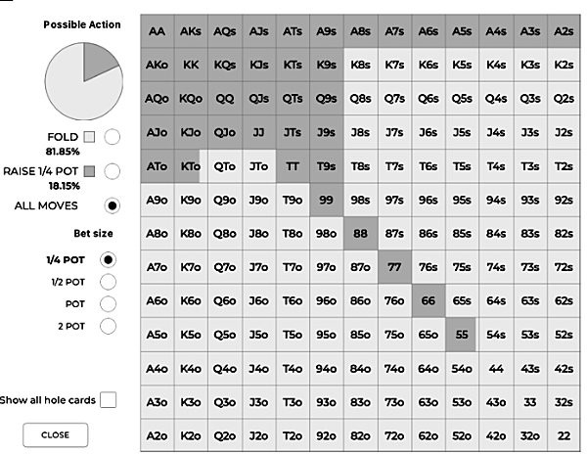

This is the Big Blind’s response:

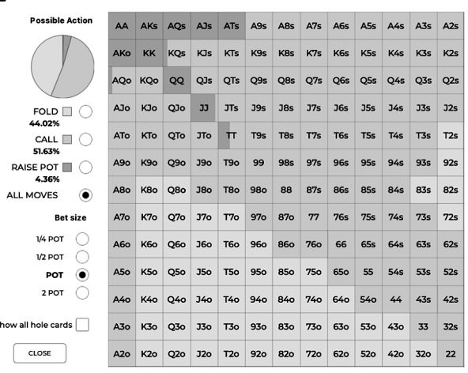

The Big Blind checks 100% of the time and this is what UTG does:

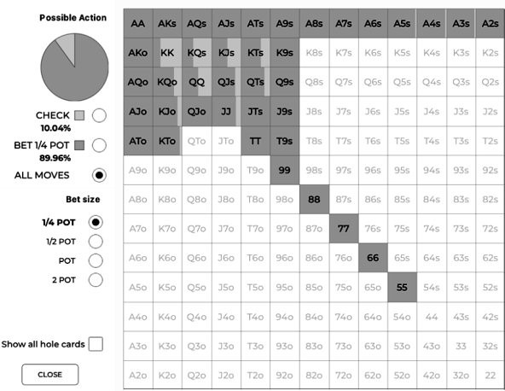

It is almost a range bet and using a small sizing for that reason, we have significant range advantage on this flop. This is how the Big Blind responds:

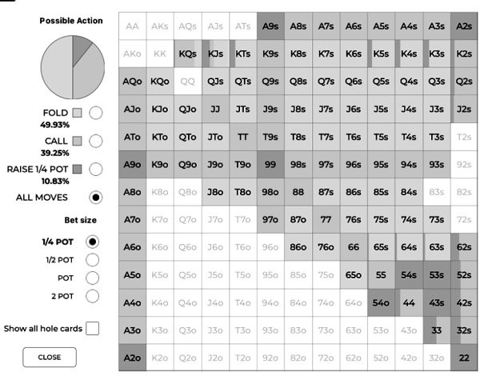

The Big Blind has to continue 80% of the time to avoid being exploited here, which they pretty much do with this range. The two pairs or better raise for value and the wheel draws raise as bluffs, while most of the calling range is built around 9x and Ax.

Let’s now look at the same spot but four way. A reminder of the UTG opening range:



This is the Button calling range:

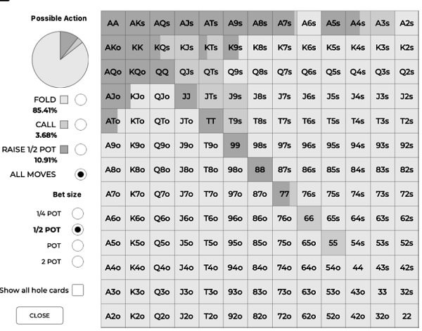

This is the Small Blind call range:

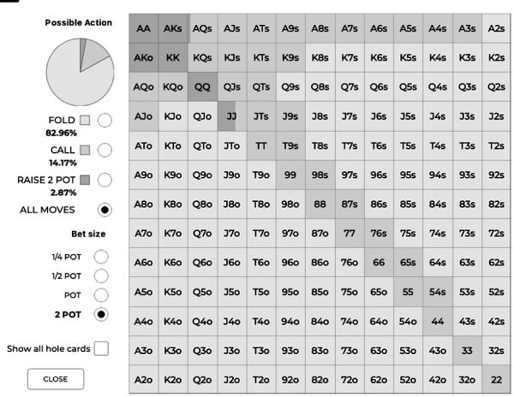

And this is the new Big Blind range:

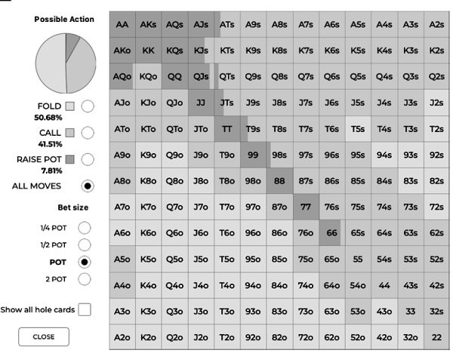

Notice there is more raising and more folding this time. We need a stronger hand to play multiway so we can’t just call all our suited stuff anymore, plus we want to narrow the field with our stronger hands.

Onto the same flop of A♦9♥2♣.

The Small Blind checks most of the time but we are looking at the Big Blind’s actions, so when they are checked to, this is their response:

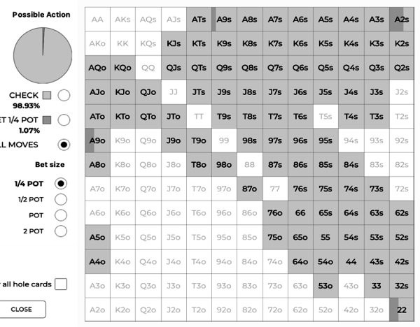

It’s a small part of the range but note that there is some leading out now with two pair or better. Also notice that there are no bluffs in this range, it is all value. Bluffing is a tricky prospect with three players left to act and we value bet because the hand being checked around is a disaster for us. Also notice the small bet size, we want to be called so we have to bet small.

When we check, this is what UTG does:

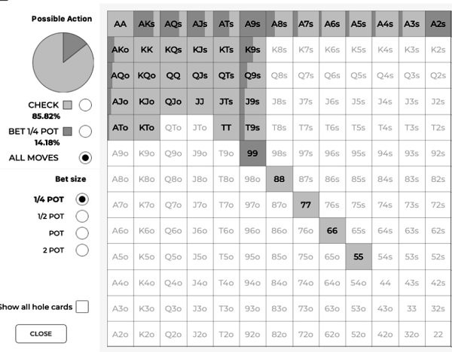

They range bet the last time, now they only bet 14% of hands. Again, there are no bluffs in this range. Almost all the Ax is bet and some of the 9x is bet, the only hand play deceptively is AA, which is because it is so far ahead and it heavily blocks the calling range. We also check back some Ax for protection reasons.

The nearest thing we have to a bluff is the 9x - we are very happy to take down the pot with 9x and fold out KK-TT or high cards that can outdraw us easily. If we get called, we can still hit draws/two pair/trips on the river. In that respect there is some balance taking place, but rather than value/bluff ratio, it is value/worse value that is being balanced.

When UTG does bet, and the Button and Small Blind fold, this is the Big Blind response:

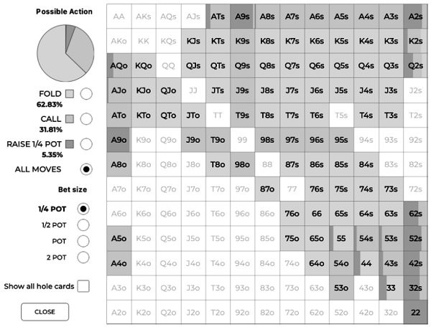

This has now become an almost correctly balanced defending range, because the hand has essentially gone heads-up again. What happens if instead the Small Blind calls ahead of the Big Blind?

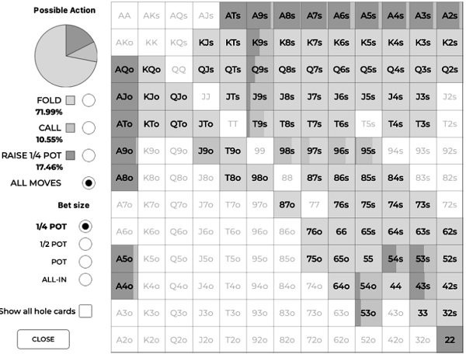

Even though the Big Blind is getting an even better price to call, they almost never defend with two players still in the hand. In fact they mostly raise their Ax for value and pretty much get out of the way with everything else.

To summarise, what we know about multiway pot strategy is not GTO, but solver technology has shown us that the optimal way to play them is to bluff and bluffcatch less, and stick to very strong ranges to volunteer more money in the pot post flop. It is not an exaggeration to say that multiway pots should be played face up for the most part (until the pot gets heads-up).

# CHAPTER 12: EXPLOITATION REVISITED

We started this book talking about exploitation and, now that you have taken a crash course in GTO, we wanted to revisit it.

A strange rift developed in poker about five years ago, you were either a GTO player or an exploitative player. Hopefully we have made the case for being both throughout this book. One big misconception is that solvers do not show you how to exploit bad players, they only show you how to play GTO against good players. Nothing could be further from the truth. PIOSolver, the main solver out there, has a feature that shows you the best way to exploit your opponents if you know their tendencies. Not everyone uses it, but they should, it is called Node Locking.

A solver will show you how perfect GTO players will play their assigned ranges against each other, using the preselected bet sizes available. This provides you with a strategy that cannot be exploited, but what about if your opponent plays differently, which they very likely will? In PIOSolver you can change the way your opponent acts to mirror how they play in real life, and it will adjust the strategy accordingly. For example, the solver approved line with a strong range will be to make a small ‘range bet’ which the opponent will have to call a decent portion of the time to avoid being exploited. What if your opponent in real life always bets 2/3rd pot no matter what with all their range? Well, you can give the solver the instruction that they will always do that and a new strategy is created to adjust.

By now you will know these ranges like the back of your arm, this is the 40BB UTG opening range:



And the Big Blind defending range:



The flop is 6♠5♥4♦.

You may remember from earlier in this book that this is the flop type where you will see the most leads from the defending player. This is what the Big Blind does when they act first:

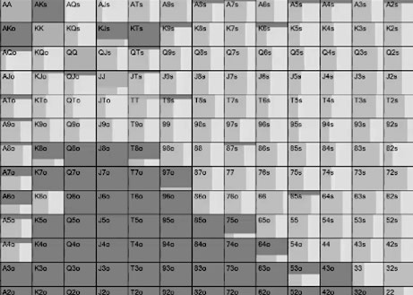

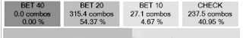

They bet almost 60% of the time because this is a really favourable board for the Big Blind because they have all the sets, all the two pair, all the flopped straights and all the high equity combo draws. In response to a small bet, this is what UTG should do…

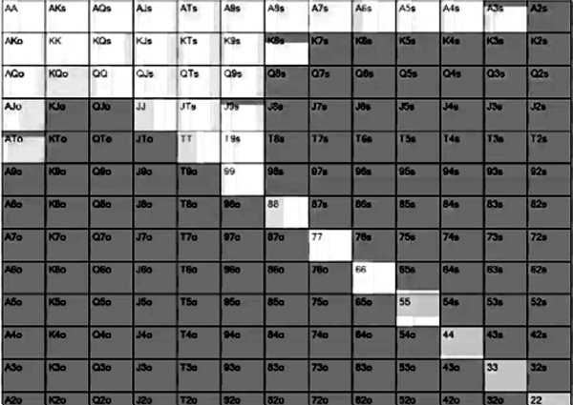

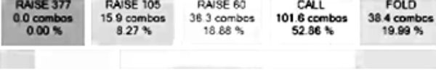

They raise with hands like 77 and 88 that have draws, and also hands like QQ-TT which are the most vulnerable. Hands like AA-KK mostly call.

When the Big Blind instead checks, this is what UTG does:

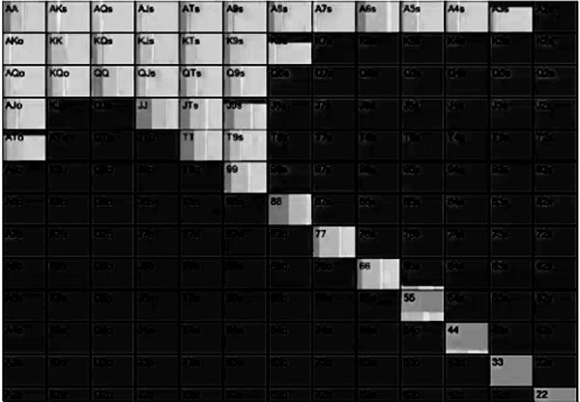

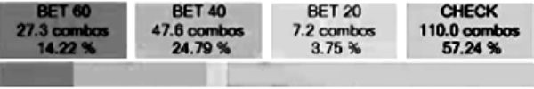

They now bet some of the time, because the Big Blind has weakened their range by not leading. However, most of the time they check back because the Big Blind still has lots of big hands here. It is mostly the vulnerable overpairs again that bet in this spot for value. In response to a 2/3rds size bet, this is what the Big Blind does:

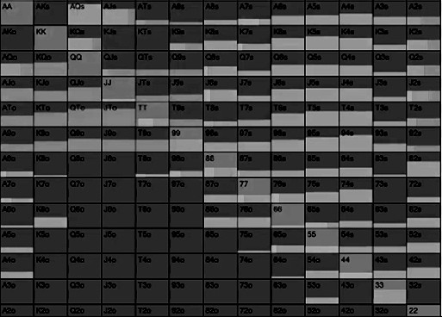

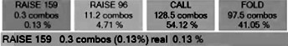

Mostly calls, plenty of folds and very little raising here.

## Node Lock Example 1

This is all good and well, but most players, even good players, don’t realise that this is a very good flop for the Big Blind to lead out. So what happens when we node lock and tell a solver not to allow the possibility to lead out here? Obviously the Big Blind, therefore, checks 100% but what does UTG do?

No need for a hand grid in this example, the answer is simply that UTG checks behind 100% of the time.

In the first example when the Big Blind checks, they have weakened their range, in this example however they still have all their nutted hands in their checking range. As such UTG does not want to bet and get check/raised, so they check behind.

In the first example the Big Blind expects to make 3.45 big blinds in EV when they lead out, in this example that goes down to 3.32 big blinds. That might not seem like much, but it is huge over a large sample (13 bbs/100 hands).

## Node Lock Example 2

Let’s flip this around and this time make our UTG player the one who deviates from the game tree. We tell the solver the Big Blind is allowed to lead out again, but this time we tell UTG to bet 100% of the time when checked to, rather than 42.76% of the time like they did in our initial example. This is a common leak you will see live or online, where a player will mindlessly bet when checked to because they were the preflop aggressor.

This time the Big Blind checks 100%, even though they have the option to lead out, which they did almost 60% of the time in the initial example. Let’s see why, this is what the Big Blind does when UTG bets 2/3rds pot, 100% of the time…

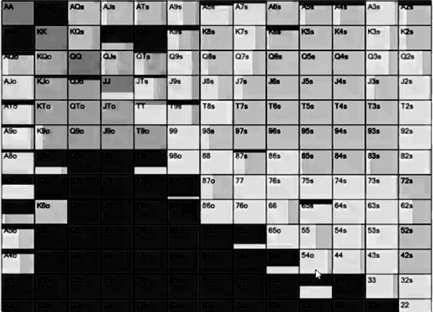

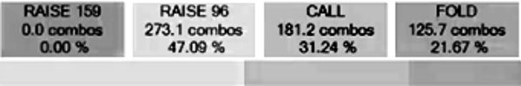

They now check/raise 47.09% of the time. In the initial example they check/raised less than 5% of the time.

In this example, the Big Blind makes 3.9 big blinds on average, compared to the 3.4 big blinds in the initial example. When UTG is guaranteed to bet when checked to, the best way to make money is to let them do it.

This is a great example of good exploitative poker which the solver has arrived at. They have adjusted a strategy of leading out 60% of the time to one where they check/raise almost half the time, to capitalise on the fact that the opponent continuation bets too much.

Node locking is one of those things that creates infinite possibilities and is way beyond the remit of this book (we have barely scratched the surface of GTO), but we wanted to end the book with one example of how node locking can help you develop a very profitable exploitative strategy with solvers. We mostly just wanted to show you that playing GTO is just the tip of the iceberg where this new paradigm of poker study is concerned, and that if you wanted to go deeper after reading this book, you can learn both how to play unexploitable and exploitable poker with the same tools.

# FURTHER STUDY

GTO is such a vast topic and we have only just scratched the surface with it. If you have found this book useful and want to continue your study, there are a number of directions you can go in to learn GTO.

The first step, if you are a fan of reading which you likely are if you have reached the end of this book, is to take on the two books we recommended at the start of this one. *Play Optimal Poker* (Andrew Brokos) and *Modern Poker Theory* (Michael Acevedo) are the best two books on the market. If you found this book useful they are the natural next step. Play Optimal Poker will really get you thinking about game theory in new ways, whereas Modern Poker Theory is a book you should always have close by because it is a very dense reference book. They are both excellent and will not date.

If you found following the hand grids in this book easy, you should probably start using some solver technology.

A really good place to start is the *DTO* app. This essentially turns poker study into a game, you are shown two ranges and a flop, then asked to pick the correct, GTO approved, action. After which you are scored on your actions and you can review what the correct actions were. What you will find with DTO is that there are hands that simply do not make sense. This is a good thing, DTO is really good at showing you your blind spots in poker study.

Once you are ready to study your own hands, we recommend software like *Range Trainer Pro, GTO Wizard* and *Poker Snowie*. These are not technically solvers, they are databases of previously solved hands with a lot of the outputs you see on a solver like *PIOSolver*. They are a really good way to quickly bring up a spot you played and study it, without the learning curve or hardware requirements that come with *PIOSolver*. There are limitations with these ‘Solver Lite’ tools, mostly due to the hand you want to study not being in the database, but they are perhaps the best value option out there.

Of those options, right now GTO Wizard is the most robust and easiest to use. If you head over to tinyurl.com/slowdoke you can get 10% off your first month.

If you graduate from using these tools, the final step is running your own solves with a tool like *PIOSolver*. This is the best way to really dig deep, study and get into the weeds. It also is the only way you can currently ‘Node Lock’ and study the exploitative side of the game. It is not easy to get started, however. You require a PC or Mac with an emulator. The software is not as intuitive as the other tools we have listed. You need a very fast PC and sometimes solves can take hours, if not days.

Whatever the tool, there are right ways and wrong ways to study hands.

Always start by comparing the two ranges in the hand, and identifying the shape of the range (Linear, polar, capped, condensed). Also look at the overall equities of both ranges. Identify who has range advantage/nutted advantage and ask yourself how that should affect the strategy. Do this both preflop and on the unique flop you are studying.

If you are studying a spot that you played at the tables, avoid the urge to look at just your own hand and whether you were ‘right’ to play it the way you did. Always look at the hand based on how your entire range should be played first and foremost. Also make sure you look at how your opponent should have played too.

Look for outlier hands. Look for hands that do not progress in the same manner as the rest of the range. If, for example, A2s, A3s and A5s all bet, but A4s checks in a spot, ask yourself why? The answer is often related to blockers, the outlier hand either blocks or unblocks a key hand in your opponents range. You learn a lot from recognising why outlier hands play the way they do.

Which brings us to the final piece of advice on using solver technology. You will learn the most and enjoy the process when you treat solvers with curiosity. It’s a fool's errand to consult a solver to see if you played the hand correctly, you don’t learn much and just confirm existing biases. The fun way to use solvers is to ask yourself ‘why did the solver do this?’

Solvers take very unusual lines, many of which have fundamentally changed what we know about the game. I have learned the most from solvers when they have taken a line that has baffled me, forcing me to investigate why they did what they did. This is why I believe that simply owning a solver is not going to turn anyone into a crusher. Think of solvers as a puzzle in the same way that you should poker, and there will be no limit to what you can learn.

If you want more strategy insights from me, I have a regular newsletter where I share advice, which you can sign up for below.

tinyurl.com/GTOPoker

You are very welcome to ask me any question you want on Twitter @daraokearney - I am always happy to discuss strategy with my readers. I also have a long standing ‘Ask Me Anything’ thread at CardsChat where I am an ambassador which I update regularly.

https://tinyurl.com/askdara

And if you want a good laugh you can also ask Barry what he thinks at @barry_carter.

# ACKNOWLEDGEMENTS

There are so many people to thank in helping us complete our fourth book together. No matter how big or small the contribution, you all helped make this happen.

Big thanks to our MVPs in the final stages of this book - Saron Harford, Kat Arnsby and Carlos Barletta. We could not have done this without you.

We would both like to thank everyone at Unibet, PokerStrategy.com, CardsChat, Vegas Slots Online, Share My Pair, RecPoker, Learn Pro Poker and Jaka Coaching. Your

support every year means the world to us.

Thanks to our army of early readers and in particular Danny Sprung, energiser bunny Katie Swift, Kevin Snelgrove, Matt Skeadas, Nancy Matson, Turlough McHugh, Jim Reid, Peter Cole, Christopher and Siddharth Sudunagunta who all influenced the final version of this book.

This book could not have been done without the software available at PIOSolver, Range Trainer Pro, GTO Wizard, Poker Snowie and Odin.

Neither of us would like to thank David Lappin because frankly he has been leaching off our hard work and talent for too long. If we were forced to say something nice about him it would be that he is one of the most selfless and loyal friends we could ever ask for, but we won’t be saying that.

Barry would like to thank Gina, Sarah and Mum. As always a big thanks to Simon ‘Jonesy’ Jones for teaching him the game in the first place.

I’d like to thank my long-suffering, ever supportive, wife Mireille, my poker kids Jack Hardcastle, Jack Sinclair, Daragh Davey, Simon Steedman, Tim Davie, Josh Abady, Jamie Nixon, Paulina Loeliger, Chris Frank, Henry Kilbane, William Shilibier and Alan Widmann, and my real life kids Paddy, Fiona and Oisin. I’d also like to thank my study buddies Sameer Singh, Monica Vaka, Paulina Loeliger and Jack Hardcastle who acted as a soundboard for many of my ideas, and my longest standing poker friends David Lappin, Jason Tompkins, Daragh Davey, Gary Clarke, Dani Petcu, Dave Curtis, Rob

and Cat Taylor, Nick Newport, Kasia Scanlon, Dan Wilson, Padraig O’Neill, James Noonan and Ian Simpson, Alex O’Brien, Maria Konnikova, Jared Tendler, Kevin Martin and Louise Butler.

It also means a lot to me how many of you have supported my work, coaching, books and blogs by sharing them a lot over the years on social media. There are too many of you to mention but I know I must say thank you to Elron Steele, Jason Tompkins, Mark Smyth, Neil Channing, Jennifer Tilly, David Tuchman, Donna Morton, Kevin Mathers, Chad McVean, Geri Batjargal Ishdorj, George Devine, Brad WIlson, Brendan

Chambers, Kevin O’Donnell, Ray Wheatley, Aidan from Kerry, Paul Seaton, Christin Maemets, Dominik Nitsche, Liam McMurray, Ray Woods, Ilana Belsky, Feargal Nealon, Tony and Gillian Baitson, Kevin O’Donnell, Luke Vrabel, Elena Stover, Louise Butler, Sylvia Hewitt, Kelly Saxby, Maureen Bloechlinger, Gerard Keenan, Louise Mulholland, Annette Carroll, Jason Smyth, Vanessa from Manchester, Zachary Elwood, Andrew Brokos, Karl Parrish, Paul Romain, Robbie Strazynski, Paul and Laura Spillane, Ryan Laplante, Christin Maschmann, Asif Warris, Adam Owen, Marty Mathis, Sebastian Rebhan, Andy Paton, Nataly Sopacuaperu, Shirley Ang, Christian Zetzsche, Rebecca McAdam, Clodagh Hansen, and Willie Elliot.

This book is dedicated to my friend Jan Suchanek, my dearest poker friend, confidante, business partner and mental sparring partner, who passed away unexpectedly before its completion. He was very much looking forward to reading it, and I was looking

forward to him telling me to my face at length everything that was wrong about it, secure in the knowledge that behind my back he would be recommending it to all his friends or buying it for all his friends if they didn’t immediately take his recommendation.

# ABOUT THE AUTHORS

## Dara O’Kearney

Dara O’Kearney is a professional poker player from Ireland with a long standing reputation as the best satellite specialist in the game. He is sponsored by Unibet Poker and is the co-host of The Chip Race Podcast. He is also an ambassador for CardsChat.com. He has previously released Poker Satellite Strategy, PKO Poker Strategy & Endgame Poker Strategy with co-author Barry Carter.

[**www.twitter.com/daraokearney**](http://www.twitter.com/daraokearney)[**www.dokearney .blogspot.com**](http://www.dokearney.blogspot.com/)

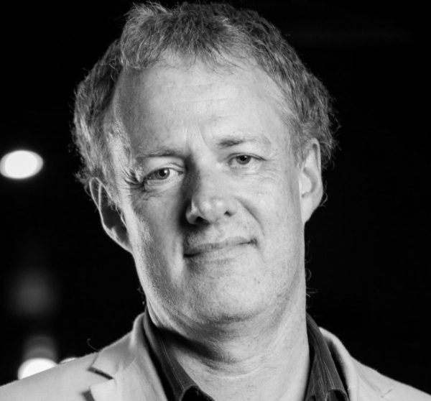

## Barry Carter

Barry Carter is a poker author from the United Kingdom with a long standing reputation as a mediocre player. He is the editor of PokerStrategy.com, the world’s largest poker community, and co-author of the best-selling books The Mental Game of Poker 1 & 2, Poker Satellite Strategy, PKO Poker Strategy & Endgame Poker Strategy.

[**www.twitter.com/barry_carter**](http://www.twitter.com/barry_carter)

[**www.pokermediap ro.com**](http://www.pokermediapro.com/)



# OTHER BOOKS BY THE AUTHORS

**Poker Satellite Strategy**

Dara and Barry give the complete guide on satellite tournaments in this ground breaking book which was an instant best seller.

The book covers when to call, shove and fold on the bubble of satellites, when to tighten up and when to keep accumulating chips, and even to fold Pocket Aces preflop.

[**Buy Poker Satellite Strategy**](http://mybook.to/satellite) **PKO Poker Strategy**

Dara and Barry return with the first book ever written on the fastest growing format in poker – bounty tournaments.

The book covers when to gamble for big bounties, how to adjust when ICM is a factor and quick PKO math for tricky spots.

[**Buy PKO Poker Strategy**](http://mybook.to/sat)

**Endgame Poker Strategy: The ICM Book**

Dara and Barry third book together and the first book to take a deep dive into the Independent Chip Model and how it impacts strategy in the final stages of tournaments.

This book covers laddering, final table deals, game selection, rebuy and late reg strategies, bubble play, final tables and how to play short/medium/big stacks.

[**Buy Endgame Poker Strategy**](http://mybook.to/ICM) **The Mental Game of Poker**

Barry teamed up with mental game coach for one of the biggest selling poker books of all time.

The book changed the landscape of poker psychology and covers how to fix tilt, motivation and confidence issues.

[**Buy The Mental Game of Poker**](http://mybook.to/mental) **The Mental Game of Poker 2**

The long awaited sequel to the best selling poker classic. Now that you have conquered your tilt, this book is about playing in the zone, every time.

This book covers mental endurance, learning, focus, discipline and decision making.

[**Buy The Mental Game of Poker 2**](http://mybook.to/mental2)